

**Authorized Signature:**

**Mr. Tri Phan Huu**

**Date of Issued:**  *07/13/2021*

--------🙟🟑🙝--------

**Zeal Education Manager**

**(ZEM)**

--------🙟🟑🙝--------

Mr./Ms.:

1. **VINH LE PHAT - Student1219094**
2. **BAO TRAN QUOC – Student1219694**
3. **TRAN NGUYEN HOANG NGOC – Student1219716**

**Team Leader:**

**Mr. Vinh Le Phat**

**REVIEW 1**

***Chapter I: Problem Definition***

1. The **Z*eal Education Manager*** is supposed to be designed to meet the requirements of the organization / institution engaged in imparting training by the name “Zeal Institute”. The idea is to set up a intranet based cost effective training candidate base management, which incorporates various day to day activities e.g. Counselling for various courses, Follow ups for various queries of the past, Advertisement of the company to get new candidates for training, complete management of student data, batch details, faculty information, subject, material information etc. Besides all these it will also take the day to day operations of the organization e.g. No. of hours worked by the each candidate, Comments and Suggestions of the candidates taking training there, maintenance of systems for the employees and candidates of the company.   
         
   The system will be under the command of In charge of the company. He will have the authority to modify the criteria for students according to the latest rules of Board of Management of the organization. In this way this system will greatly help the owner in getting latest happenings.
2. *Existing Scenario:*

Registered users (students, faculty, administrator and others) will be able to log in a request for service for any of the supported facilities. These requests will be sent to the concerned people, who are also valid users of the system, to get them resolved. There are features like email notifications/reminders, report generators etc. in this system.

*C****hapter II: Requirement Specification***

1. *Proposed Solution* *and* *Functional* *Requirements*

Following is a list of functionalities of the system:

There are registered people in the system (students, faculty, administrator, and others).

There are three kinds of users for this system:

1. those who use the system to create a request (end-users)

2. those who look at the created requests and assign them to the concerned people (administrator)

3. those who work on the assigned requests and update the status of the same on the system (assignees)

.

1. A person should be able to

login to the system through the first page of the application

• change the password after logging into the system

• see the status of the requests created by him/her (the status could be one of unassigned/assigned/work in progress/closed/rejected)

• see the list of requests (both open and closed) created by him/her over the past

• create a new request by specifying the facility, the severity of the request (there may be several levels of severity defined) and a brief description of the request

• close a request created by him/her by giving an appropriate reason

• see the requests that are assigned to him/her by the facility-heads and update the status of requests (after working on them)

• view the incoming requests (if he/she is a facility-head) and assign them to registered users of the system

• get help about the OHD system on how to use the different features of the system

2. As soon as a request is created, a message will be displayed to the person who created the request and the concerned facility-head.

3. Similarly, when any status-change occurs for a request (such as the request getting completed etc), an automatic message will be updated to the person who created the request and the concerned facility-head.

4. A summary report on the requests that came in and requests that were serviced should be sent to every facility-head periodically (say, once in a month)

➢ Mainly Input/ Output

o Login :

• Input: username,password

• Output: successful or unsuccessful

o Search Information:

• Input:address, datetime,money,category…

• Output:Information of property…

1. *Technical System requirements*

* **Developer:**
* Hardware
* Intel® Core™Duo CPU 1.60GHz, 1,00GB of RAM or higher
* Windows XP, Windows Vista or Windows 7
* Software
* Visual Studio 2010
* SQL Server 2008
* Internet Explorer 8.0
* Mozilla Firefox 3.6
* Google Chrome 8.0
* **User:**
* Hardware
* Intel® Core™Duo CPU 1.60GHz
* 1,00GB of RAM or higher
* Software
* Internet Explorer 7.0
* Mozilla Firefox 3.6
* Google Chrome 8.0
* Windows XP, Windows Vista or Windows 7

***Chapter III: Architecture and Design Project***

1. *Tiers of Application*



1. *Design project by DFD/UML*

* **Define DFD**

Data Flows Diagram (DFD) describes the information flow in the system. The next step of system analysis is to consider in detail the information necessary for the implementation for functions discussed above and the one necessary for the improvement of the functions. Modeling tool frequently used for this purpose is DFD. DFD will support 4 main activities.

* **Analysis**

DFD is used to determine requirement of users.

* **Design**

DFD is used to map out plan and illustrate solution to analysis and users while designing a new system.

* **Communication**

One of the strength of DFD is its simplicity and ease to understand to analysts and users.

* **Document**

DFD is used to provide special description of requirement and system design. DFD provide an overview of key functional components of the system but it does not provide any detail on these components. We have to use other tools like database dictionary, process specification to get an idea of which information will be exchanged and how.

**The main Component of Context Diagram**

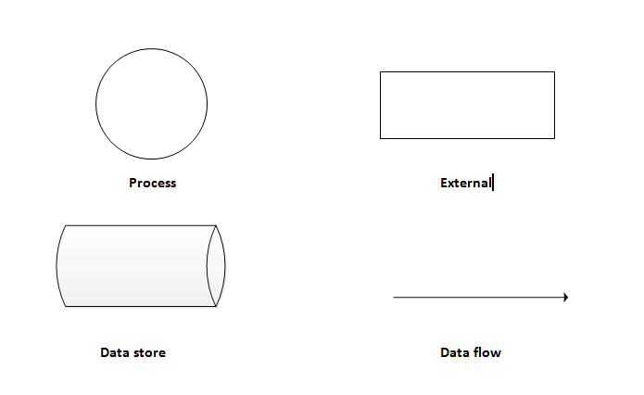

1. **USECASE DIAGRAM:**

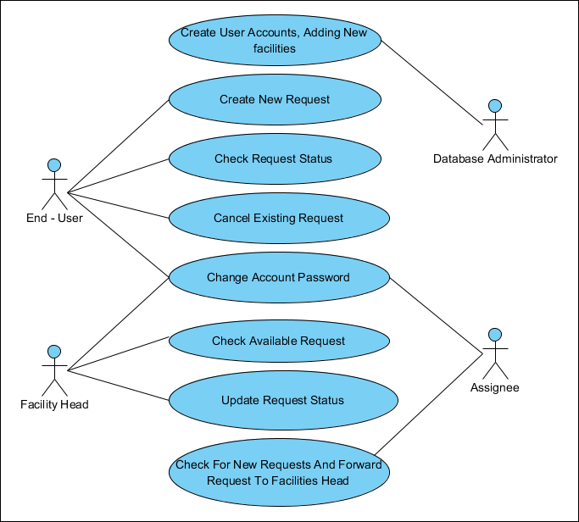 **DESCRIPTION USECASE:**

|  |  |  |  |
| --- | --- | --- | --- |
| **Use case name**: Create User Accounts, Adding New Facilities | **ID**: 1 | | **Important level**: High |
| **Primary actor**: Database Administrator | | **Use case type**: Detail, necessary | |
| **Stakeholders and interests**: employees want to use the system. Database administrator created Accounts.. | | | |
| **Brief description**: Describe the creation account, and add new facilities | | | |
| **Trigger**: Database Administrator.  **Type**: | | | |
| **Relationships**:  Association: Database Administrator.  Include:  Extend:  Generalization: | | | |
| **Normal flow of events**:   1. Login in system 2. Create New User Account. 3. Create Notice to Person through email | | | |
| **Sub flows**: | | | |
| **Alternate/exceptional flows**: | | | |

|  |  |  |  |
| --- | --- | --- | --- |
| **Use case name**: Create New Request | **ID**: 2 | | **Important level**: Medium |
| **Primary actor**: Faculties | | **Use case type**: Detail, | |
| **Stakeholders and interests**: Faculties | | | |
| **Brief description**: Create New Request | | | |
| **Trigger**: Faculties  **Type**: | | | |
| **Relationships**:  Association: Faculties  Include:  Extend:  Generalization: | | | |
| **Normal flow of events**:  1/ Login in system  2/ Choose action New Request.  3/ Create New Request.  4/ Input New Request.  5/ Log Out | | | |
| **Sub flows**: | | | |
| **Alternate/exceptional flows**:  Create New Request. To see if the same | | | |

|  |  |  |  |
| --- | --- | --- | --- |
| **Use case name**: Check Request Status | **ID**: 3 | | **Important level**: Medium |
| **Primary actor**: End Users | | **Use case type**: Detail, | |
| **Stakeholders and interests**: End Users | | | |
| **Brief description**: Check Request Status | | | |
| **Trigger**: End User  **Type**: | | | |
| **Relationships**:  Association: End User  Include:  Extend:  Generalization: | | | |
| **Normal flow of events**:  1/ Login in system  2/ Choose action see status request  3/ Log Out | | | |
| **Sub flows**: | | | |
| **Alternate/exceptional flows**: | | | |

|  |  |  |  |
| --- | --- | --- | --- |
| **Use case name**: Cancel Existing Request | **ID**: 4 | | **Important level**: Medium |
| **Primary actor**: End Users | | **Use case type**: Detail, | |
| **Stakeholders and interests**: End Users | | | |
| **Brief description**: Cancel Existing Request | | | |
| **Trigger**: End User  **Type**: | | | |
| **Relationships**:  Association: End User  Include:  Extend:  Generalization: | | | |
| **Normal flow of events**:  1/ Login in system  2/ Choose action Cancel Existing request  3/ Gives Reason  3/ Log Out | | | |
| **Sub flows**: | | | |
| **Alternate/exceptional flows**: | | | |

|  |  |  |  |
| --- | --- | --- | --- |
| **Use case name**: Change Account Password by user | **ID**: 5 | | **Important level**: Medium |
| **Primary actor**: Users, Faculties, Admin | | **Use case type**: Detail, | |
| **Stakeholders and interests**: Users, Faculties, Admin | | | |
| **Brief description**: Change Account Password by user | | | |
| **Trigger**: Users, Faculties, Admin  **Type**: | | | |
| **Relationships**:  Association: Users, Faculties, Admin  Include:  Extend:  Generalization: | | | |
| **Normal flow of events**:  1/ Login in system  2/ Choose action change Account password  3/ input Current password  4/ Input New Passwords,  5/ Input Confirm Password  6/ Log Out | | | |
| **Sub flows**: | | | |
| **Alternate/exceptional flows**: | | | |

|  |  |  |  |
| --- | --- | --- | --- |
| **Use case name**: Check Available request | **ID**: 6 | | **Important level**: Medium |
| **Primary actor**: Users, Faculties | | **Use case type**: Detail, | |
| **Stakeholders and interests**: Users, Faculties | | | |
| **Brief description**: : Check Available request | | | |
| **Trigger**: Users, Faculties  **Type**: | | | |
| **Relationships**:  Association: Users, Faculties  Include:  Extend:  Generalization: | | | |
| **Normal flow of events**:  1/ Login in system  2/ Choose action : Check Available request  3/ Log Out | | | |
| **Sub flows**: | | | |
| **Alternate/exceptional flows**: | | | |

|  |  |  |  |
| --- | --- | --- | --- |
| **Use case name**: Update Request status | **ID**: 7 | | **Important level**: Medium |
| **Primary actor**: Admin | | **Use case type**: Detail, | |
| **Stakeholders and interests**: Admin | | | |
| **Brief description**: : Update Request status | | | |
| **Trigger**: Admin  **Type**: | | | |
| **Relationships**:  Association: Admin  Include:  Extend:  Generalization: | | | |
| **Normal flow of events**:  1/ Login in system  2/ Choose action : Update Request status  3/ Log Out | | | |
| **Sub flows**: | | | |
| **Alternate/exceptional flows**: | | | |

|  |  |  |  |
| --- | --- | --- | --- |
| **Use case name:** Check For New Requests And Forward Request To Facilities Head | **ID**: 8 | | **Important level**: Medium |
| **Primary actor**: Admin | | **Use case type**: Detail, | |
| **Stakeholders and interests**: Admin | | | |
| **Brief description**: : **:** Check For New Requests And Forward Request To Facilities Head | | | |
| **Trigger**: Admin  **Type**: | | | |
| **Relationships**:  Association: Admin  Include:  Extend:  Generalization: | | | |
| **Normal flow of events**:  1/ Login in system  2/ Choose action : Check For New Requests And Forward Request To Facilities Head  3/ Log Out | | | |
| **Sub flows**: | | | |
| **Alternate/exceptional flows**: | | | |

|  |  |  |  |
| --- | --- | --- | --- |
| **Use case name:** Forgot Account Password by email | **ID**: 9 | | **Important level**: Medium |
| **Primary actor**: Users, Faculties | | **Use case type**: Detail, | |
| **Stakeholders and interests**: Users, Faculties | | | |
| **Brief description**: : **:** Forgot password, change account password by email | | | |
| **Trigger**: users, faculties  **Type**: | | | |
| **Relationships**:  Association: users, faculties  Include:  Extend:  Generalization: | | | |
| **Normal flow of events**:  1/ Choose action : forgot password, input email, check code, input new password  2/ Log in system by new password  3/ Log Out | | | |
| **Sub flows**: | | | |
| **Alternate/exceptional flows**: | | | |

|  |  |  |  |
| --- | --- | --- | --- |
| **Use case name:** Contact us | **ID**: 10 | | **Important level**: Medium |
| **Primary actor**: Client | | **Use case type**: Detail, | |
| **Stakeholders and interests**: Client | | | |
| **Brief description**: : **:** Contact us | | | |
| **Trigger**: client  **Type**: | | | |
| **Relationships**:  Association: client  Include:  Extend:  Generalization: | | | |
| **Normal flow of events**:  1/ Choose action : Contact, input information, send messenger for us | | | |
| **Sub flows**: | | | |
| **Alternate/exceptional flows**: | | | |

1. **ACTIVITY DIAGRAM**

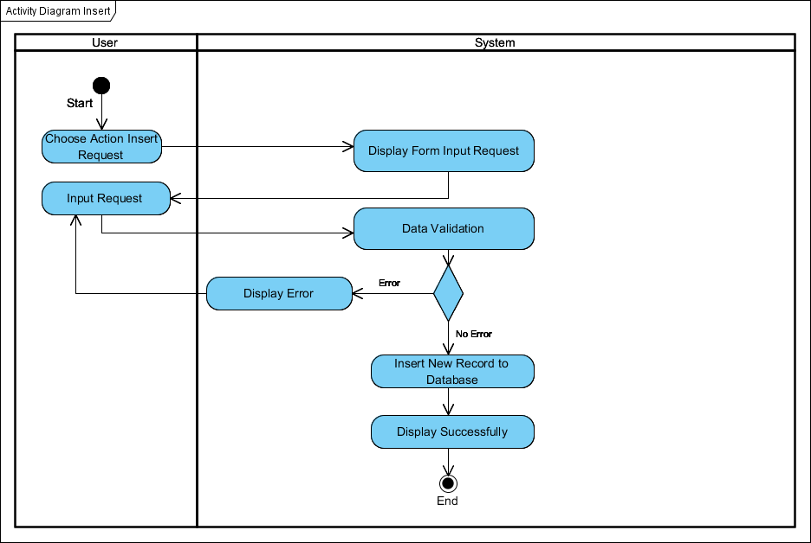

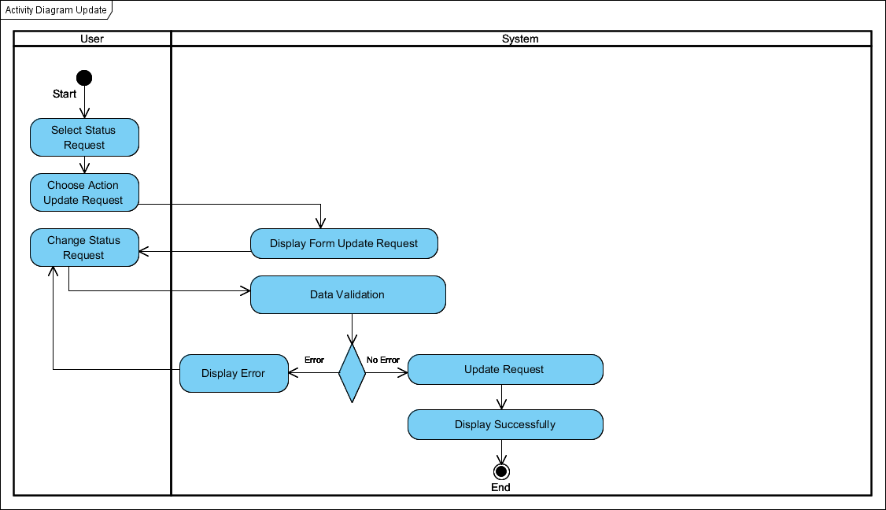

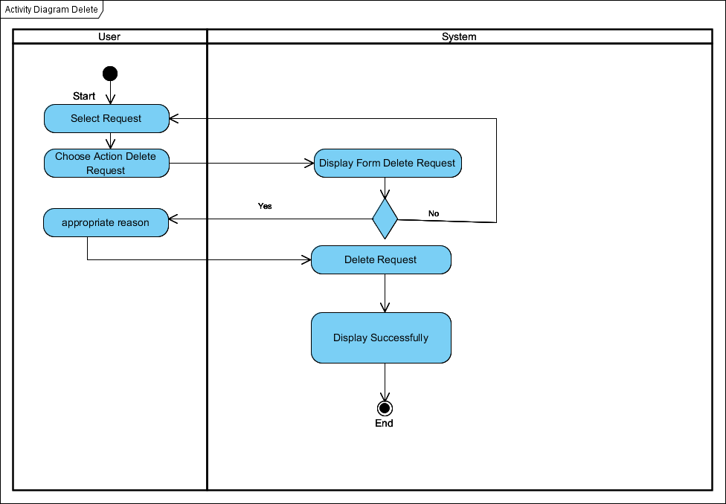

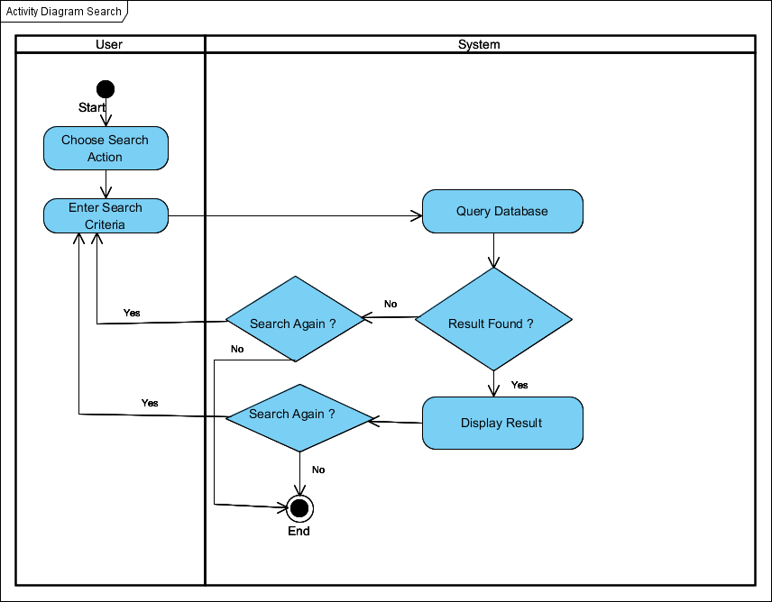

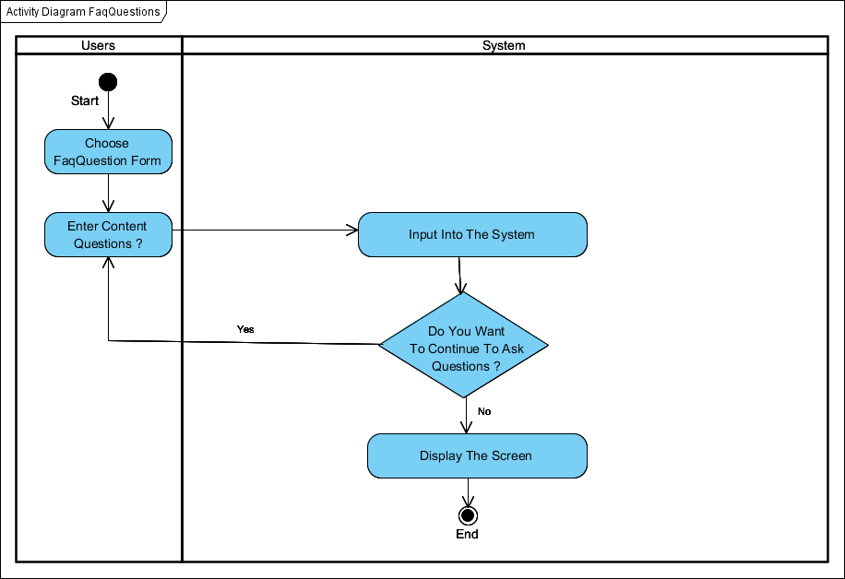

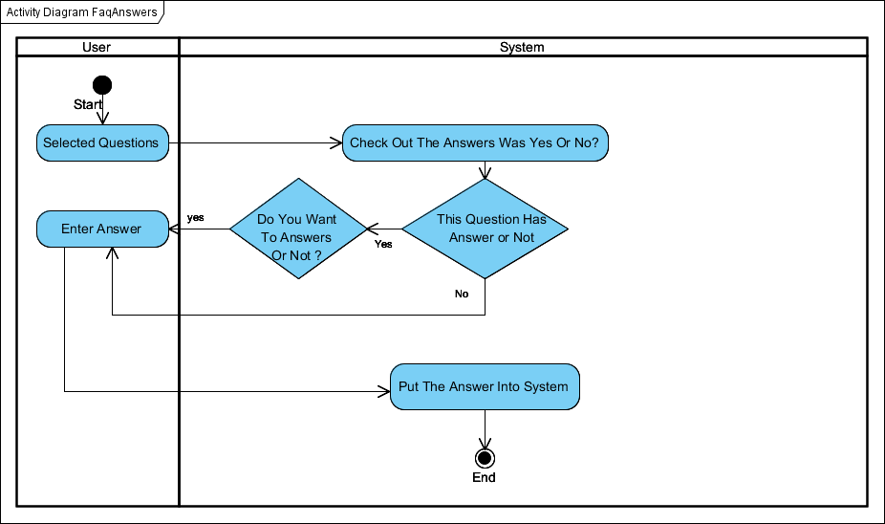

# SEQUENCE DIAGRAM

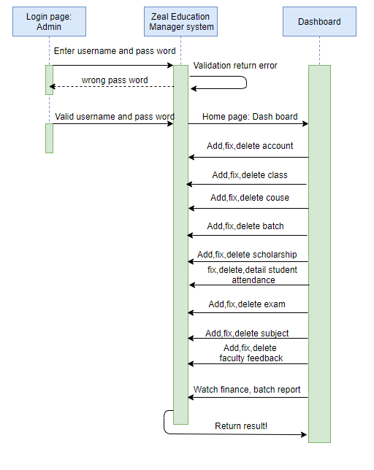

|  |  |  |
| --- | --- | --- |
| Sequence Diagram Name | Login Page: End User | |
| Actors | End User | |
| Description | End User must login to Online Help Desk system before doing anything. | |
| Requirements | End User must provide user name and password. | |
| Pre-conditions | N/A | |
| Post-conditions | Move actor to End User home page. | |
| Basic flow | End User actions :  1 – End User must input username , password  2 - End User click on Login button | System response :  3 - System would validate information  4 – System redirect End User home page. |
| Alternative flow | N/A | N/A |
| Exception | N/A | N/A |
|  |  |  |

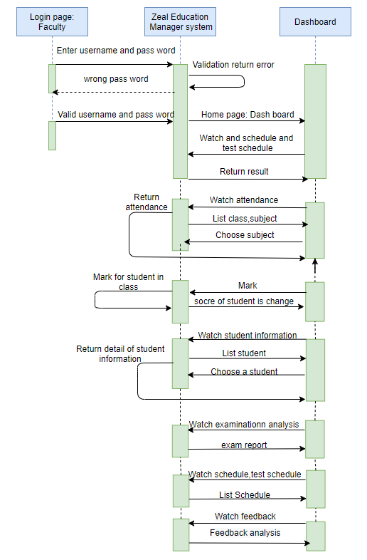

|  |  |  |
| --- | --- | --- |
| Sequence Diagram Name | Login Page: Facilities Head | |
| Actors | Facilities Head | |
| Description | Facilities Head must login to Online Help Desk system before doing anything. | |
| Requirements | Facilities Head must provide user name and password. | |
| Pre-conditions | User login, create new request. | |
| Post-conditions | Move to Facilities Head home page. | |
| Basic flow | End User actions :  1 – Facilities Head must input username , password  2 - Facilities Head click on Login button | System response :  3 - System would validate information  4 – System redirect Facilities Head home page. |
| Alternative flow | N/A | N/A |
| Exception | N/A | N/A |
|  |  |  |

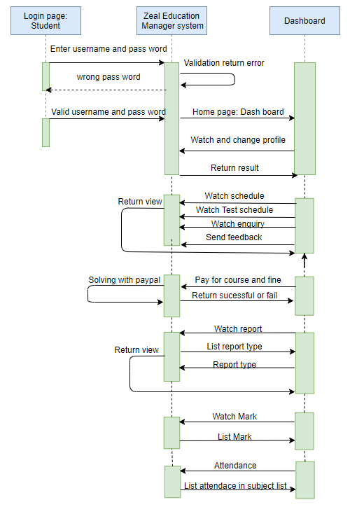

|  |  |  |
| --- | --- | --- |
| Sequence Diagram Name | Login Page: Assignee | |
| Actors | Assignee | |
| Description | Assignee must login to Online Help Desk system before doing anything. | |
| Requirements | Assignee must provide user name and password. | |
| Pre-conditions | Facilities Head sent request to Assignee. | |
| Post-conditions | Move Assignee home page. | |
| Basic flow | Assignee actions :  1 – Assignee must input username , password  2 - Assignee click on Login button | System response :  3 - System would validate information  4 – System redirect Assignee home page. |
| Alternative flow | N/A | N/A |
| Exception | N/A | N/A |
|  |  |  |

***Chapter IV: Entity Relationship and Database Design/Structure***

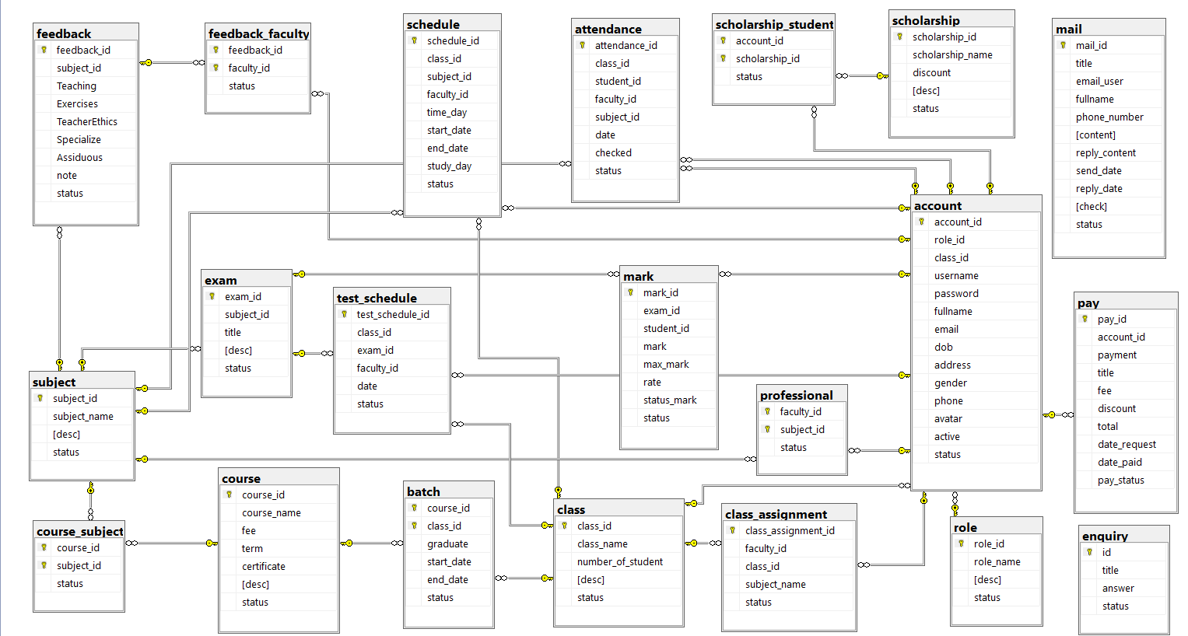

*Database***:**

1. 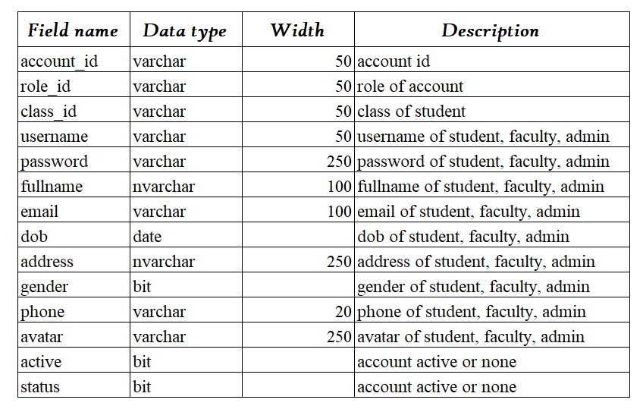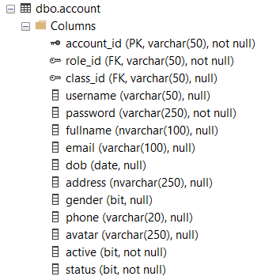Table “**Account**” contains account information
2. Table “**Attendance**” contains attendance information.

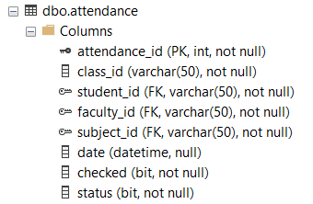

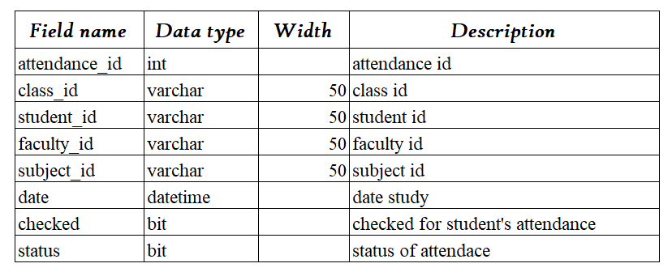

1. 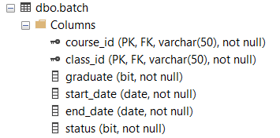Table “**Batch**” contains the learning time of 1 class of 1 course

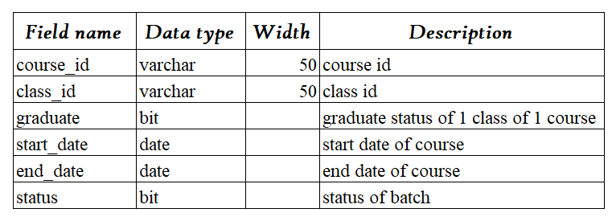

1. 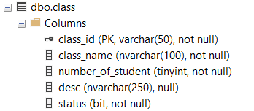Table “**Class**” contains class information

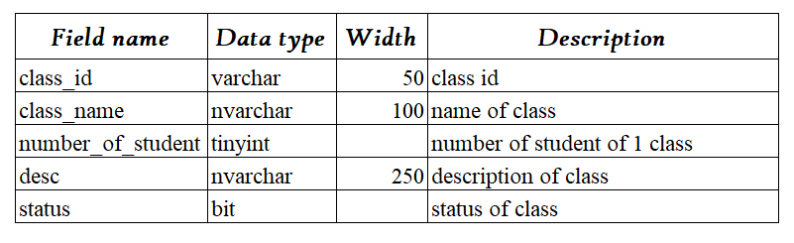

1. 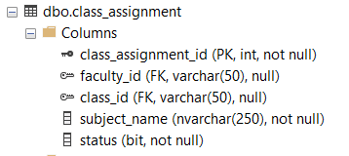Table “**Class_Assignment**” contains subjects of 1 class

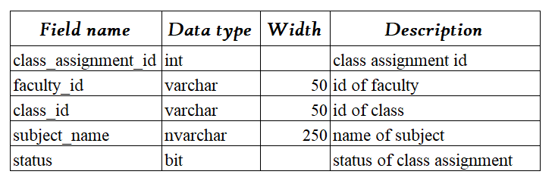

1. 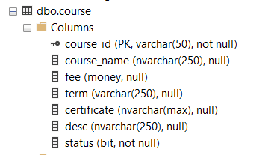Table “**Course**” contains course information

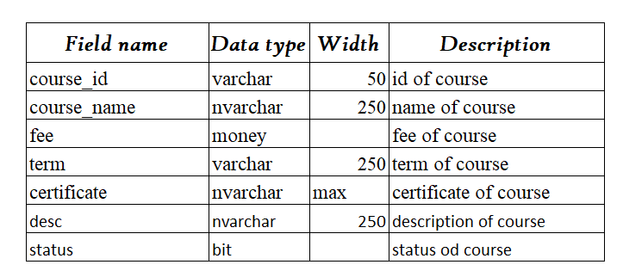

1. 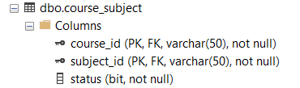Table “**Course_Subject**” contains subjects of 1 course

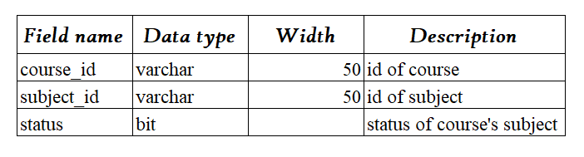

1. Table “**Enquiry**” contains askes and answers about school

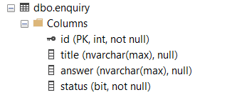

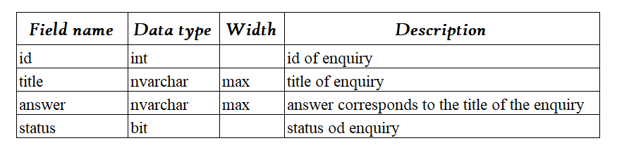

1. Table “**Exam**” contains exam information

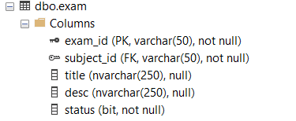

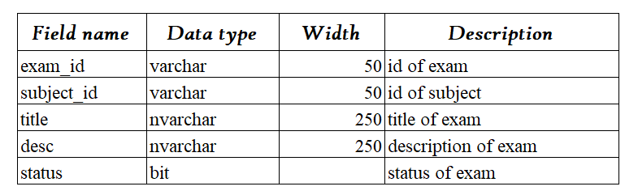

1. 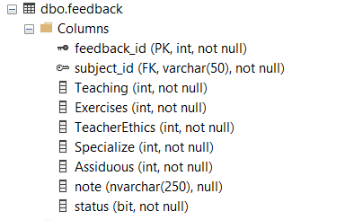 Table “**Feedback**” contains feedbacks information

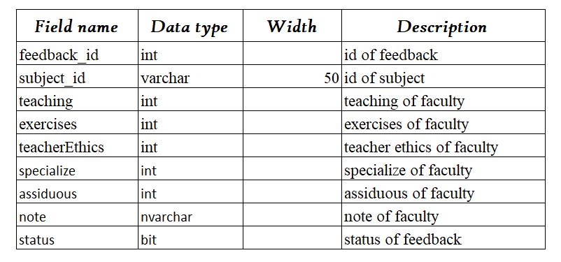

1. 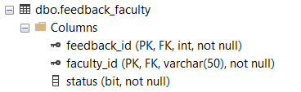 Table “**Feedback_Faculty**” contains feedbacks information of facultys

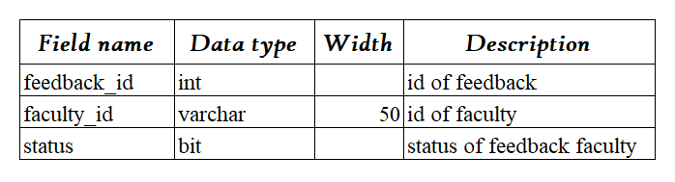

1. 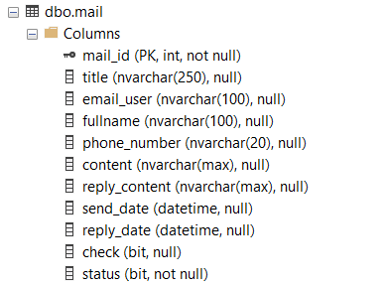 Table “**Mail**” contains mails was sent about school

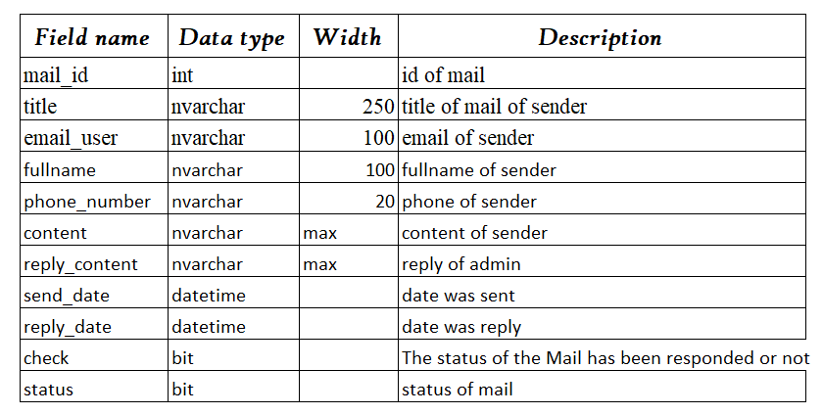

1. 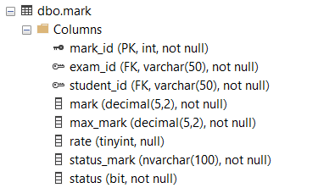 Table “**Mark**” contains student’s marks

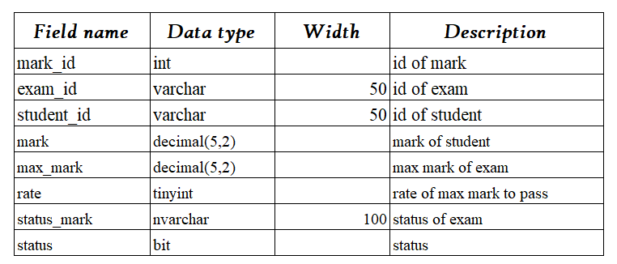

1. 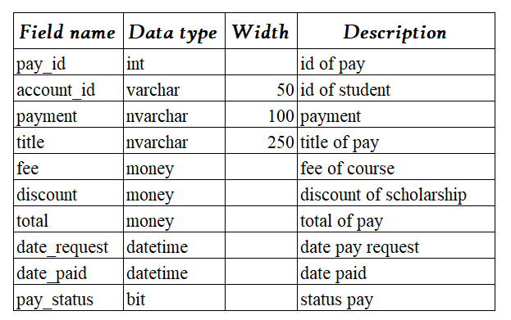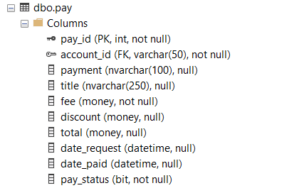 Table “**Pay**” contains the payables and paid students
2. Table “**Professional**” contains faculty ’s professionals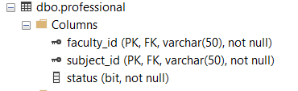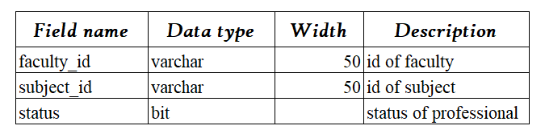
3. Table “**Role**” contains roles

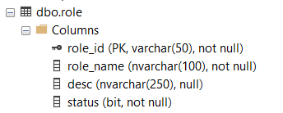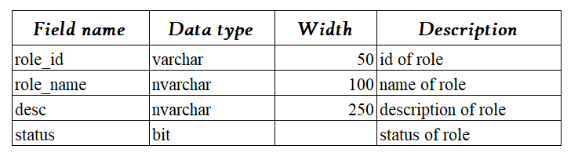

1. Table “**Schedule**” contains schedule of students

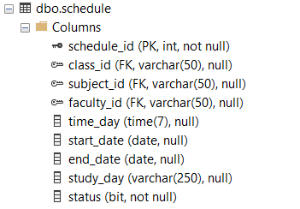

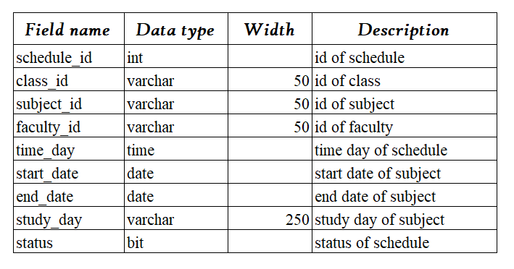

1. Table “**Scholarship**” contains scholarship information

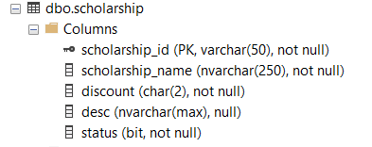

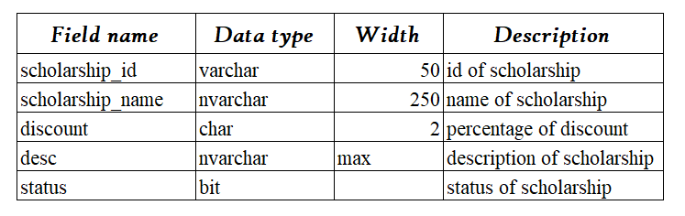

1. Table “**Scholarship_Student**” contains student’s scholarship

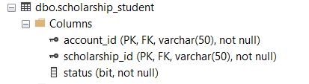

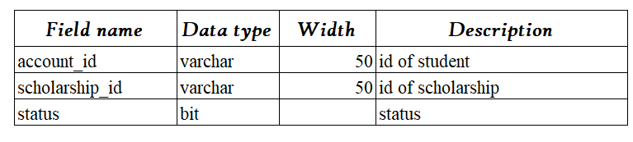

1. 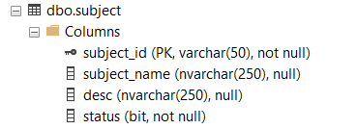 Table “**Subject**” contains subject information

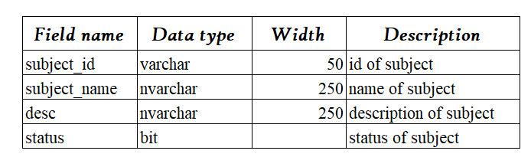

1. Table “**Test_schedule**” contains test schedule information

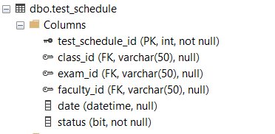

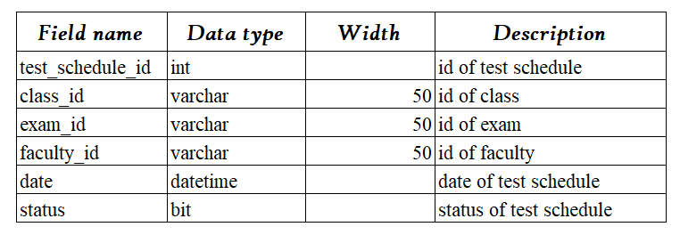

***Chapter V: The Main Interface Of eProject***

***\* Login Page: Admin, User, Faculty***:

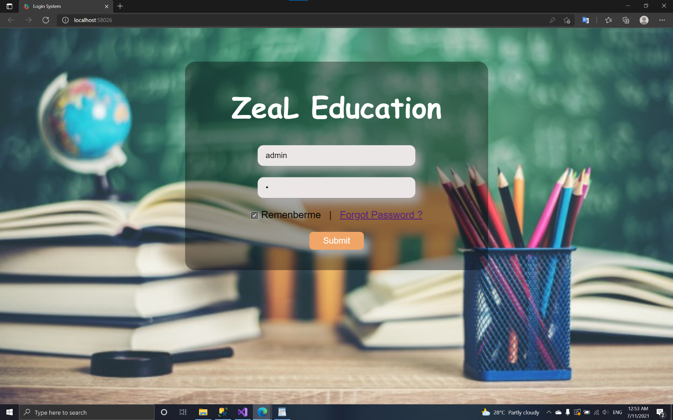

1. *Admin page:*
   * 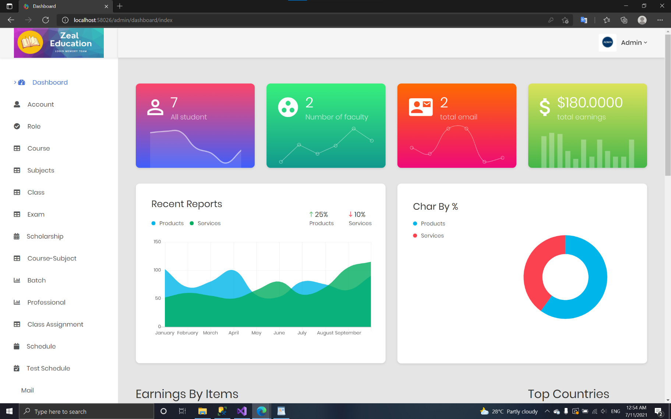**Dashboard page**:
   * 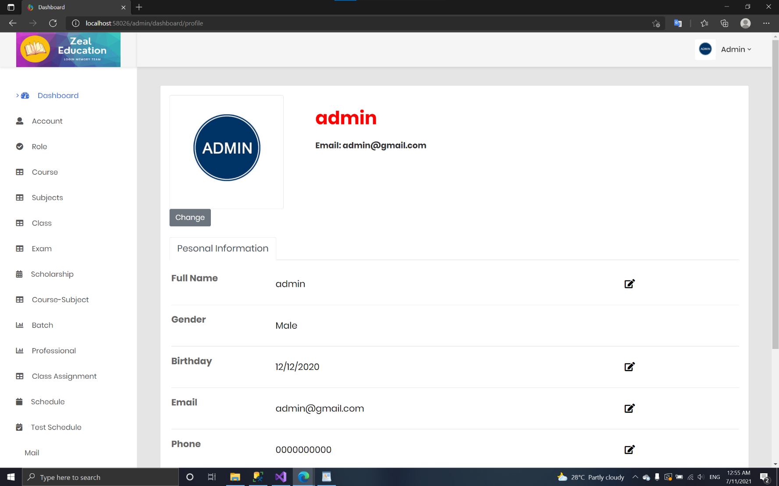**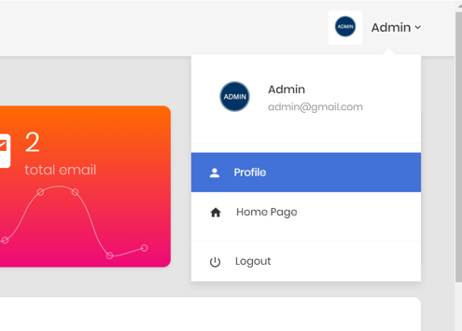Profile:**
   * 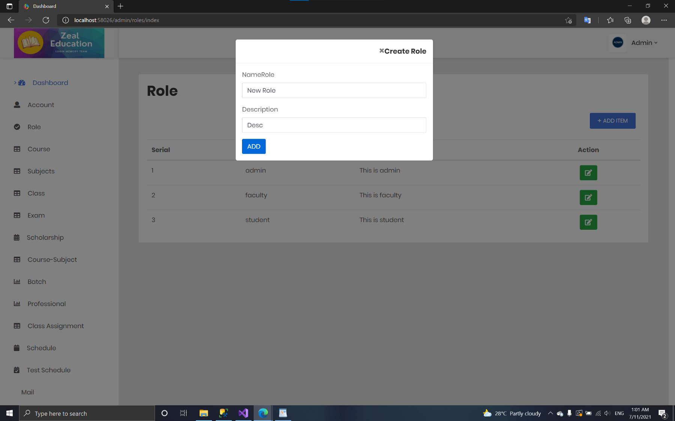**Create Role:**
   * 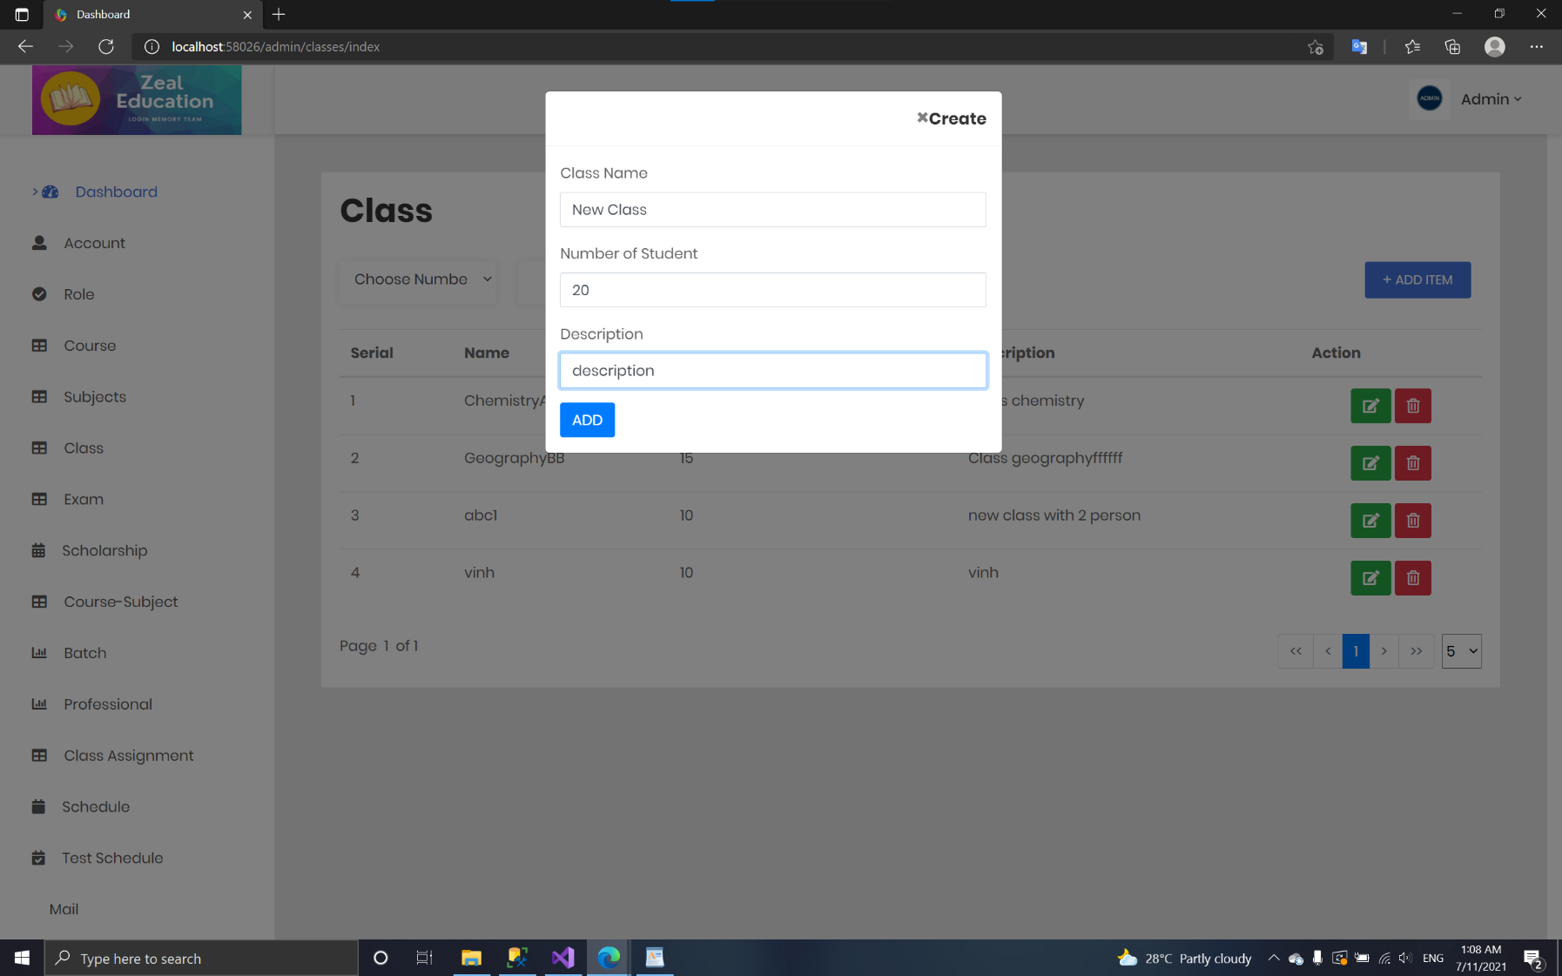**Create class:**
   * **Create course:**

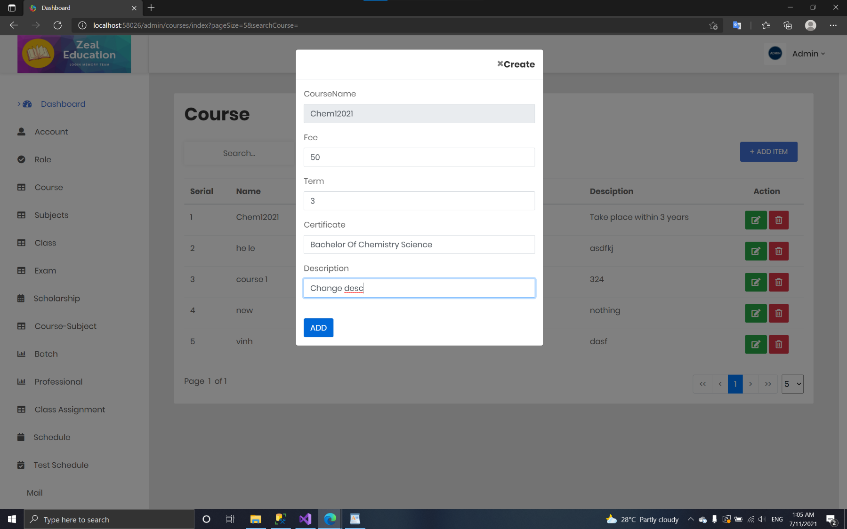

* + 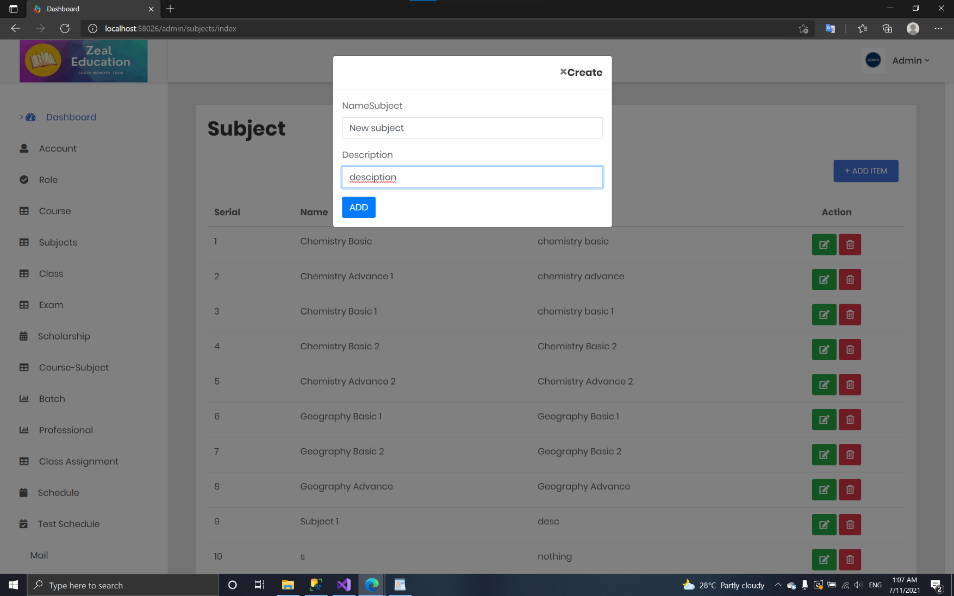**Create subject:**
  + 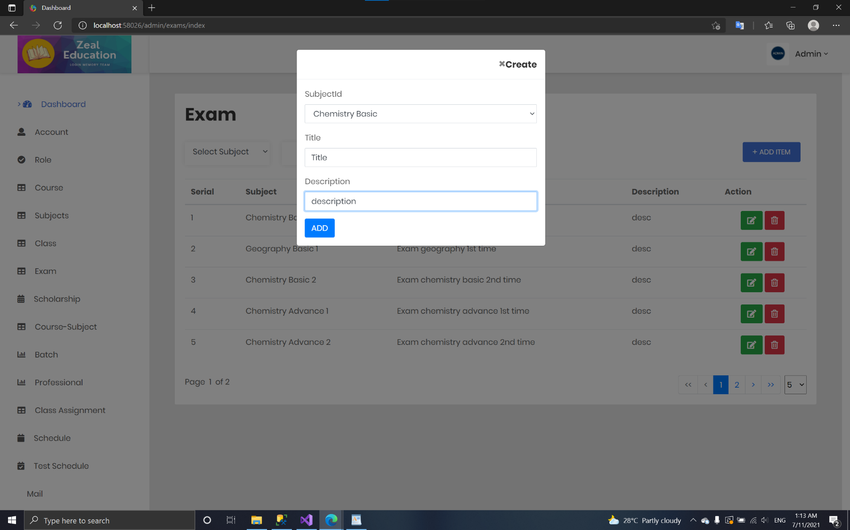**Create exam:**
  + **Create scholarship**

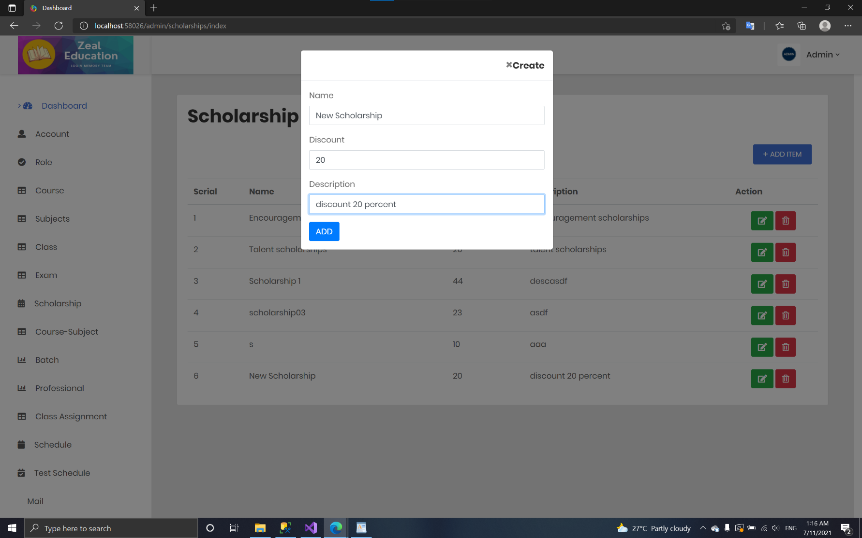

* + **Create course_subject**

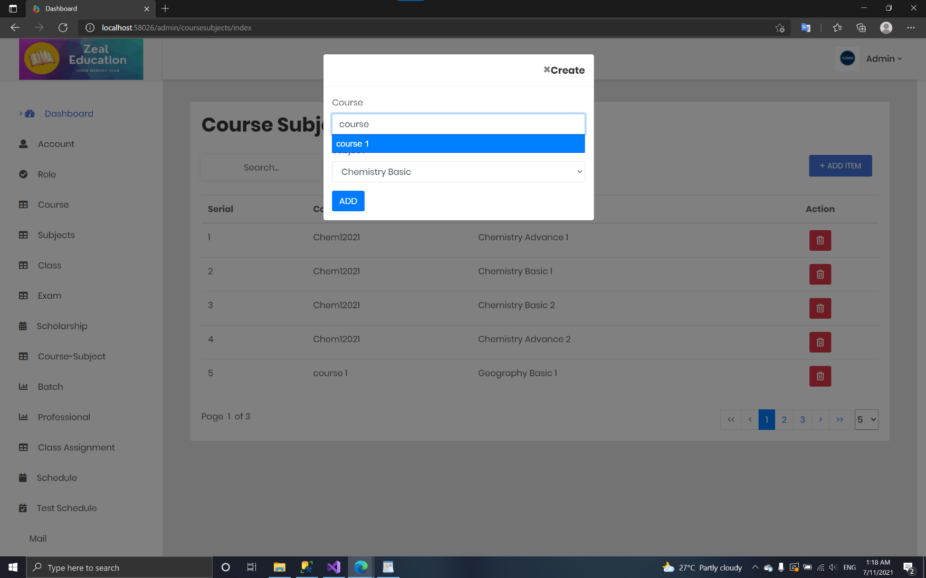

* + 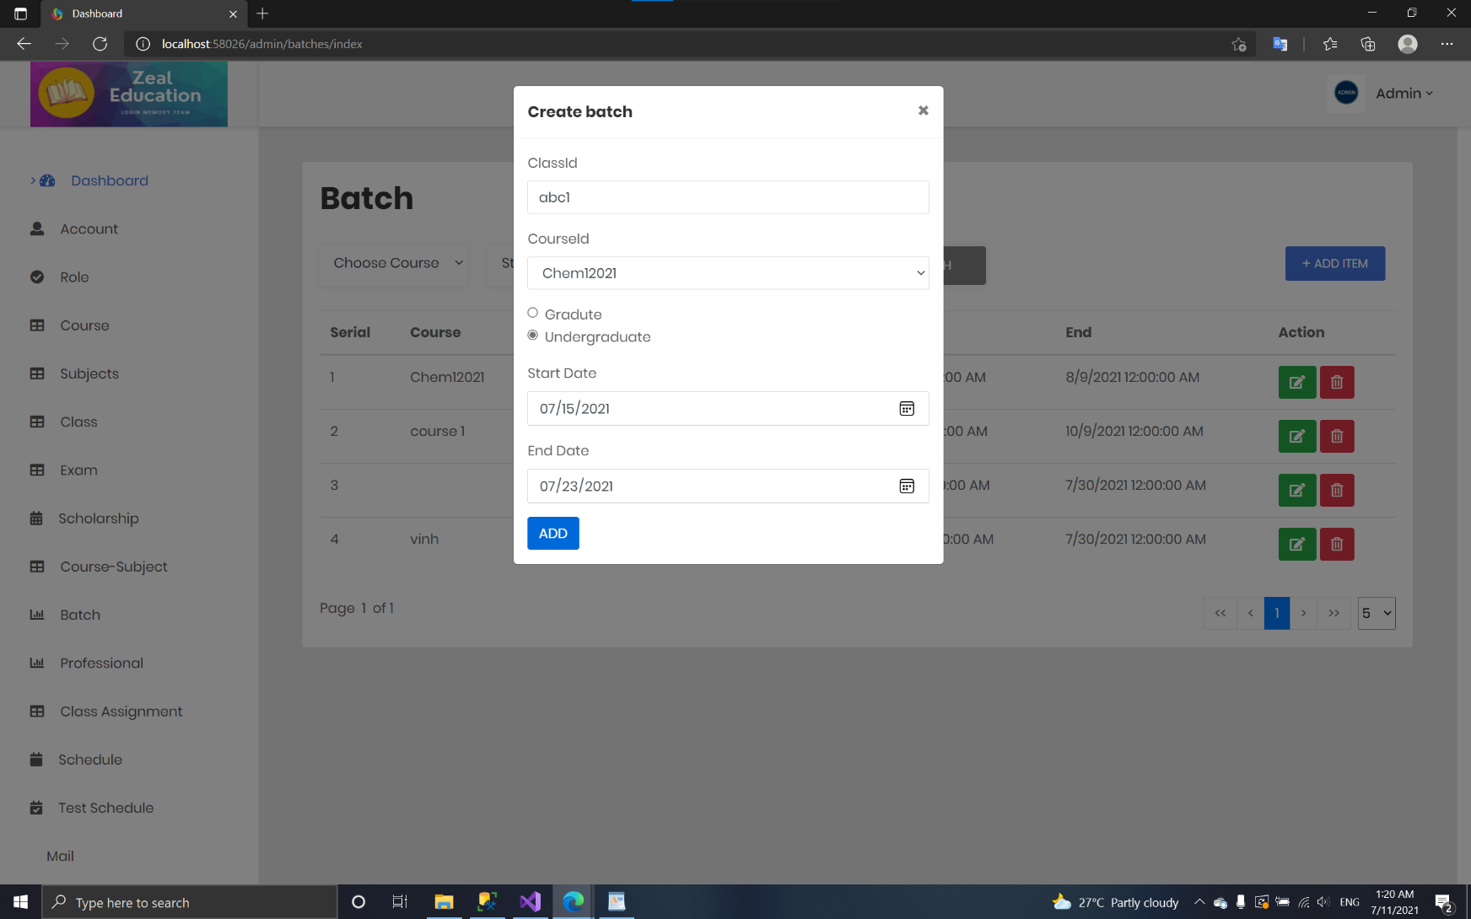**Create batch**
  + 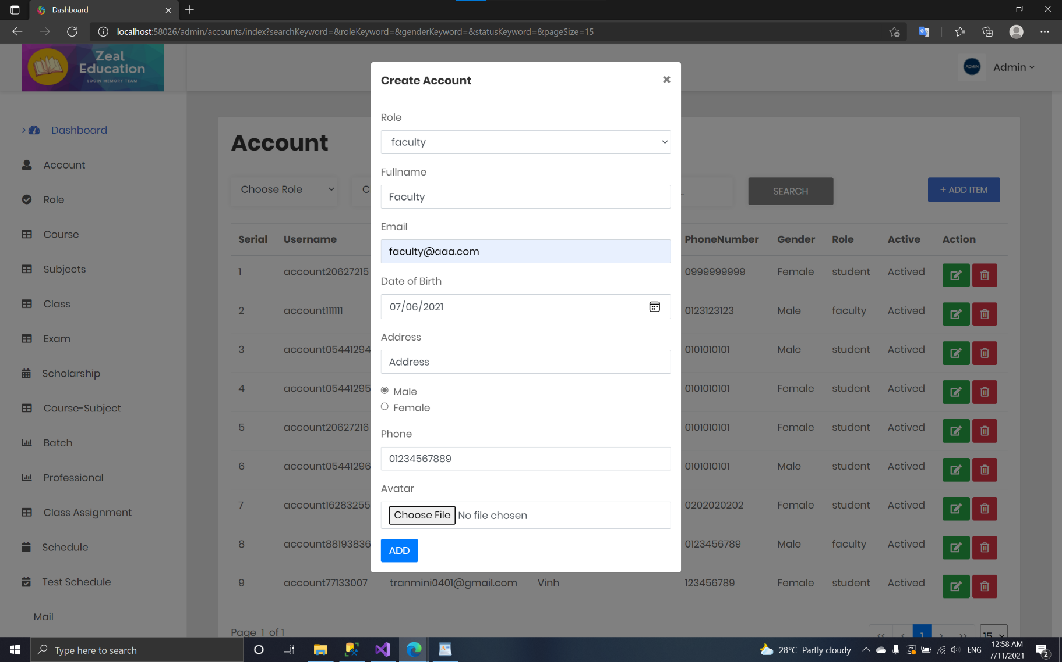**Create account**
  + **Create professional for faculty**

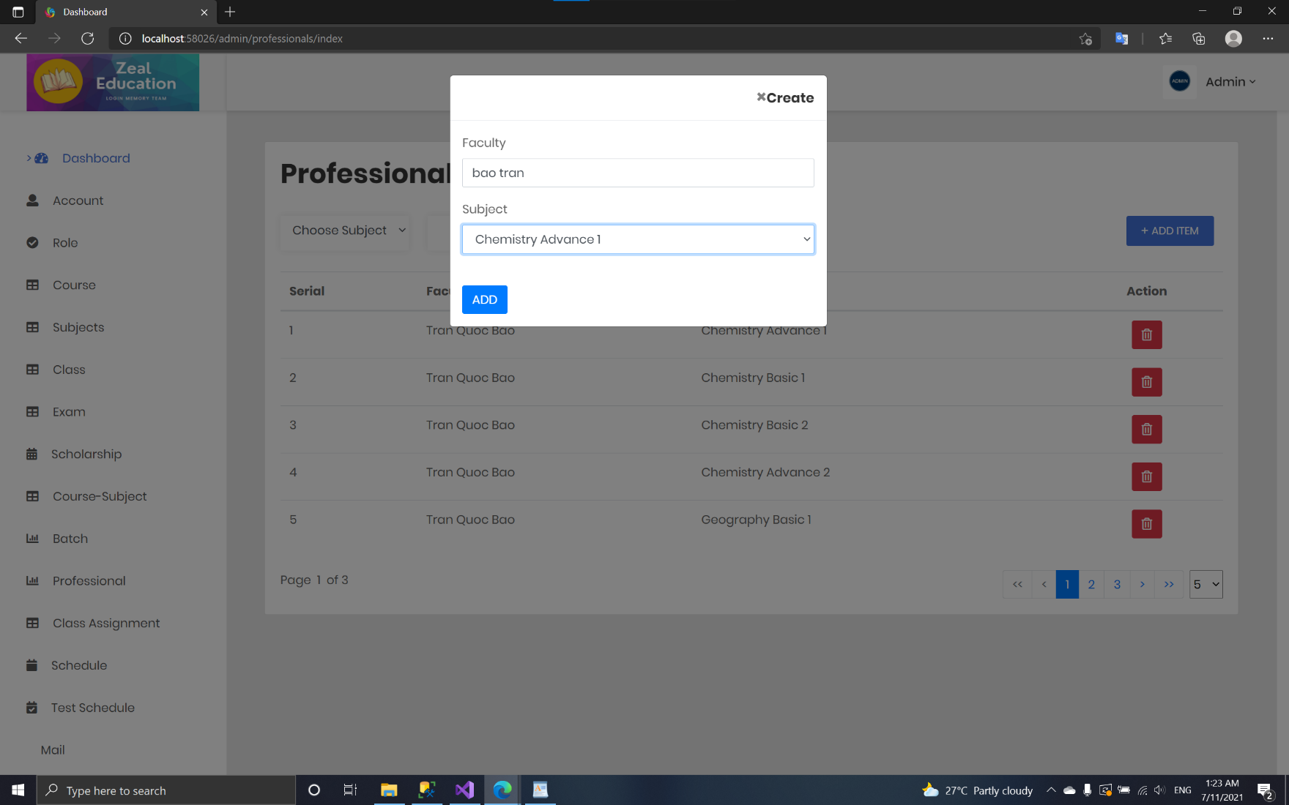

* + **Create Class – assignment**

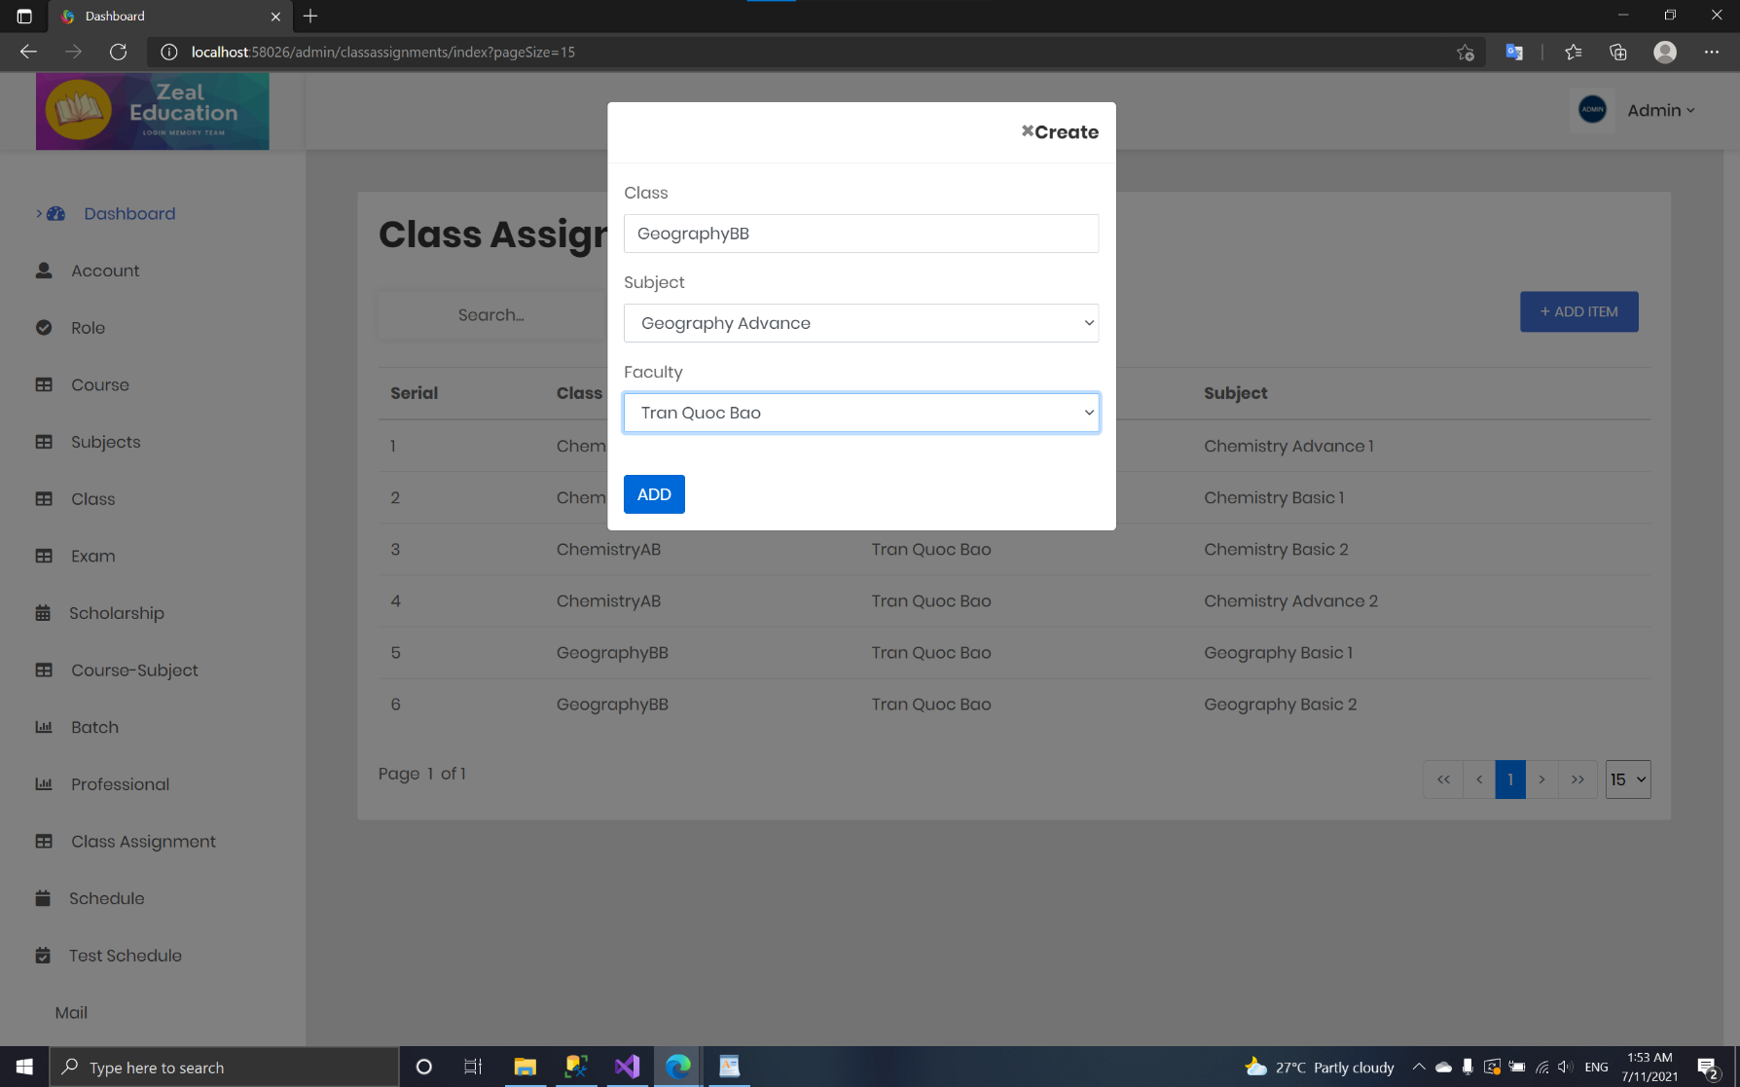

* + 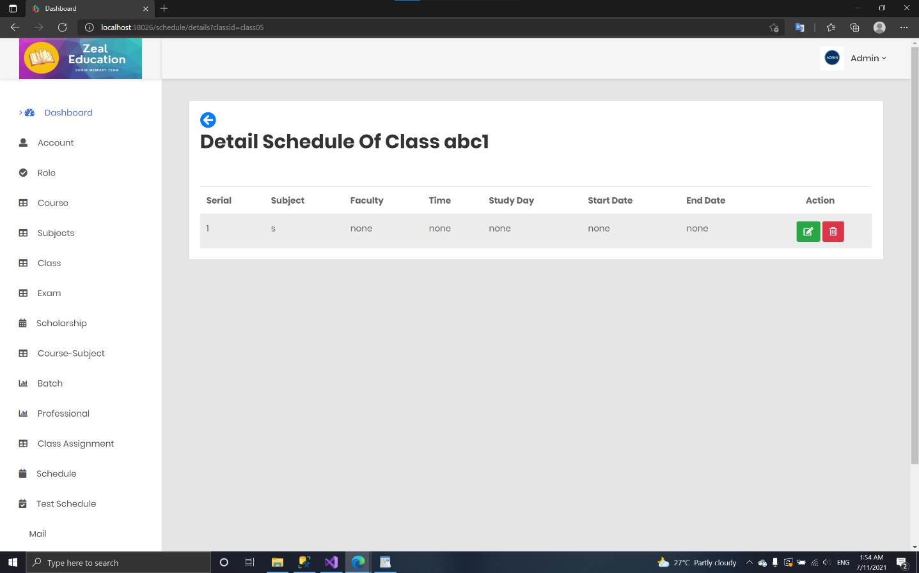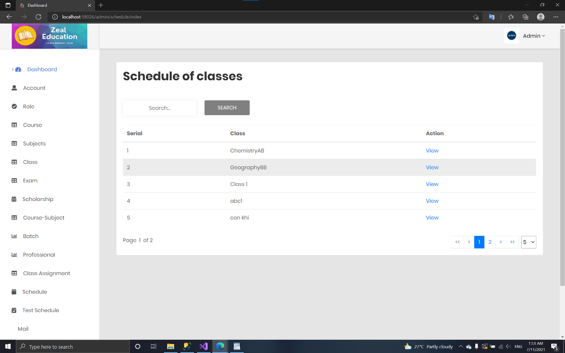**Create schedule:**

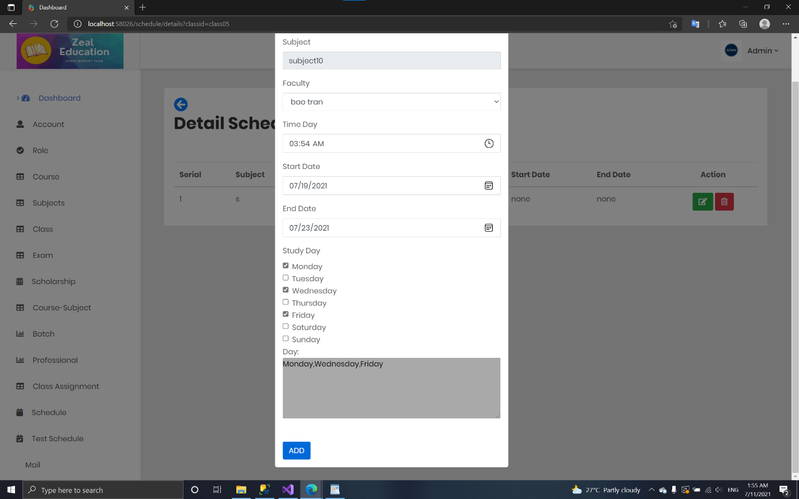

* + 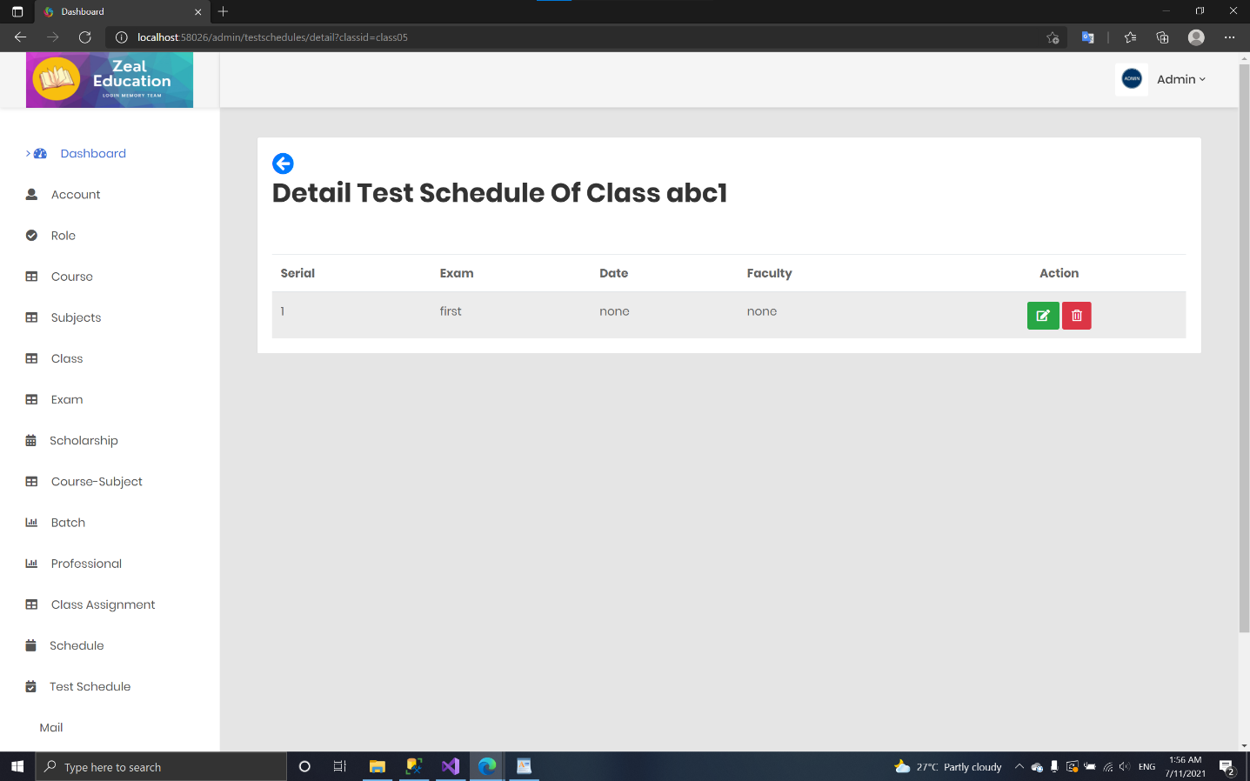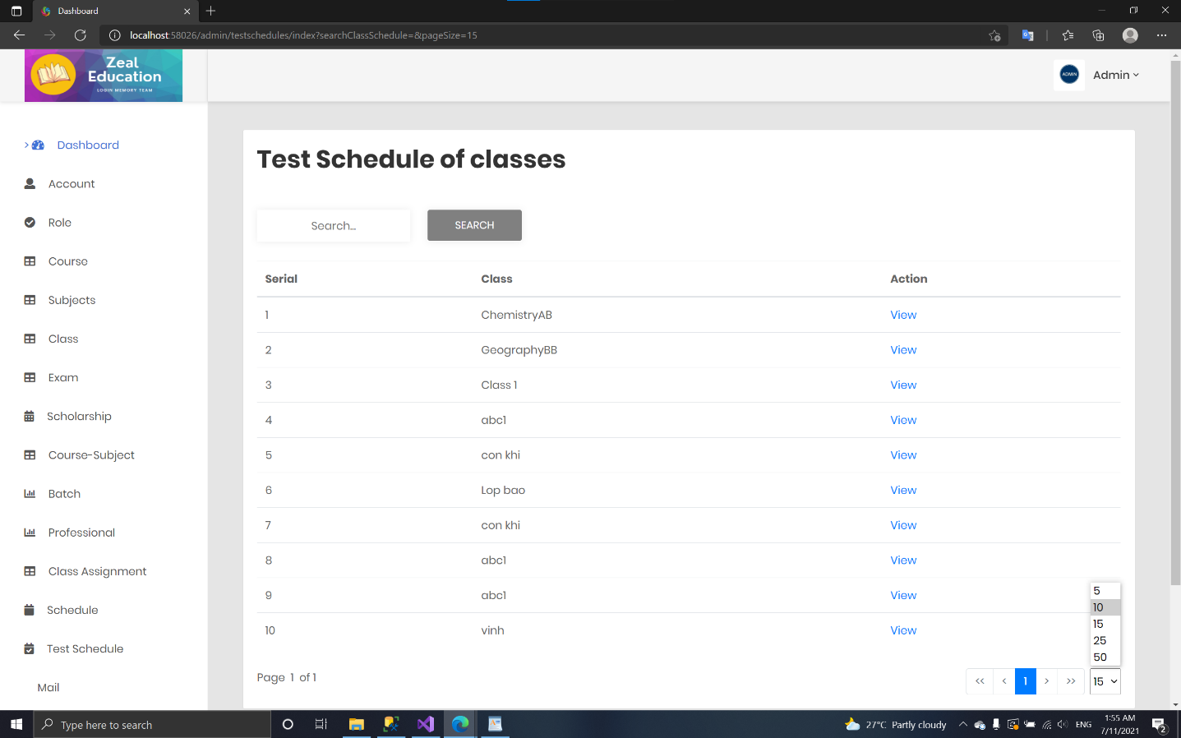**Create test schedule**

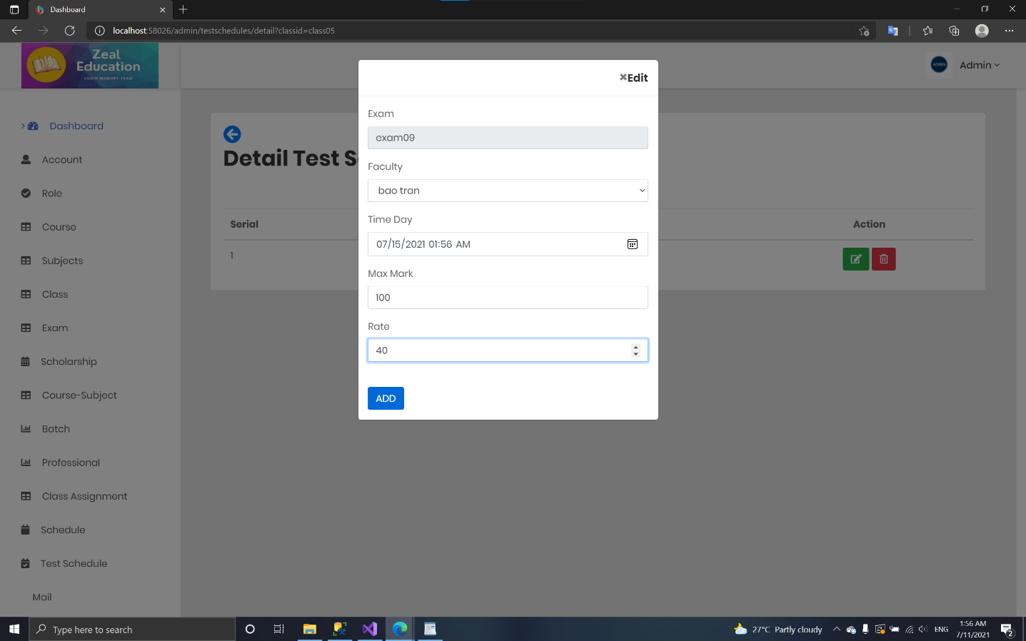

* + 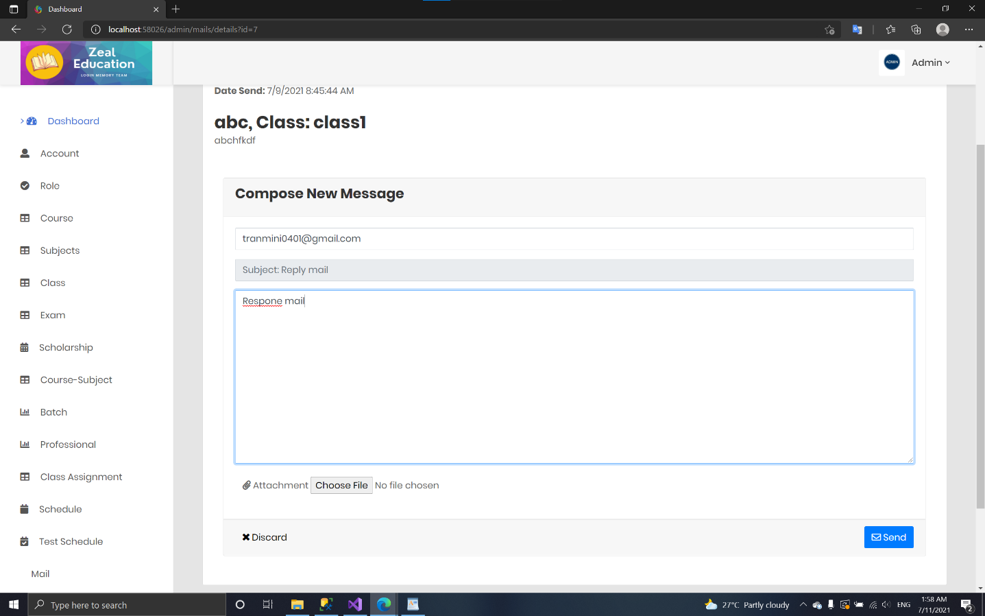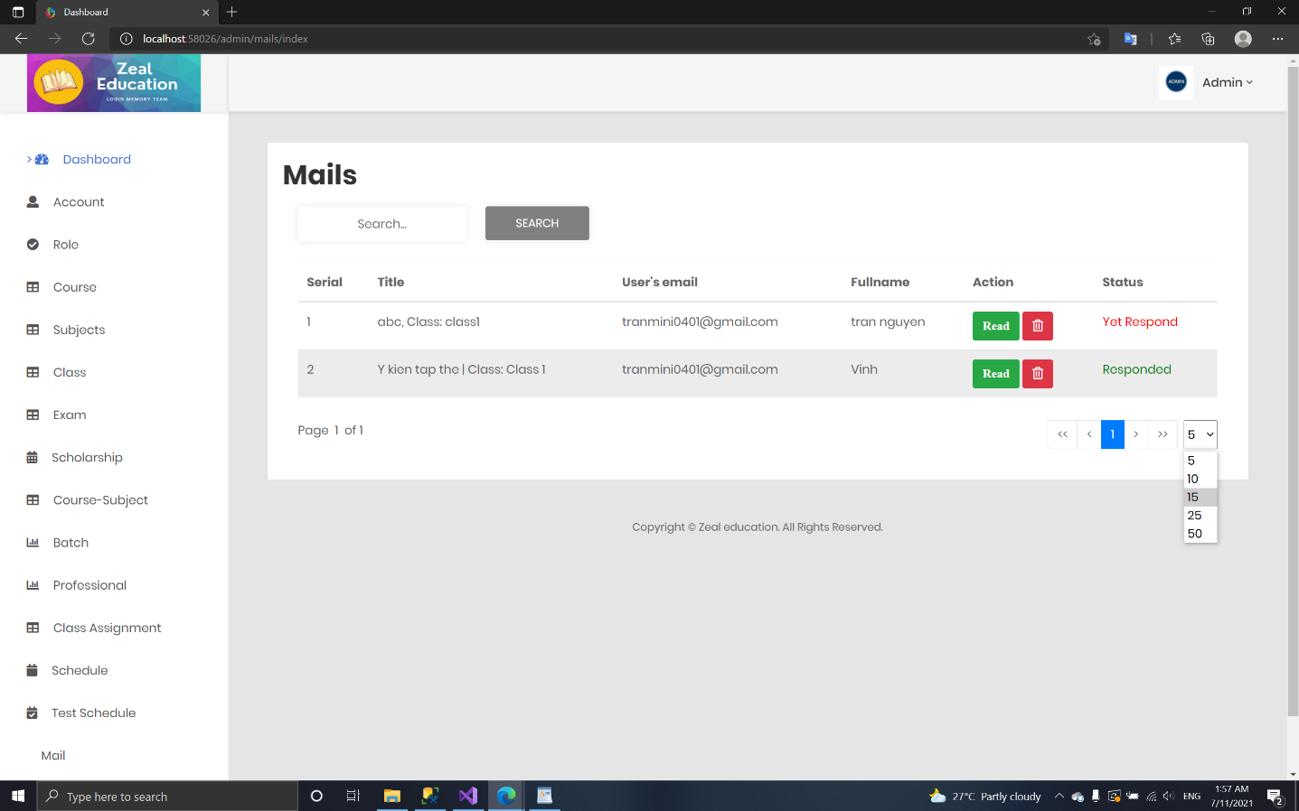 **Mail:**
  + 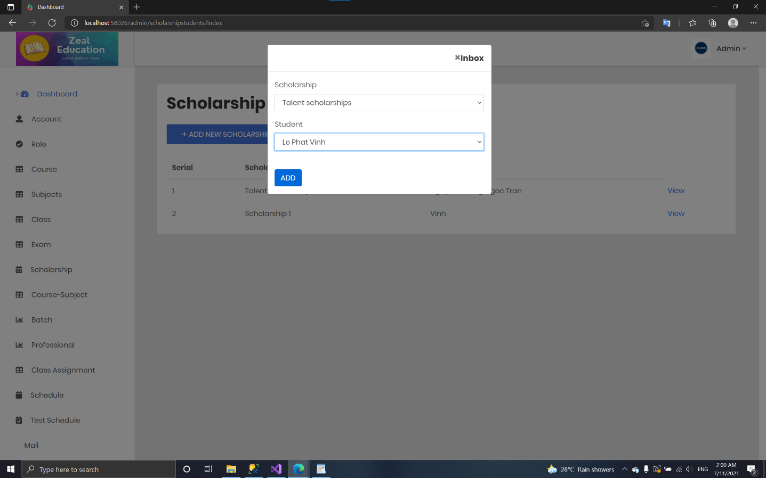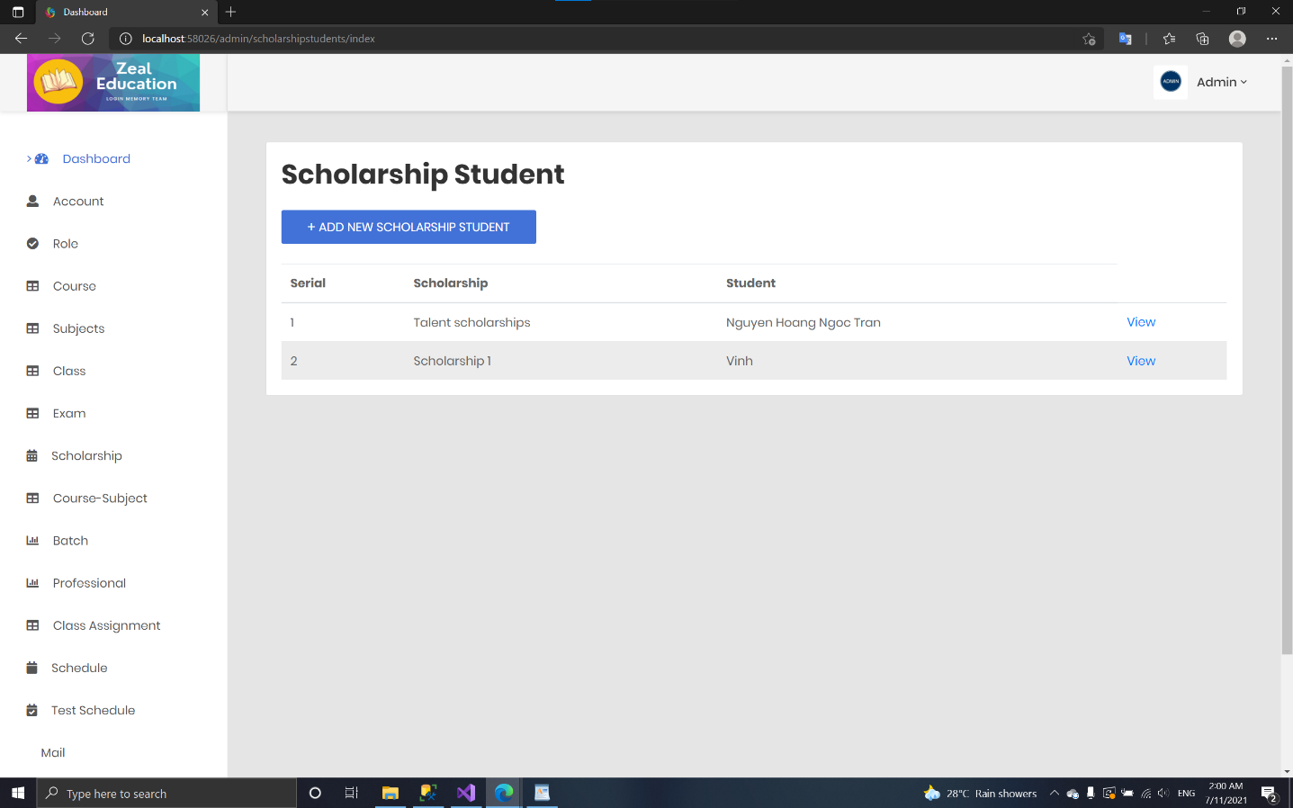 **Scholarship student:**
  + 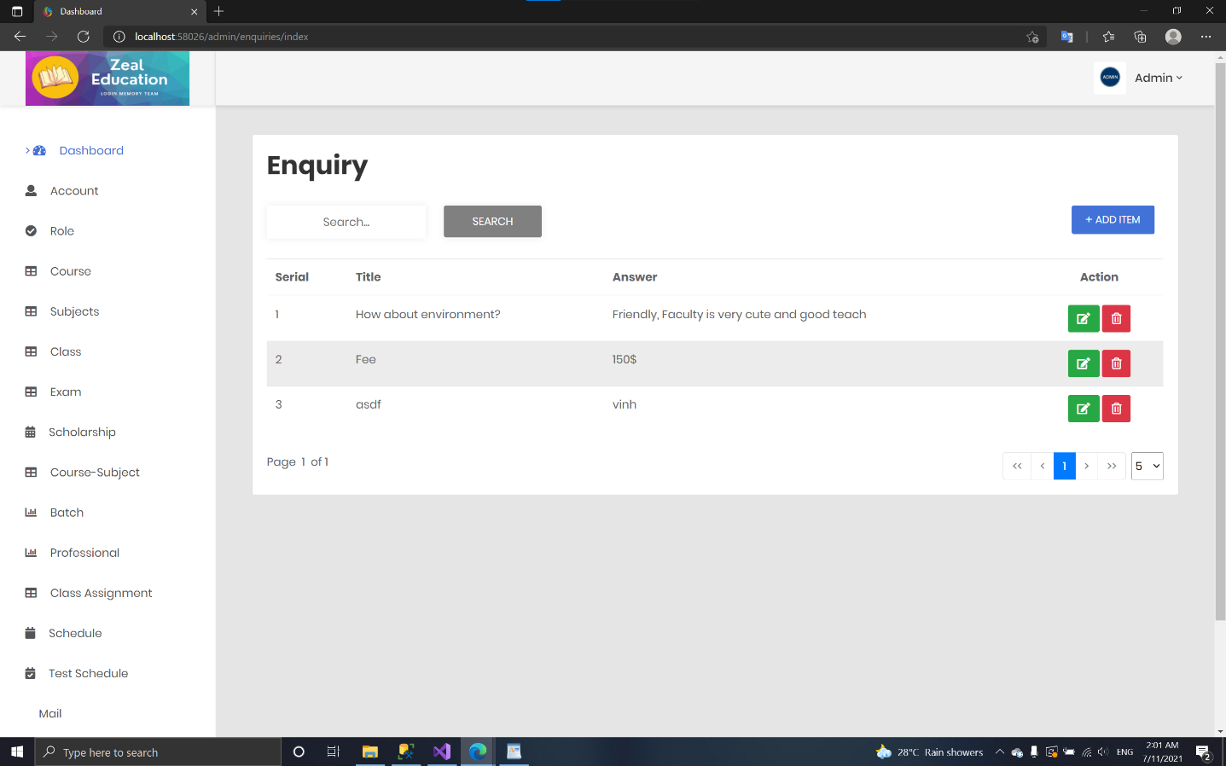 **Enquiry:**

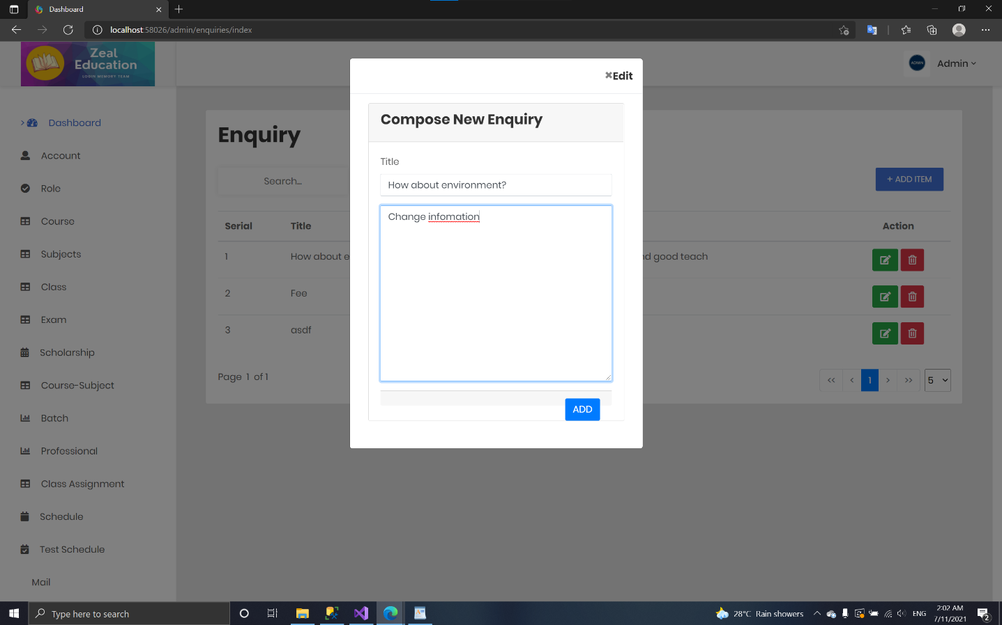

* + 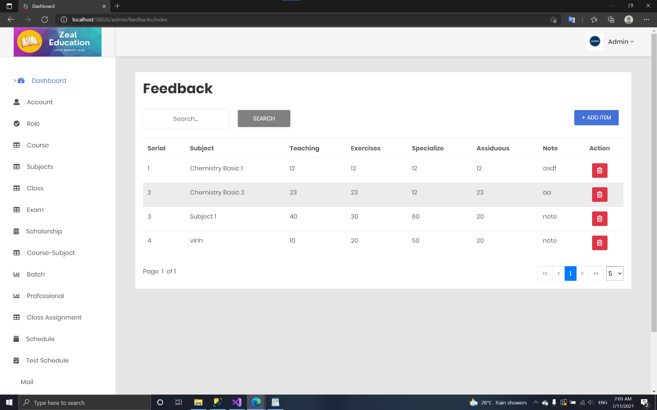 **Feedback**

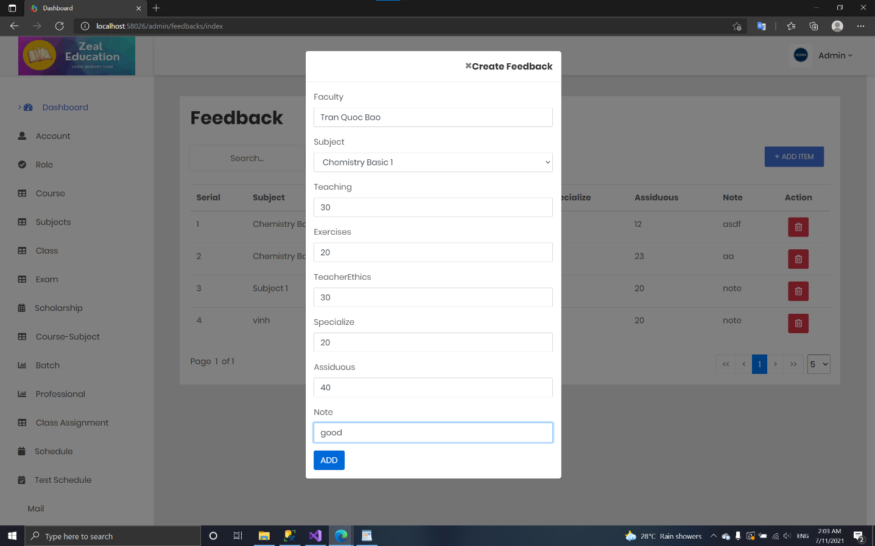

* + 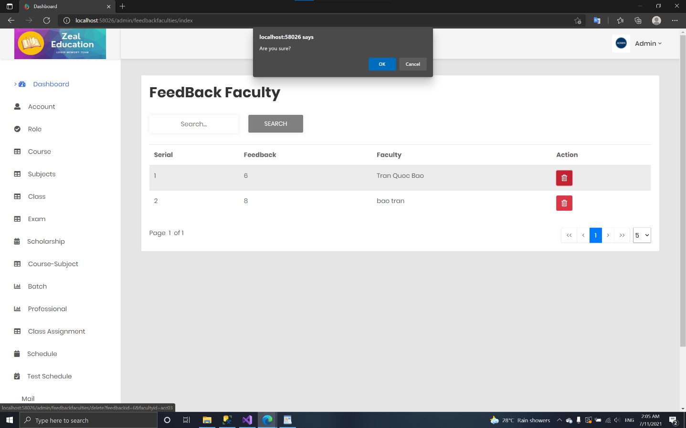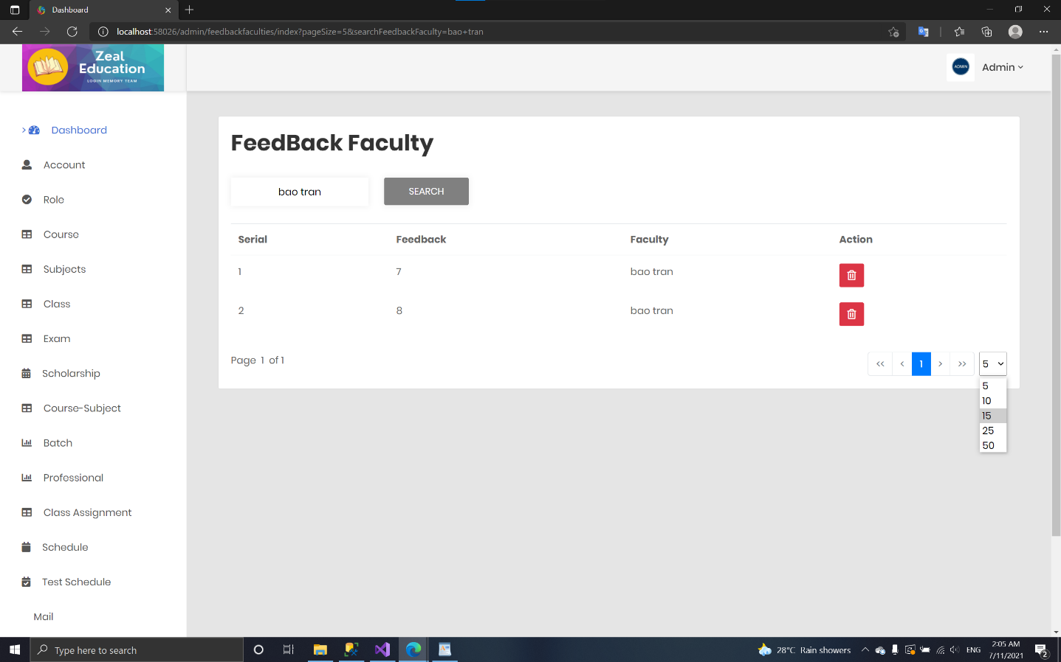 **Feedback faculty:**
  + 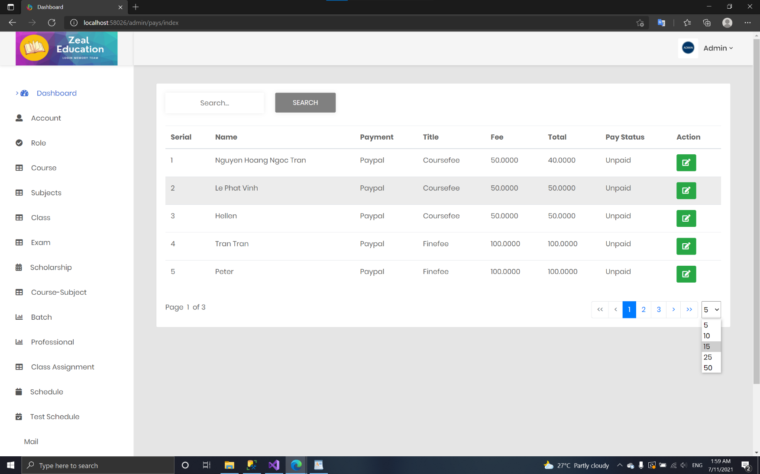 **Pay:**

1. *Faculty Page*
   * 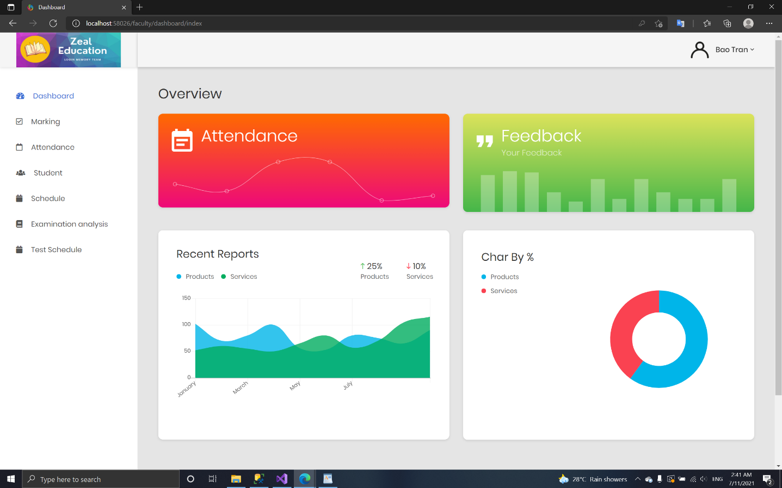**Dashboard:**
   * 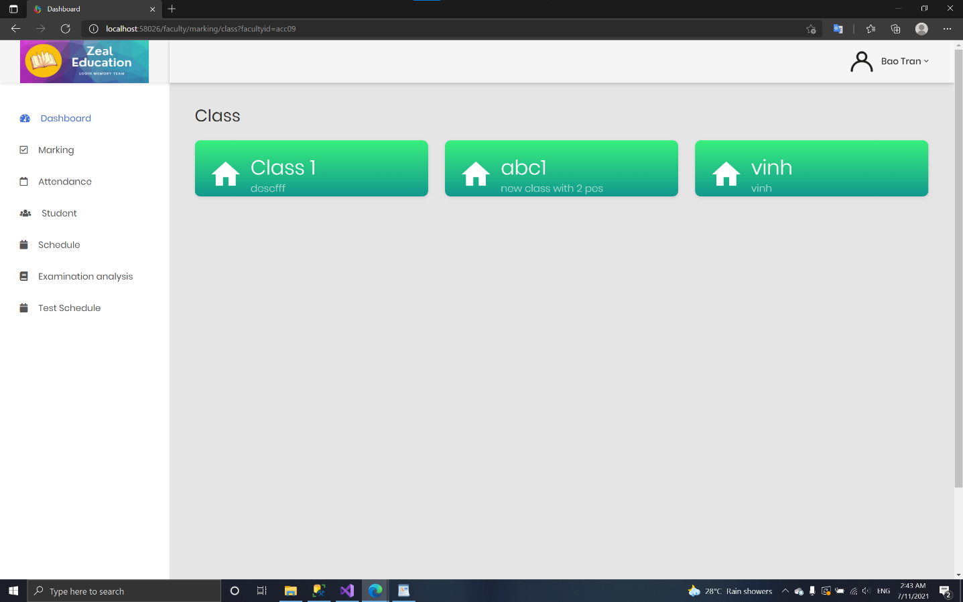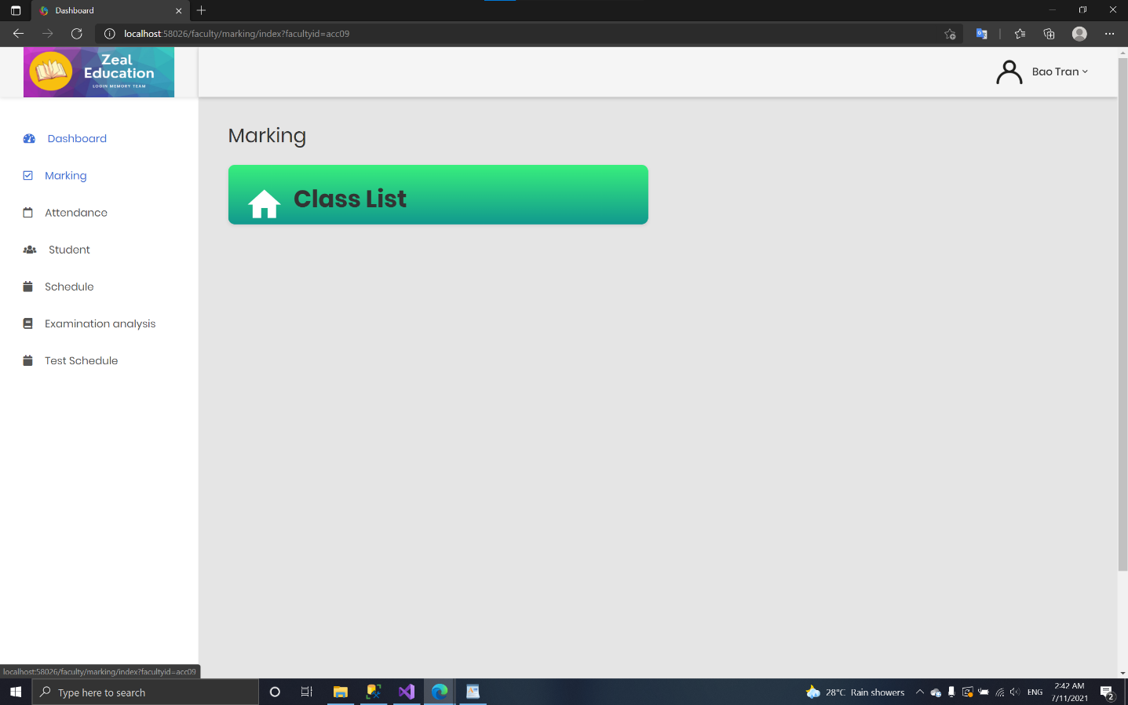**Marking:**

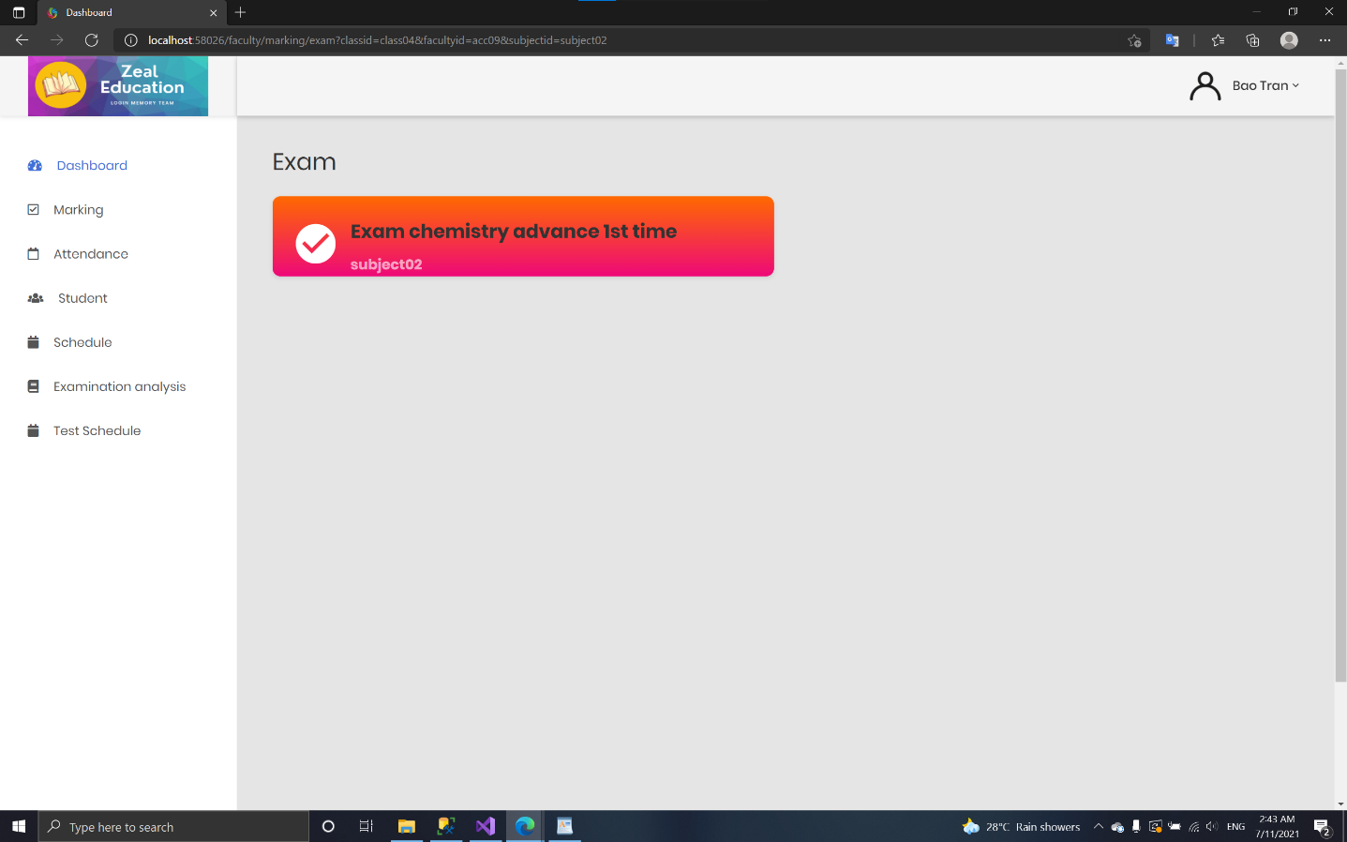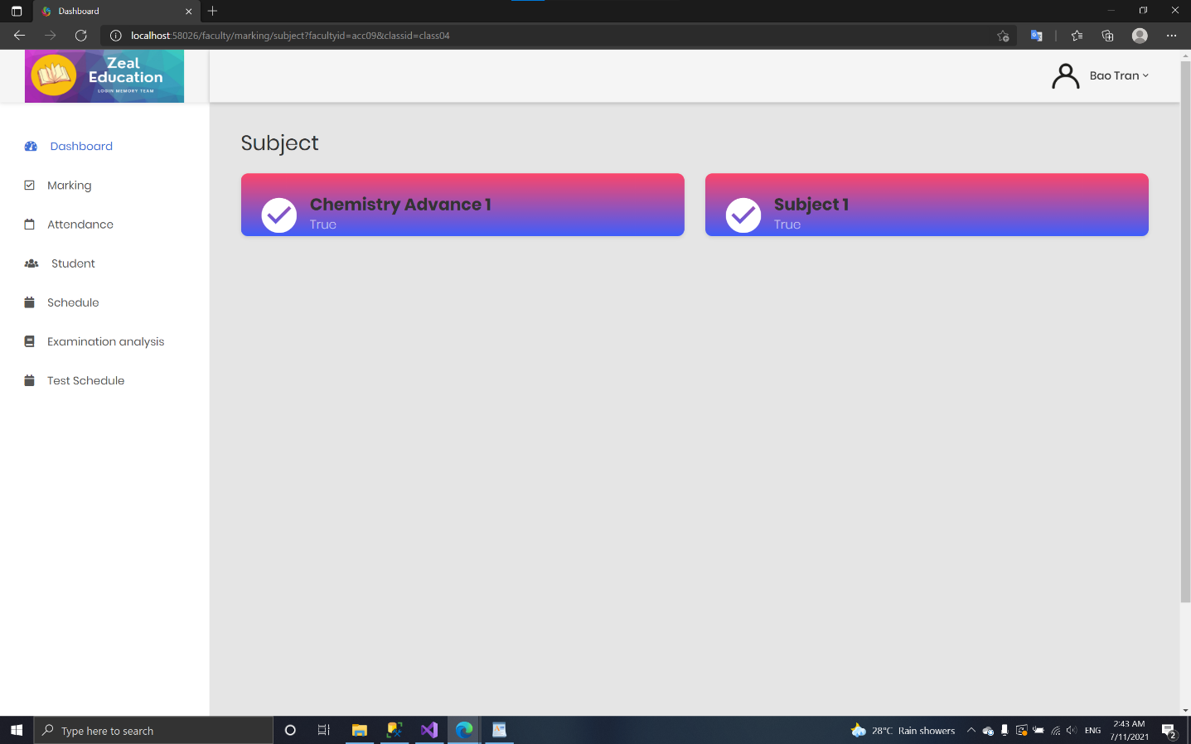

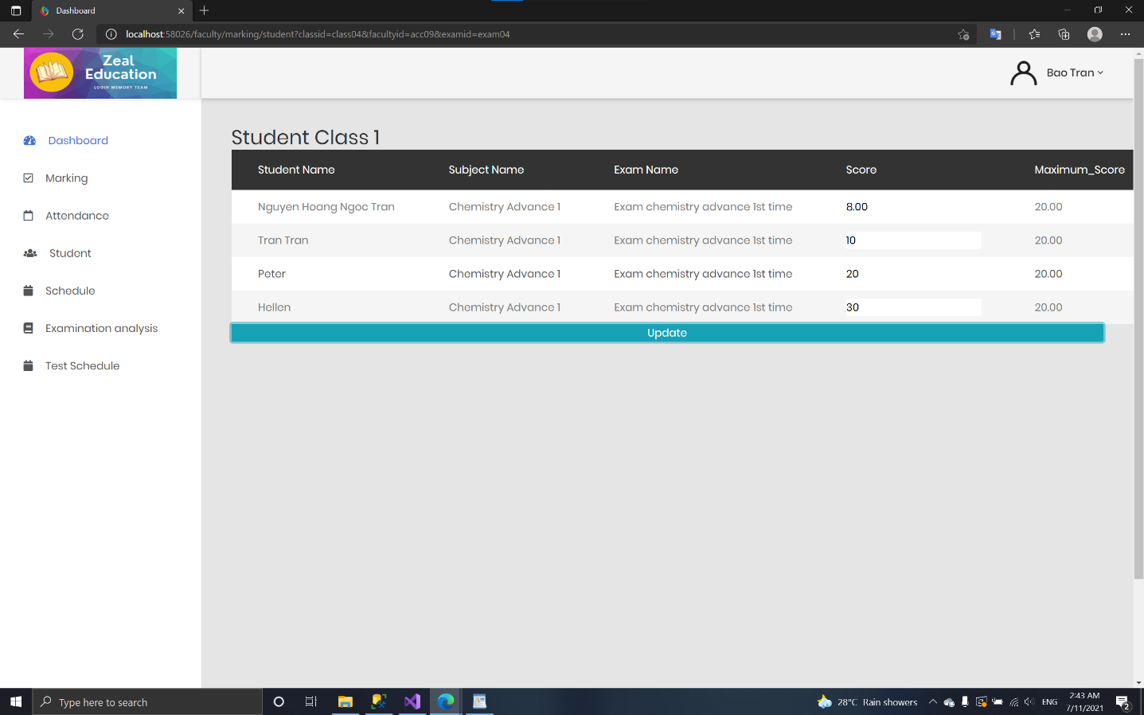

* + 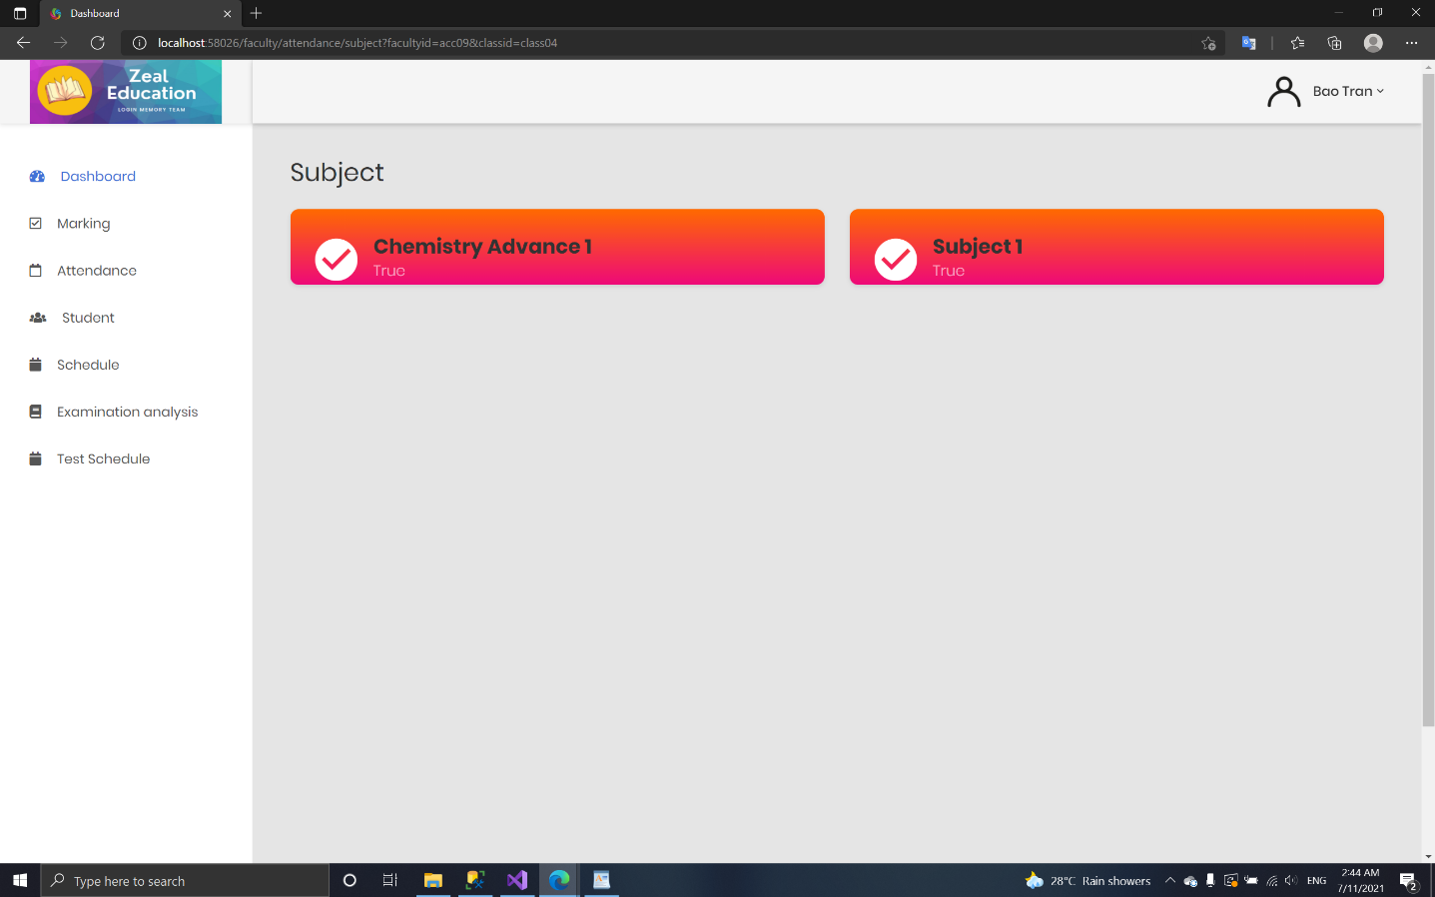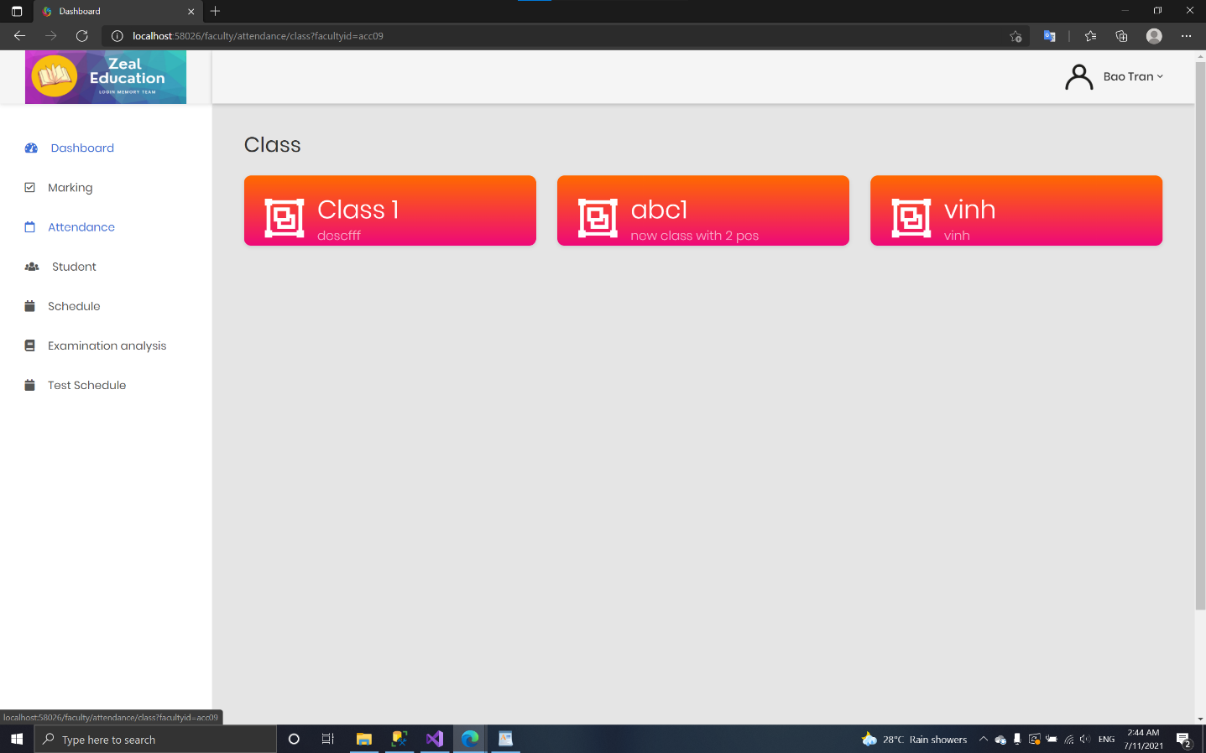**Attendance:**

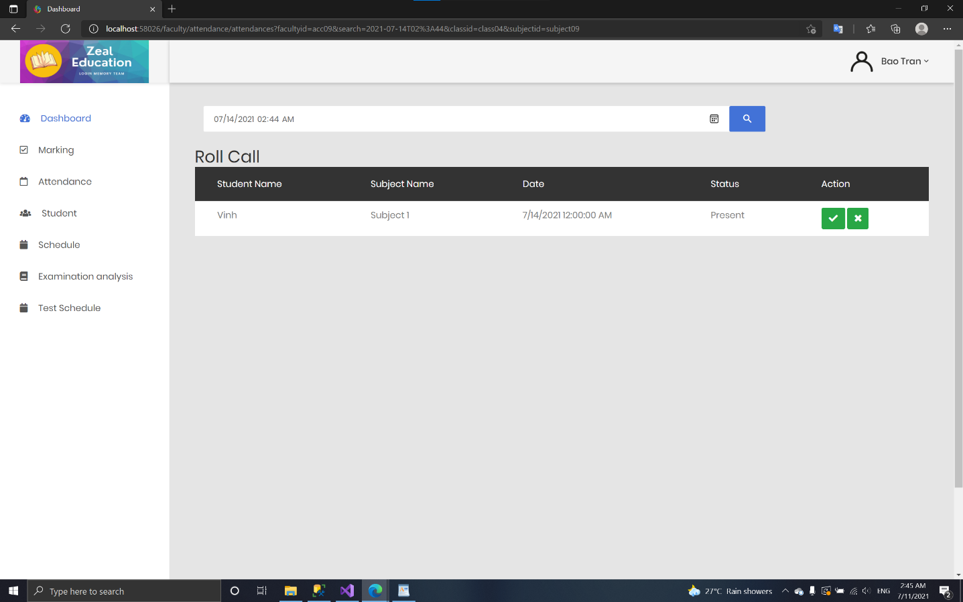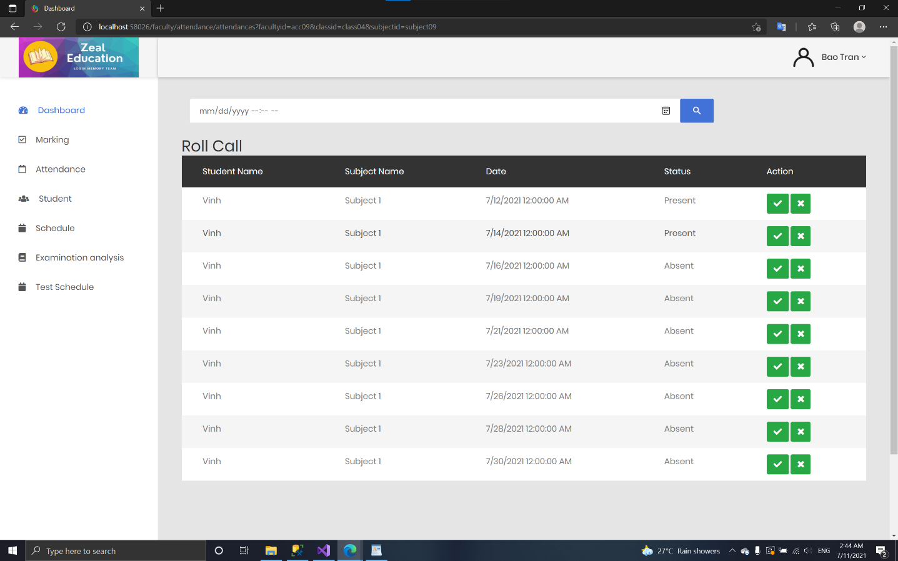

* + 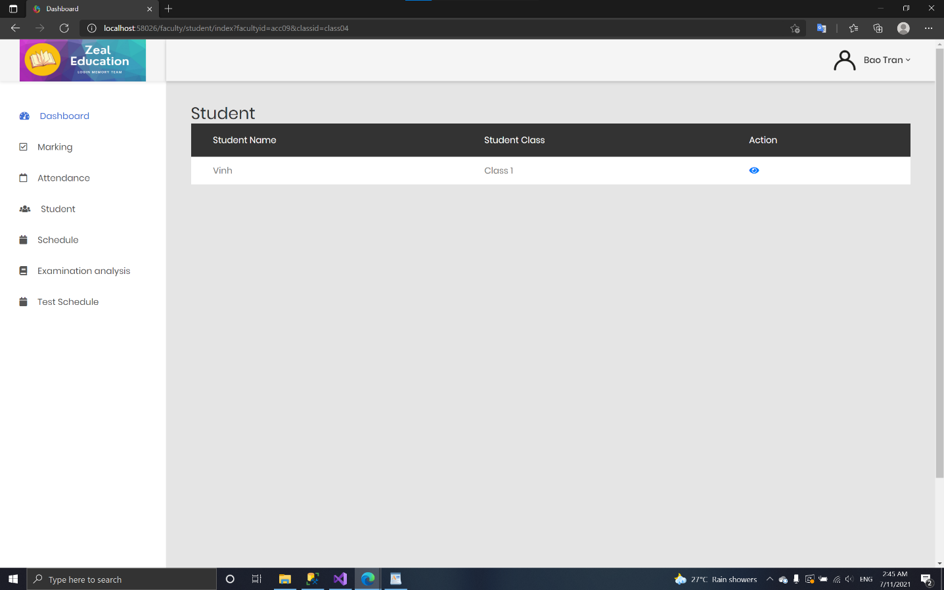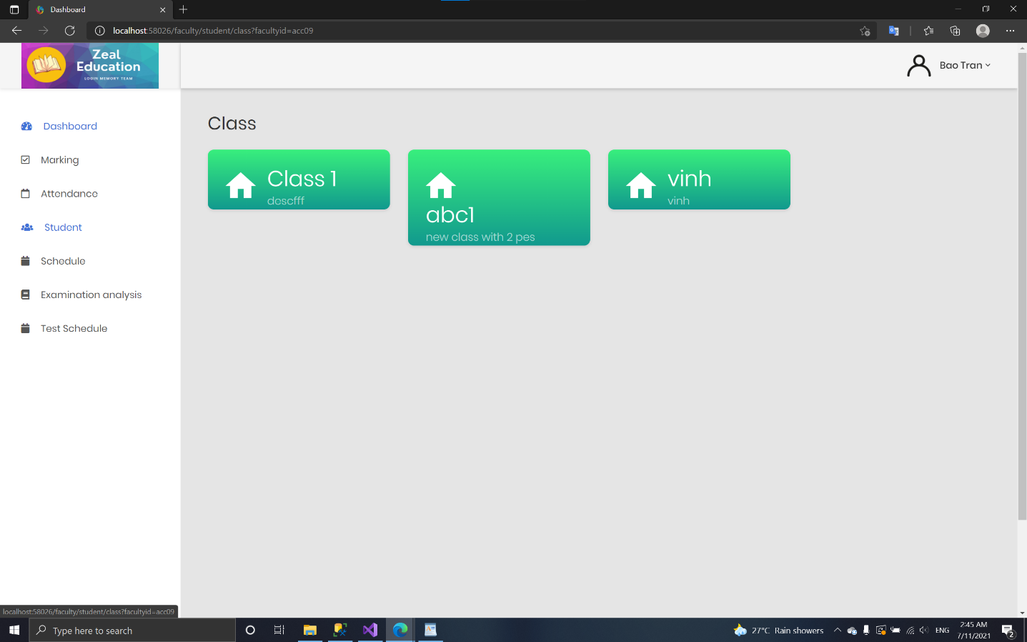**Student:**

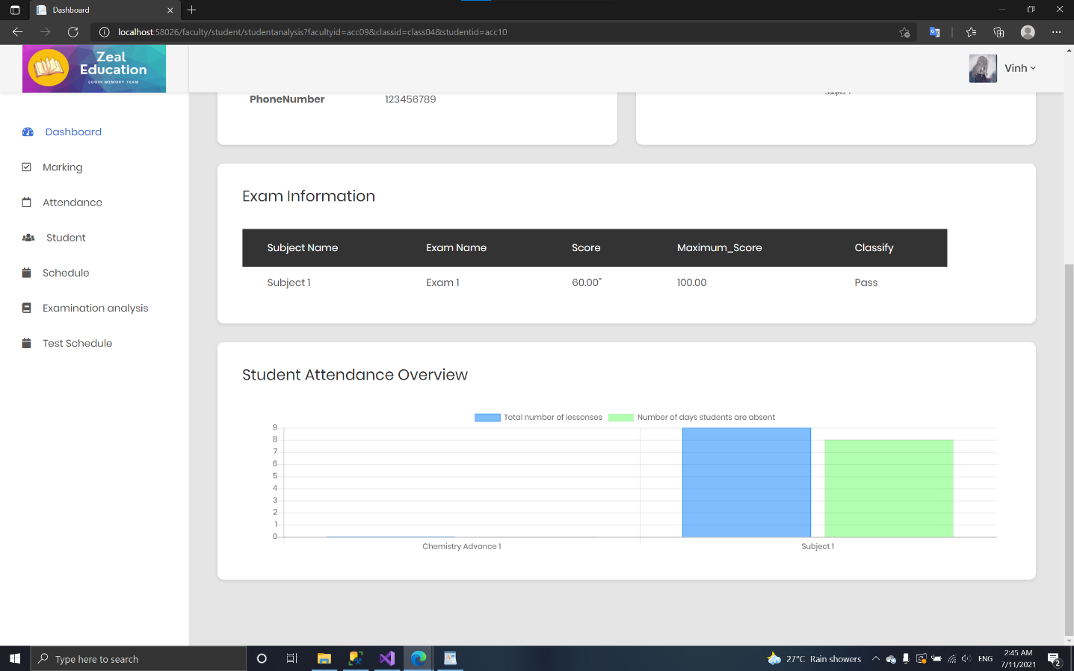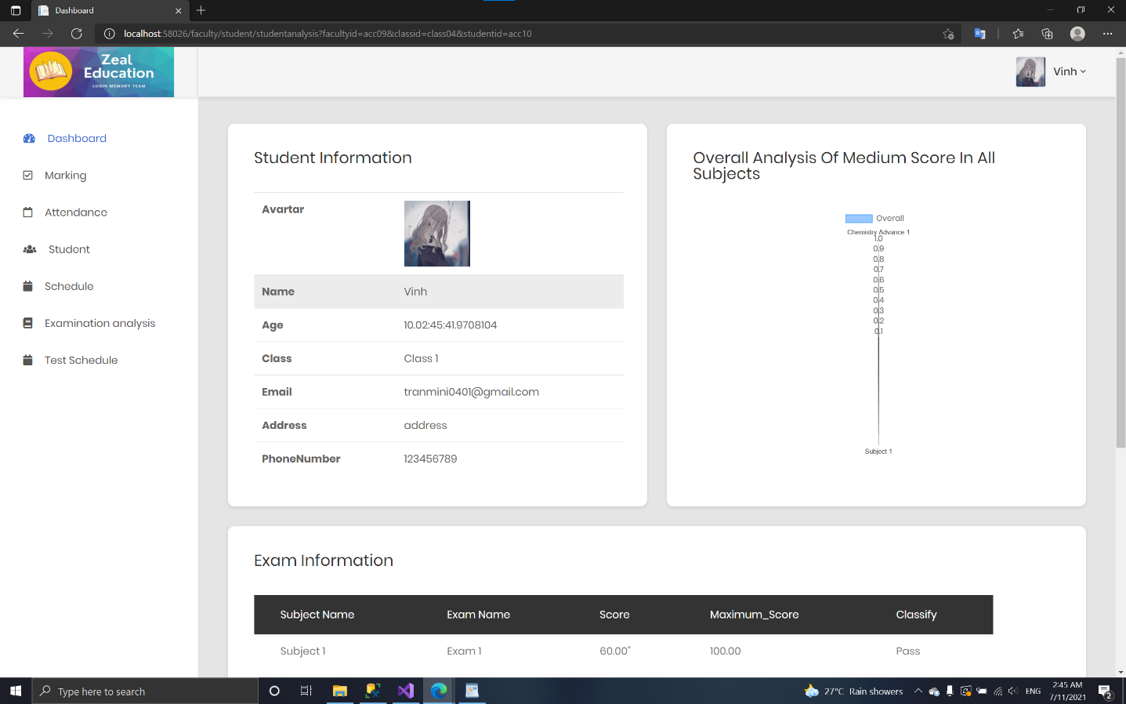

* + 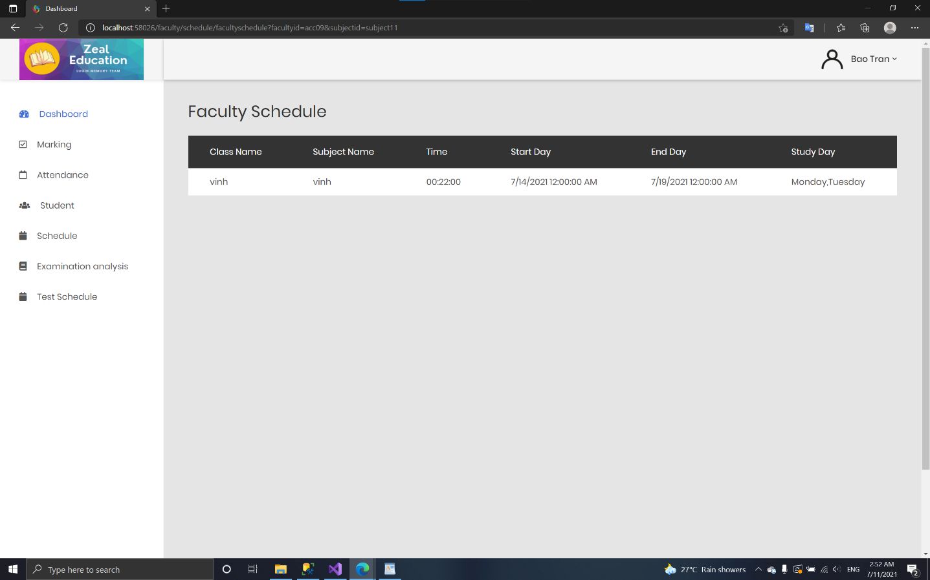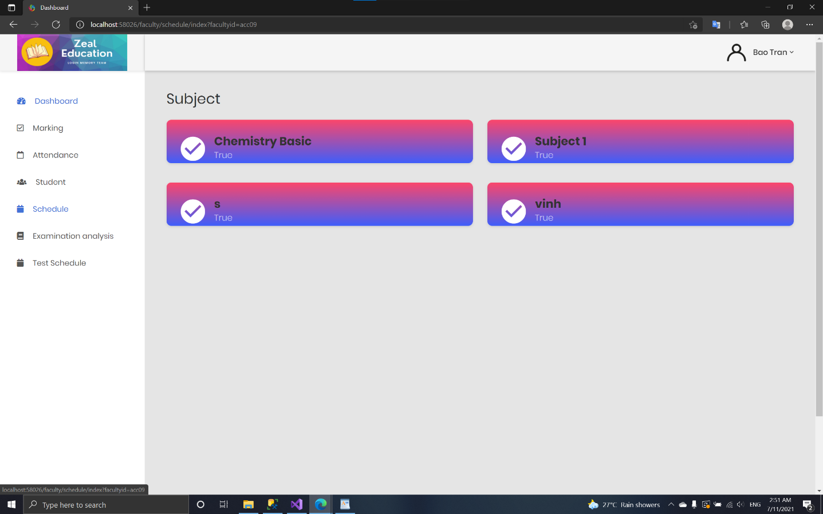**Schedule:**
  + 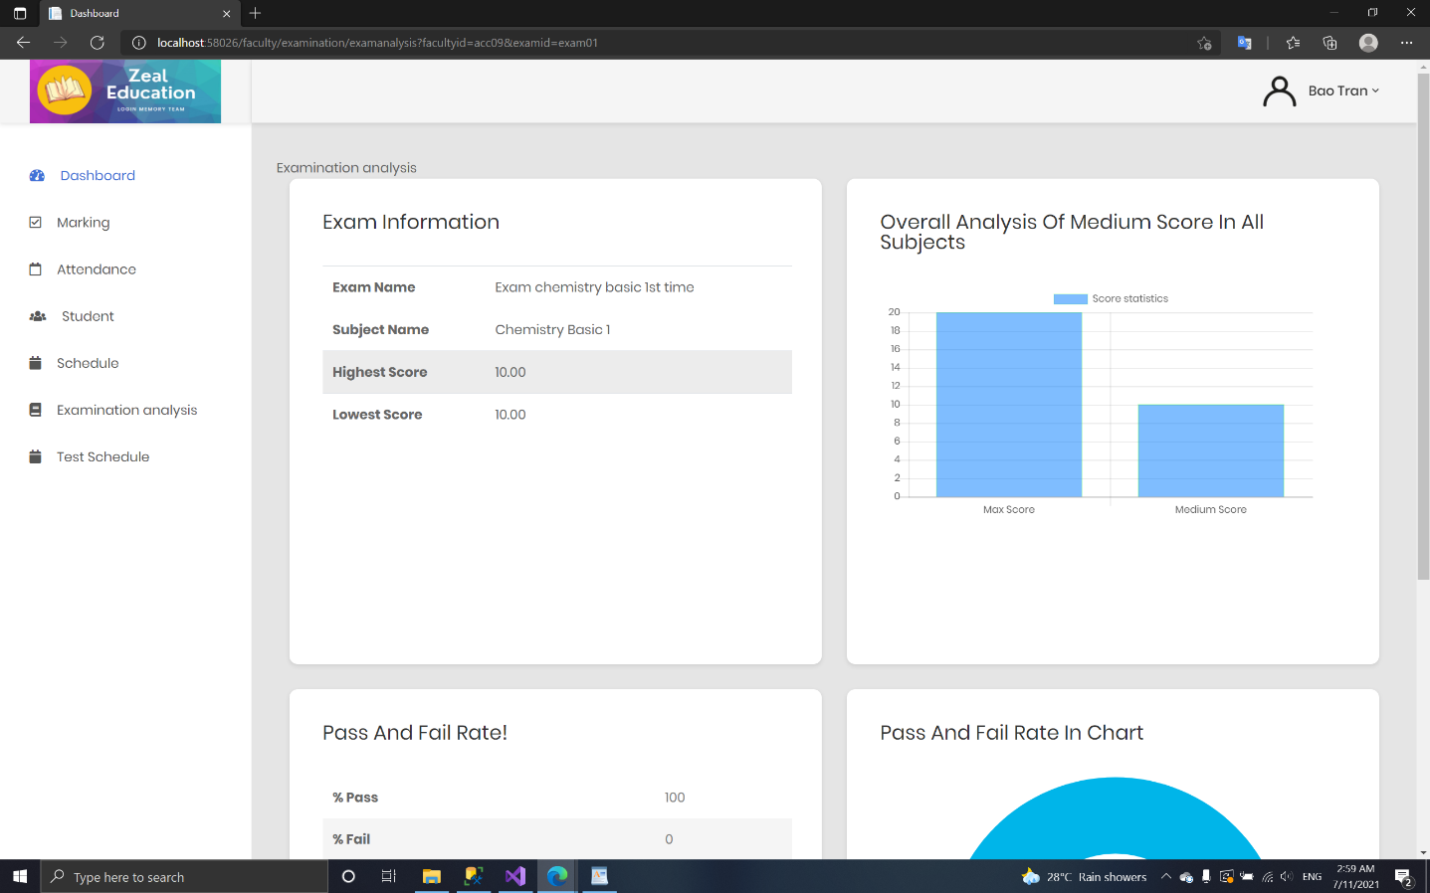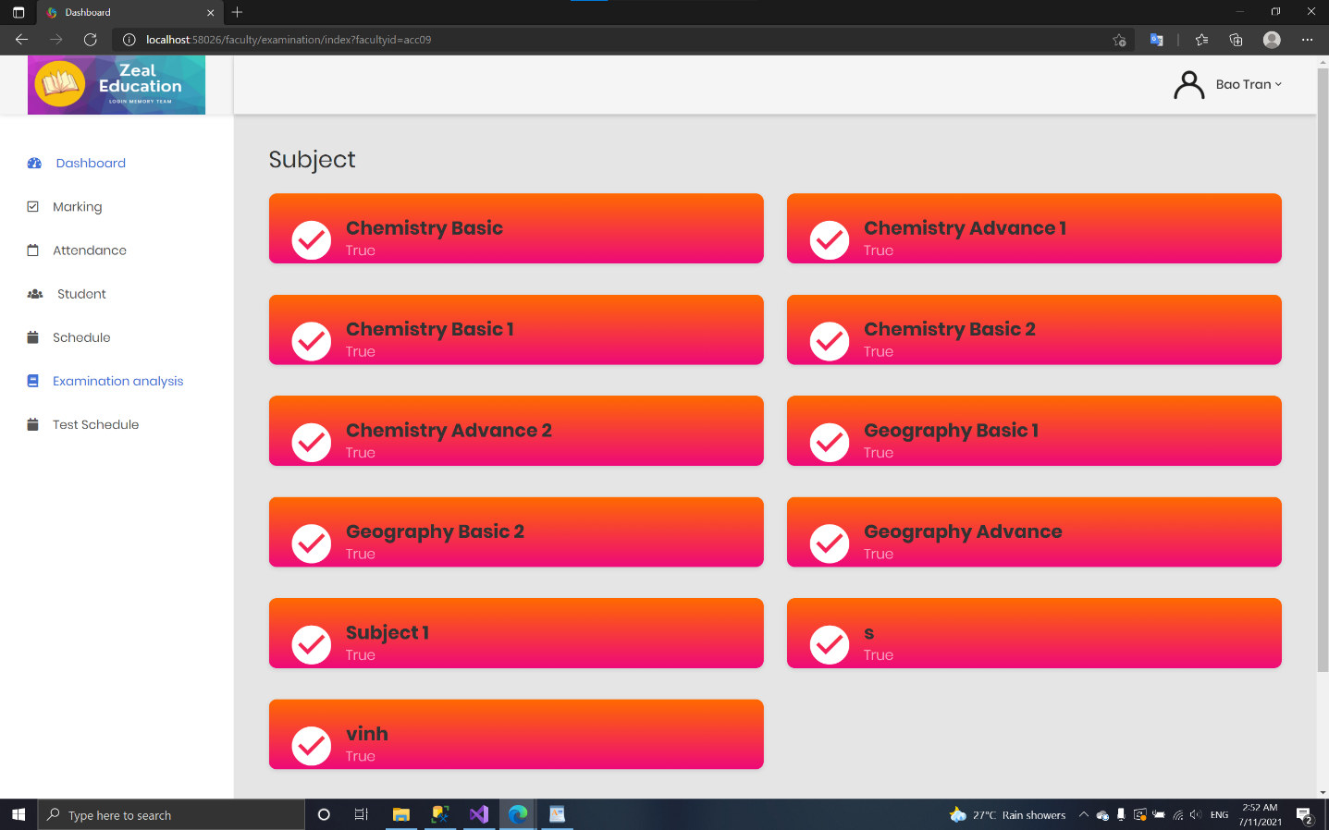**Schedule:**

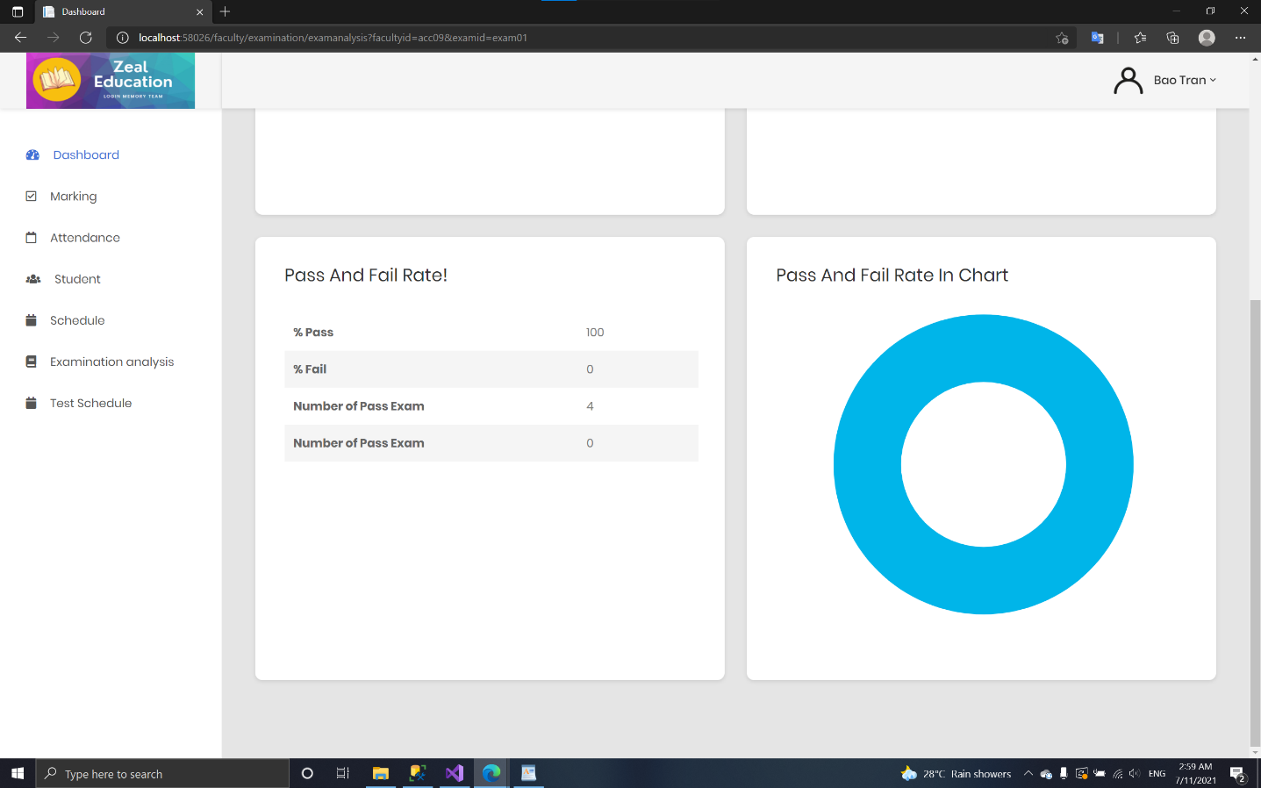

* + 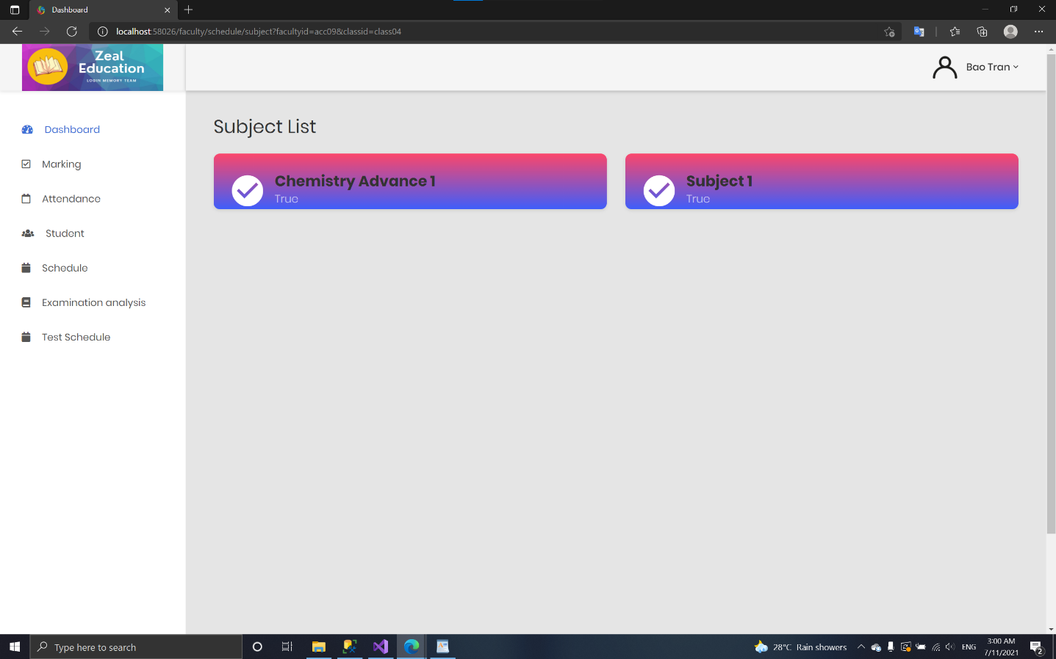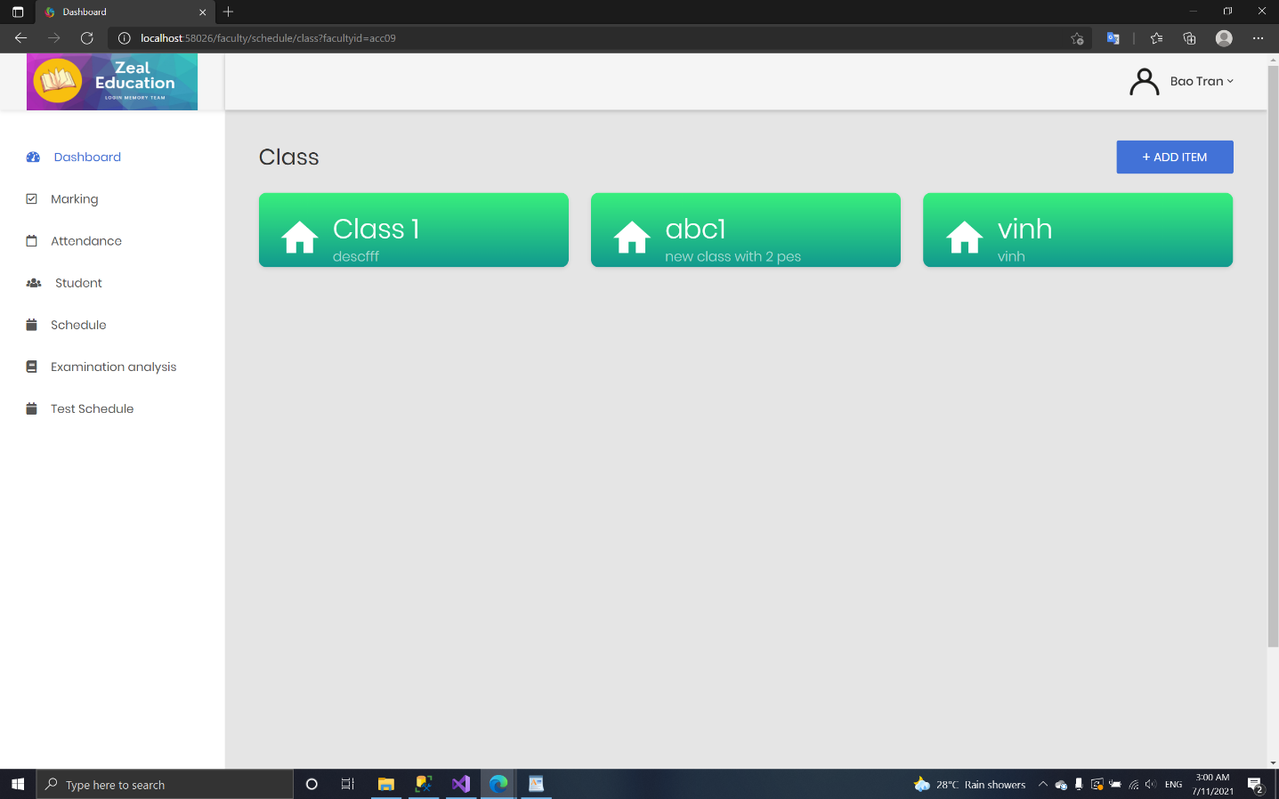**Test schedule:**

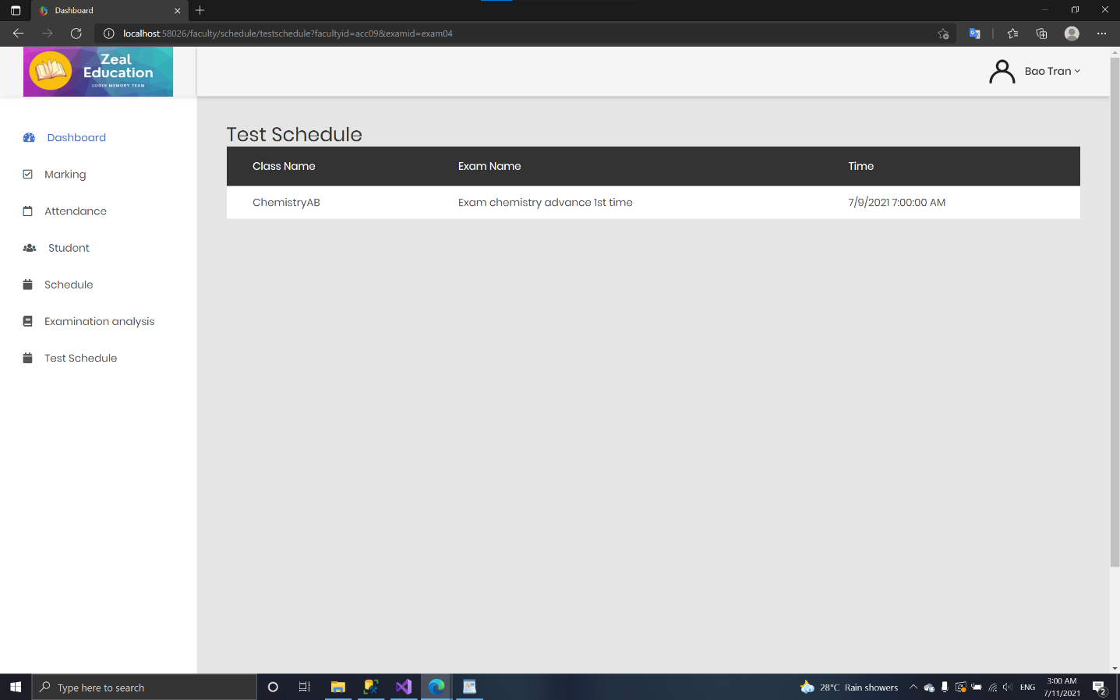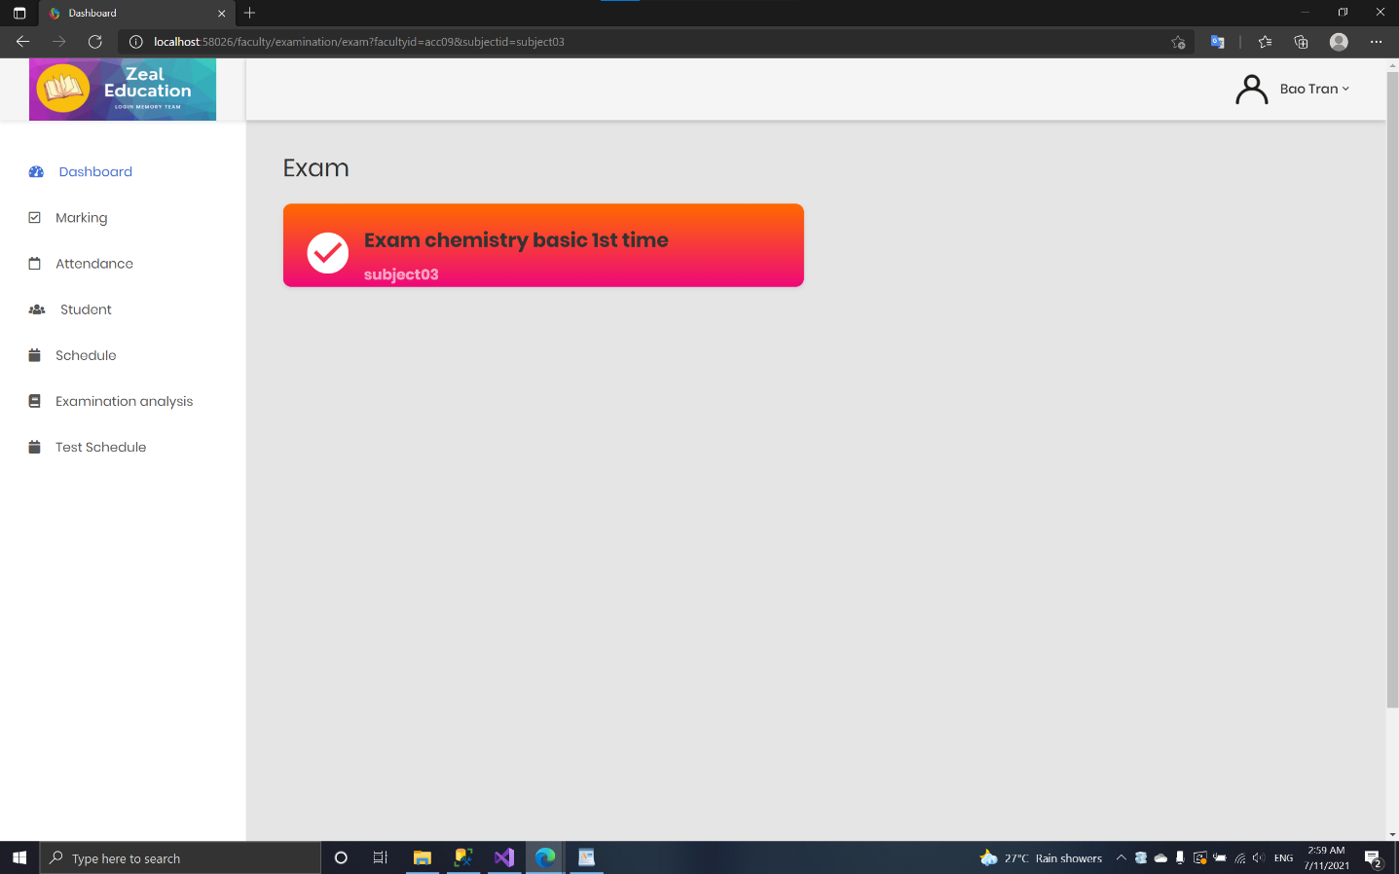

1. *Student***:**
   * 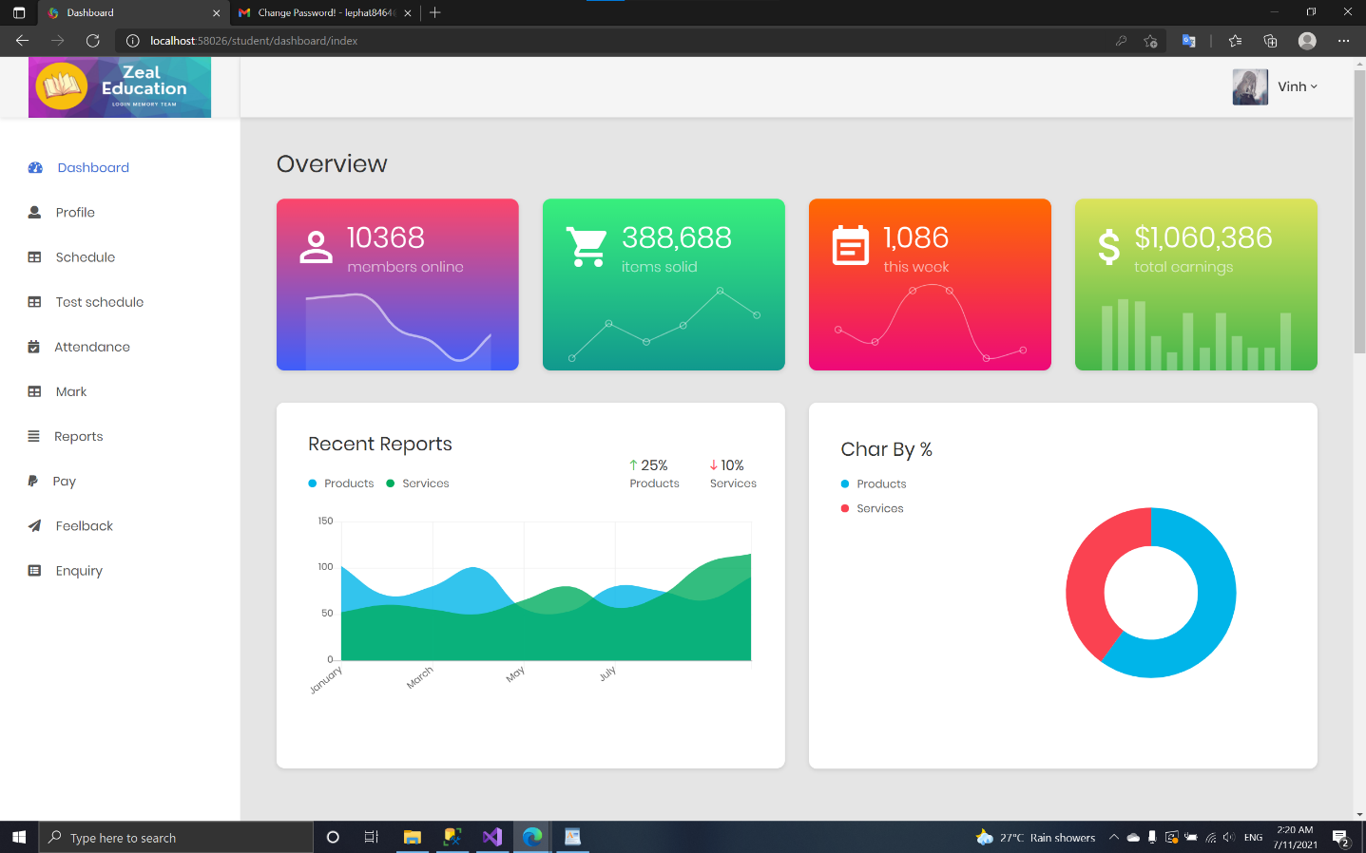**Dashboard:**
   * 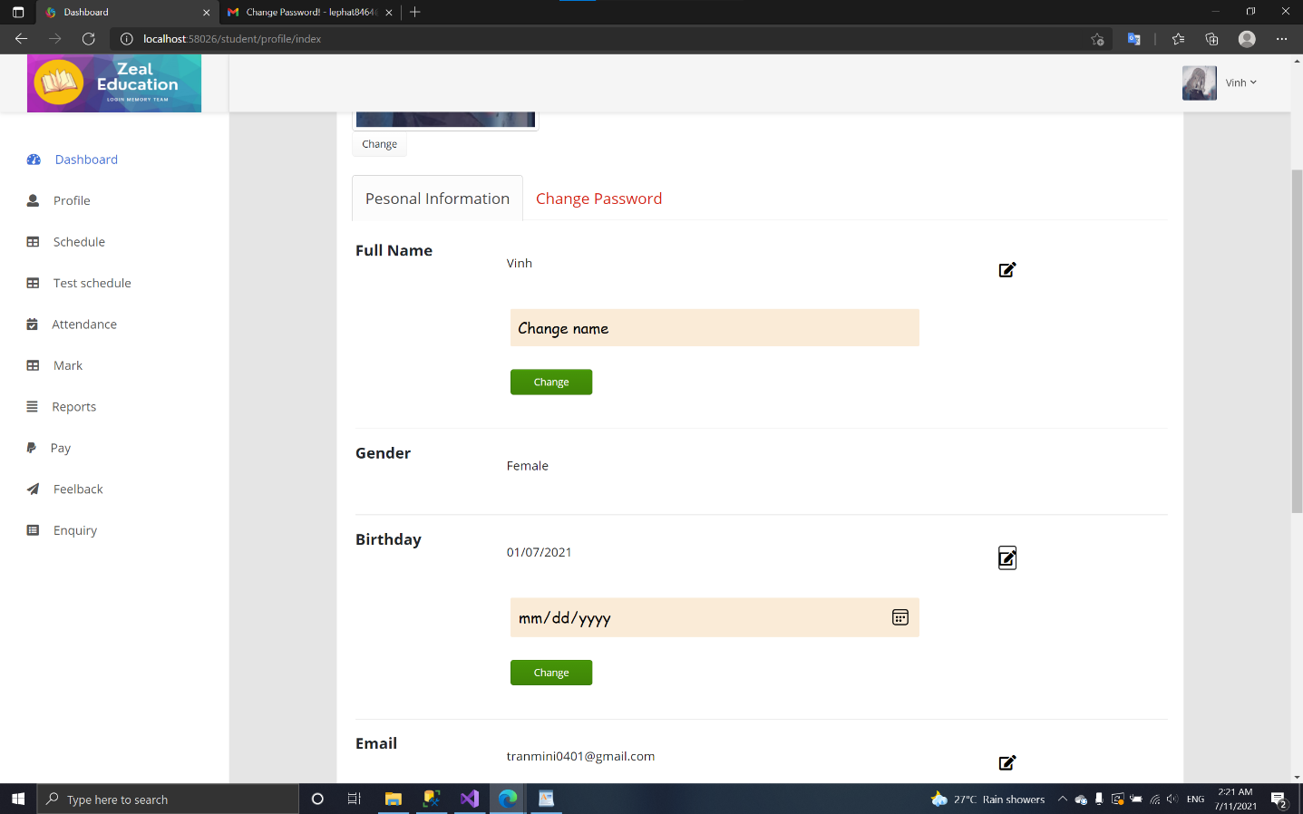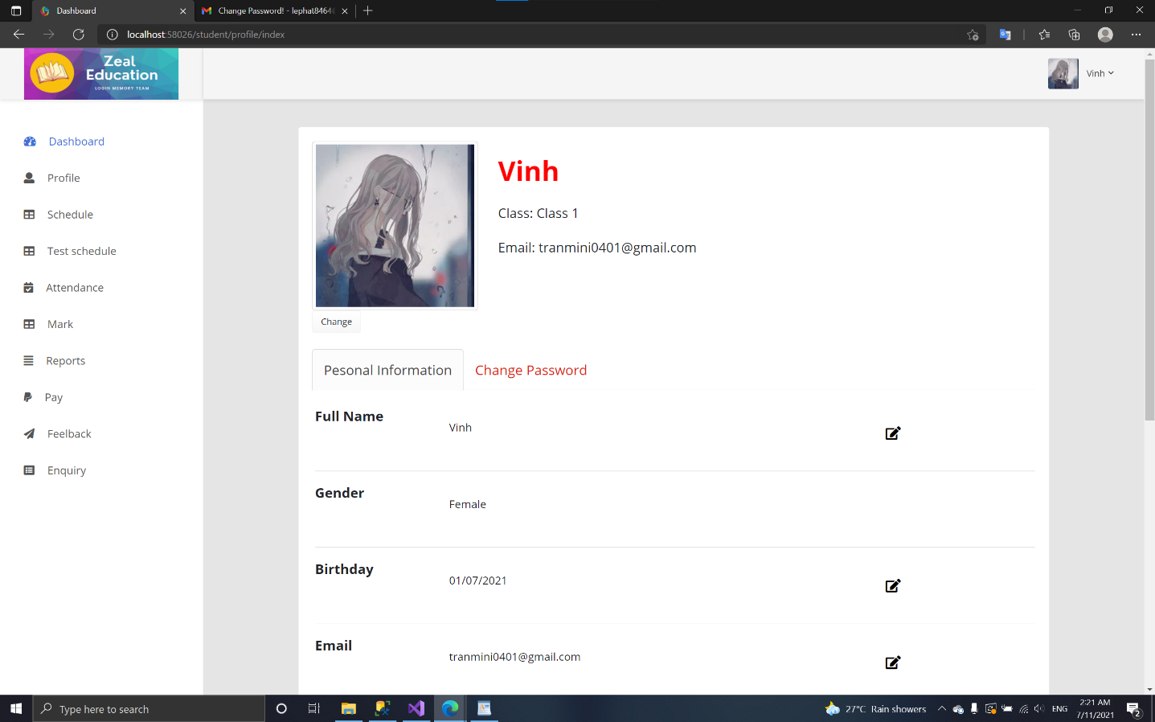**Profile:**

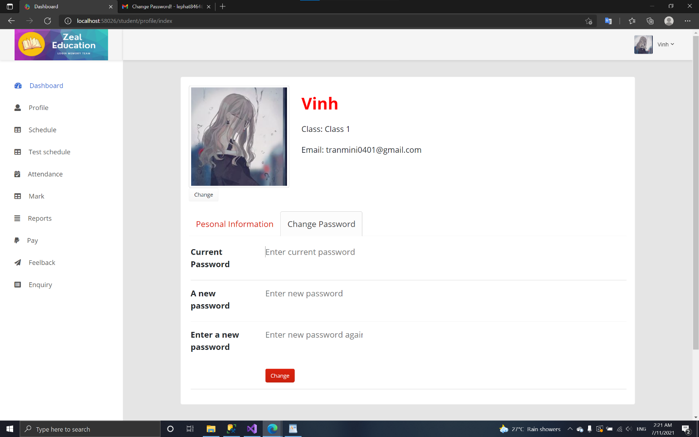

* + 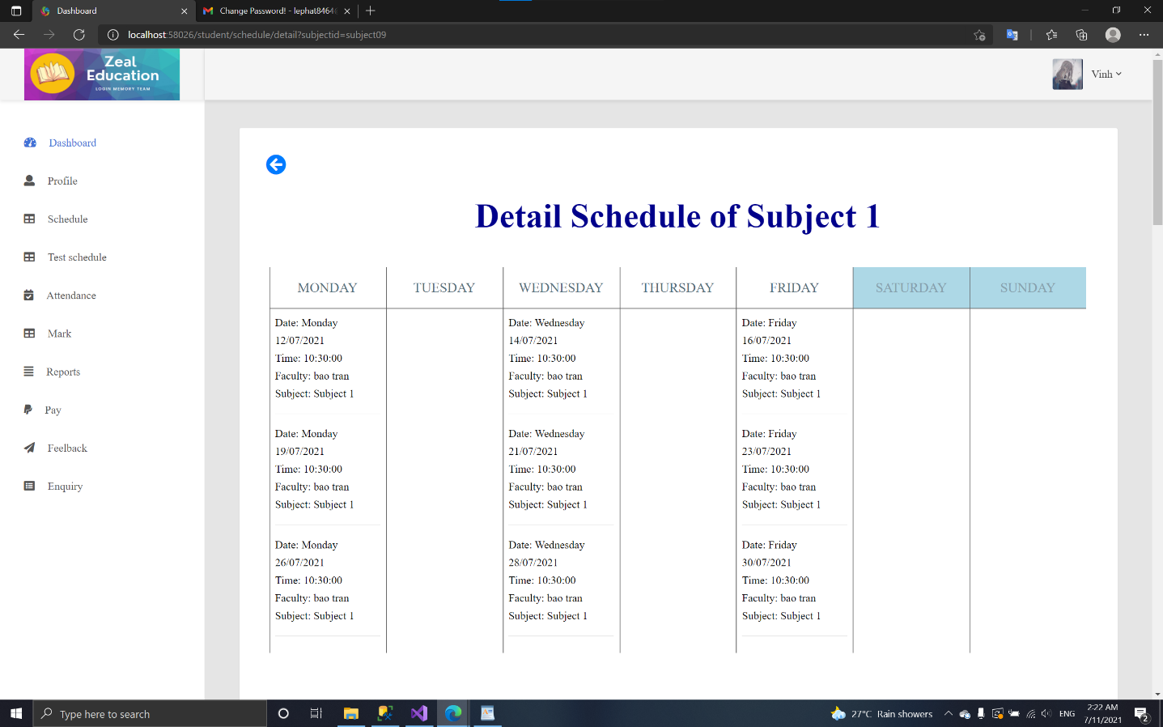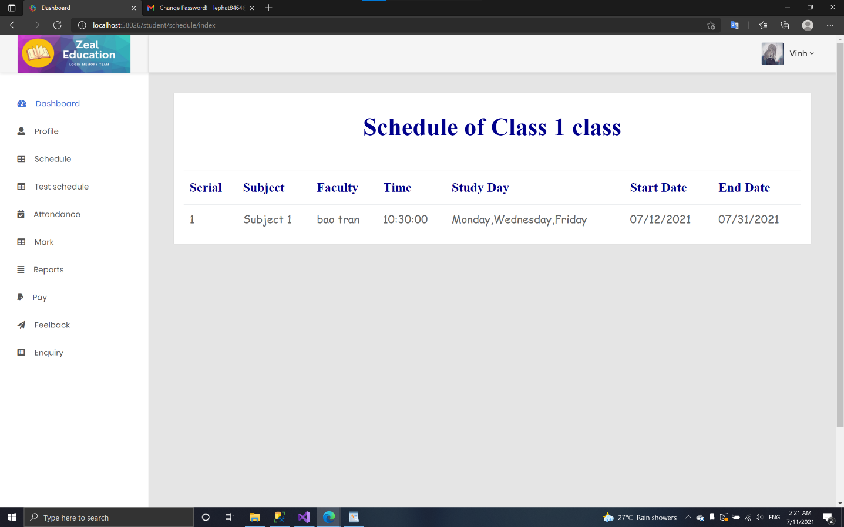**Schedule:**
  + 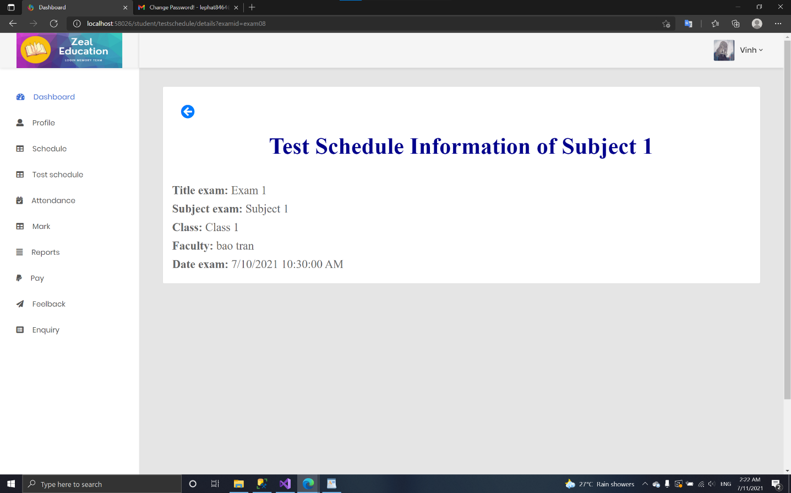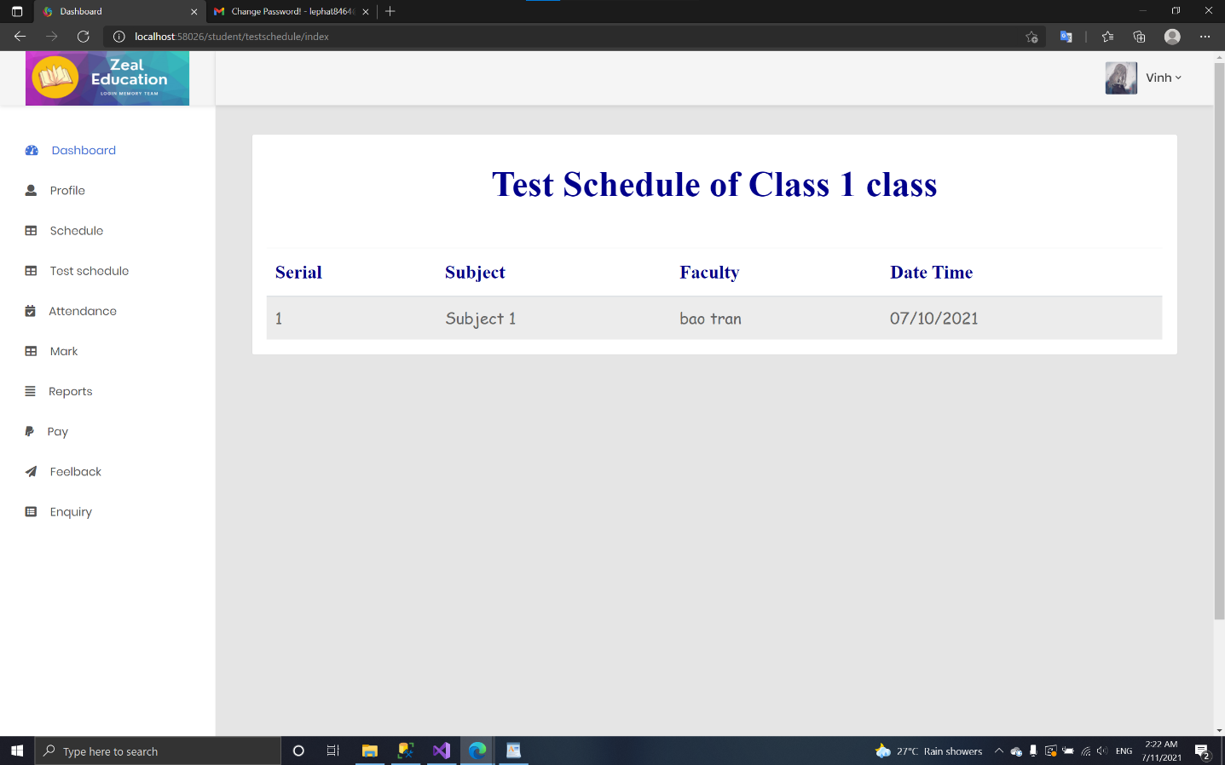**Test schedule:**
  + 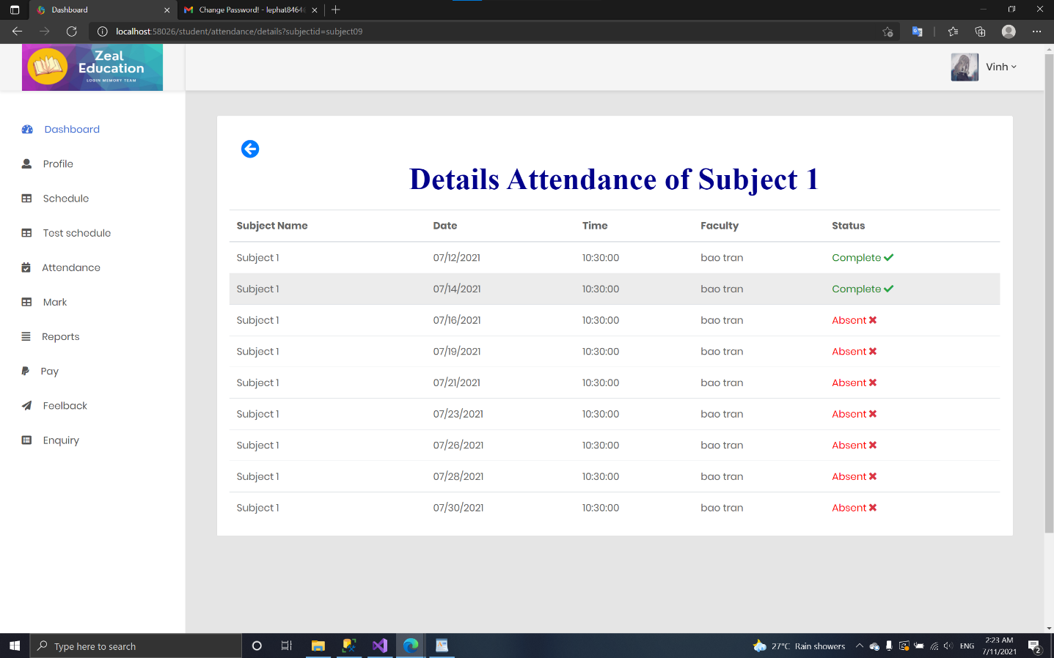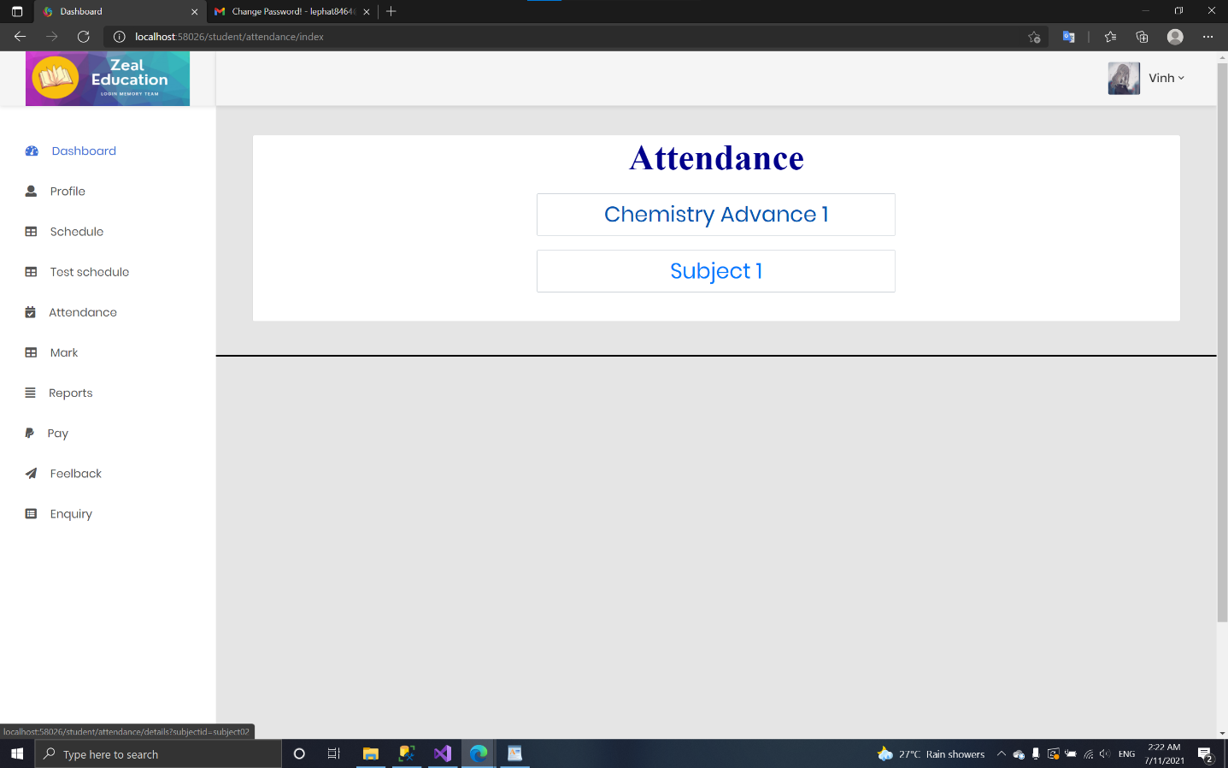**Attendance:**
  + 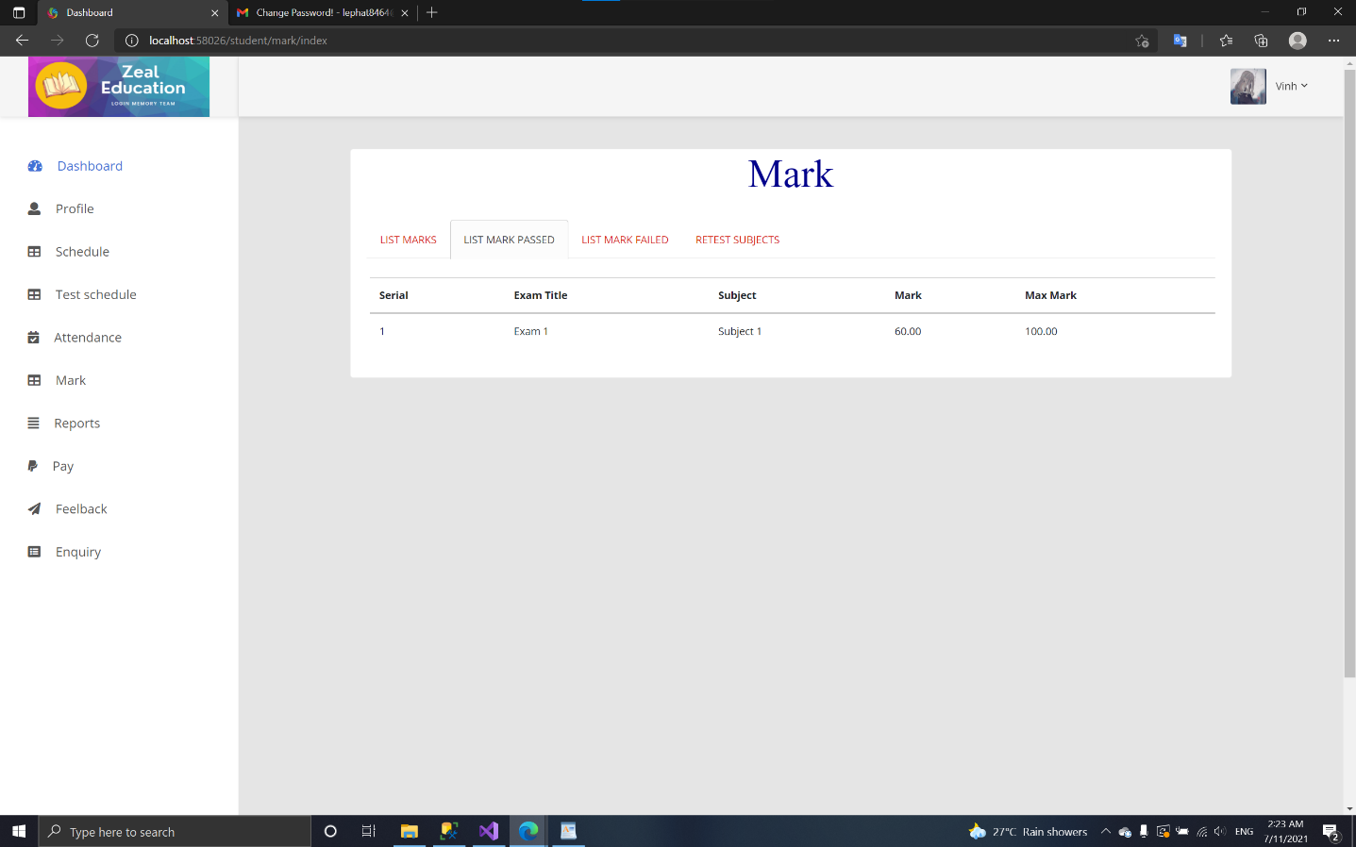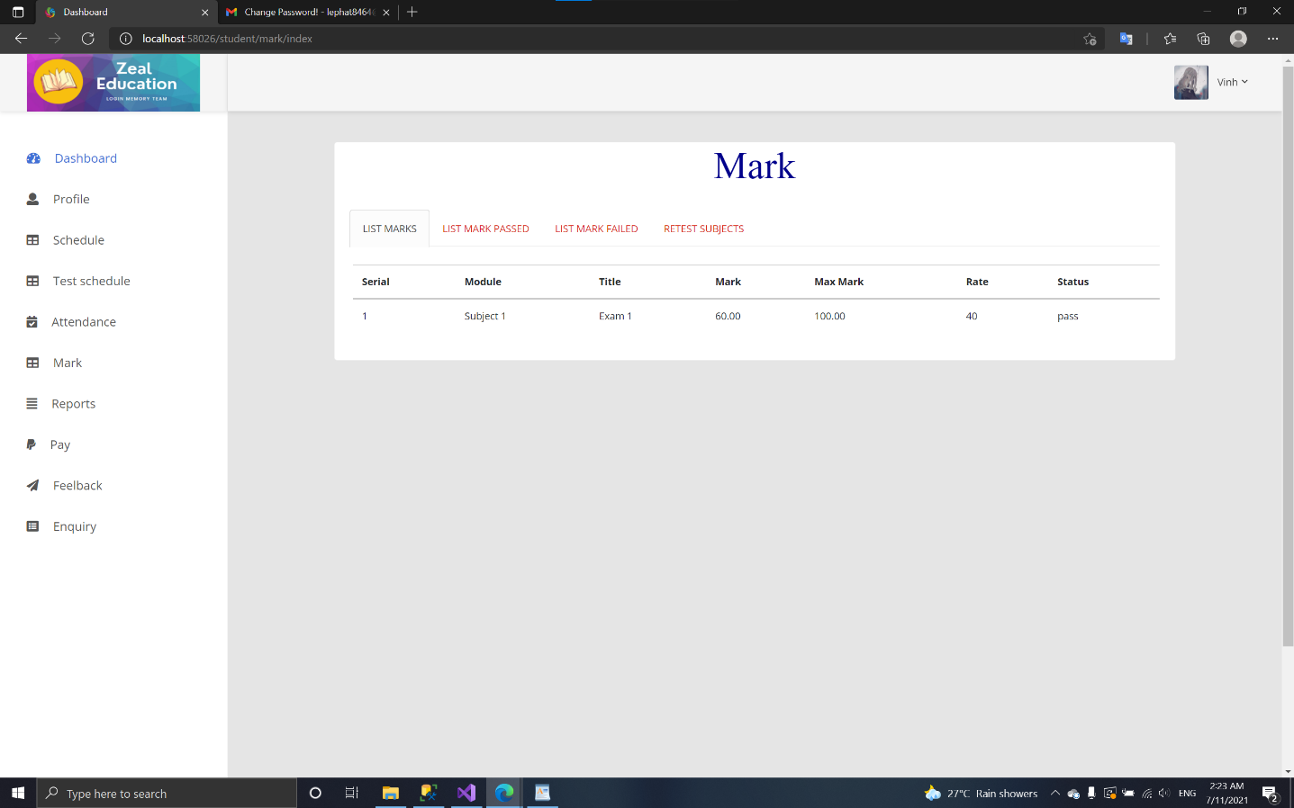**Mark:**

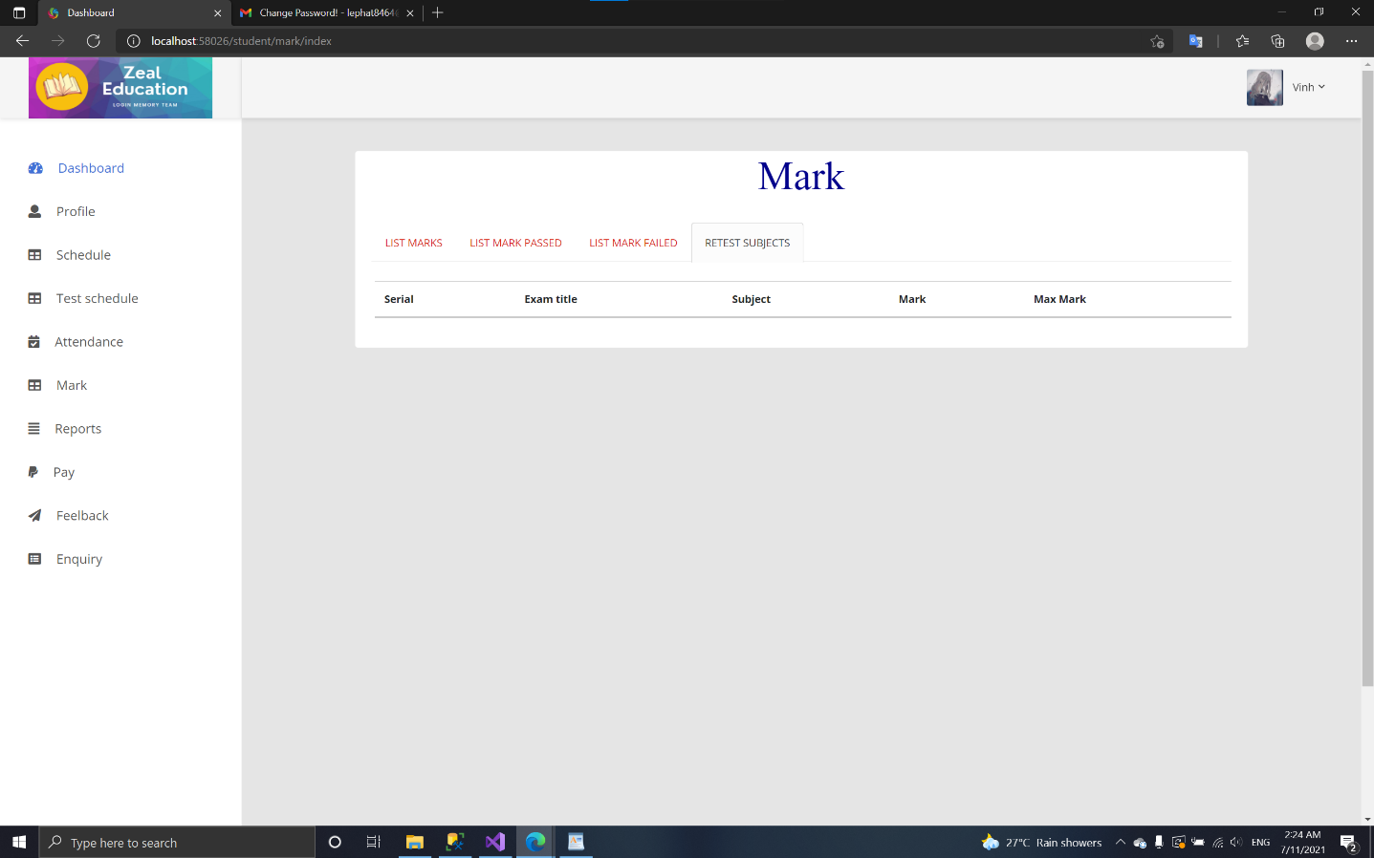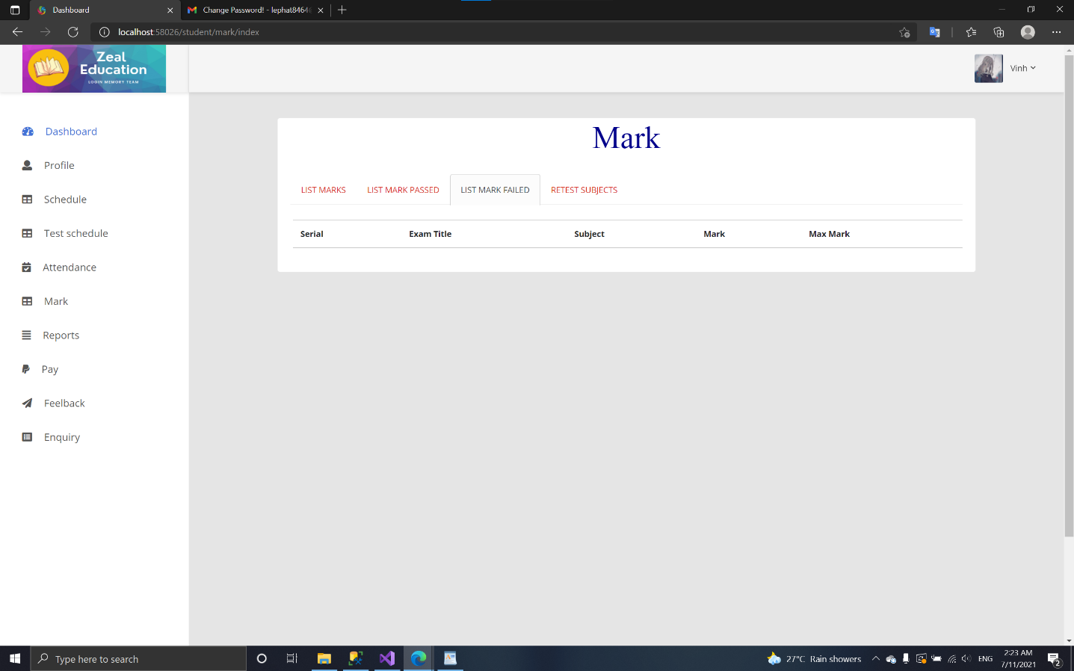

* + 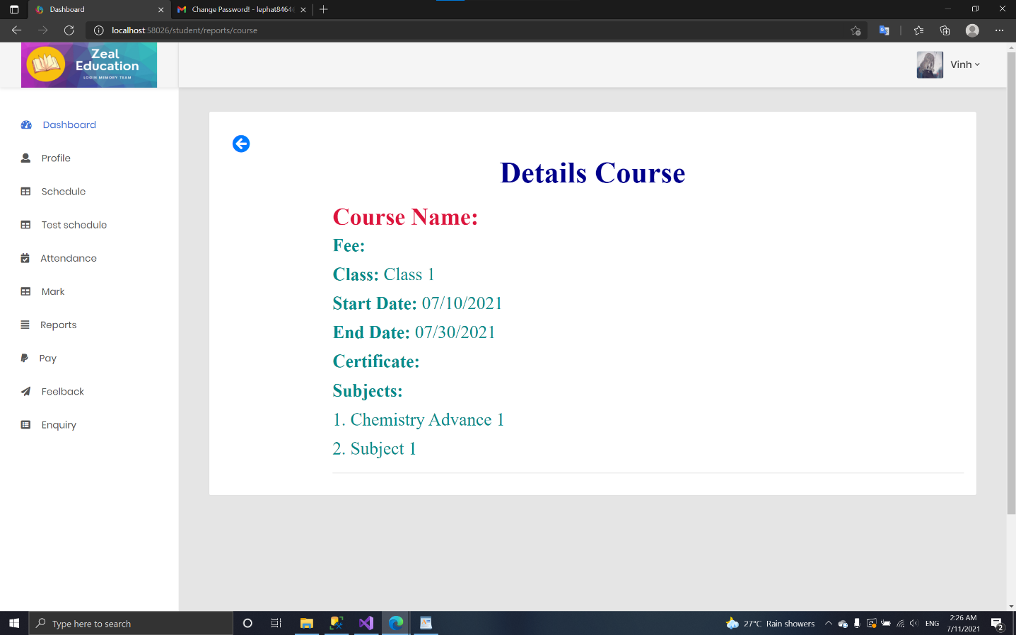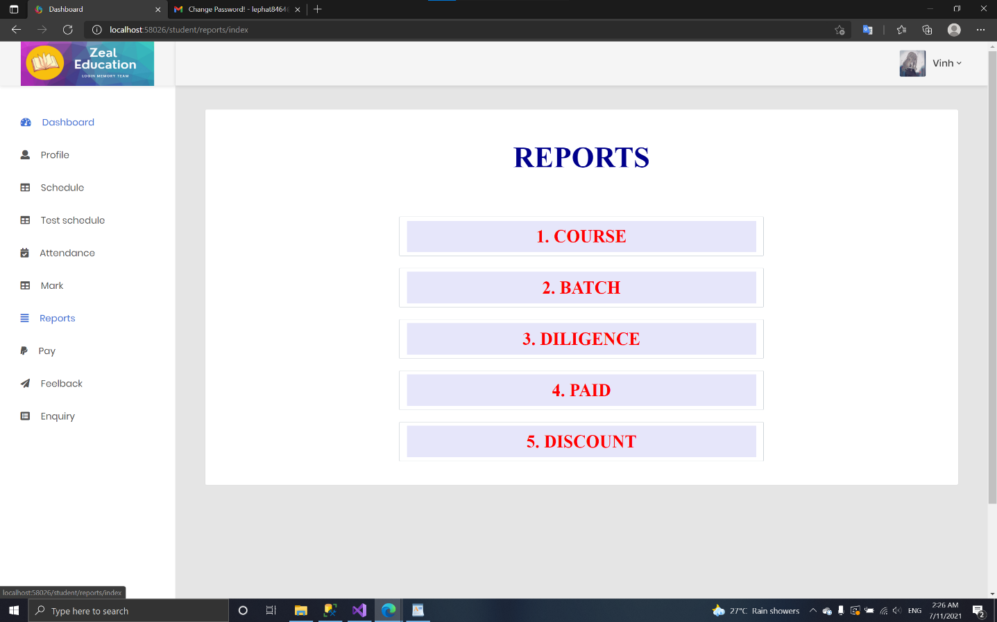**Reports:**

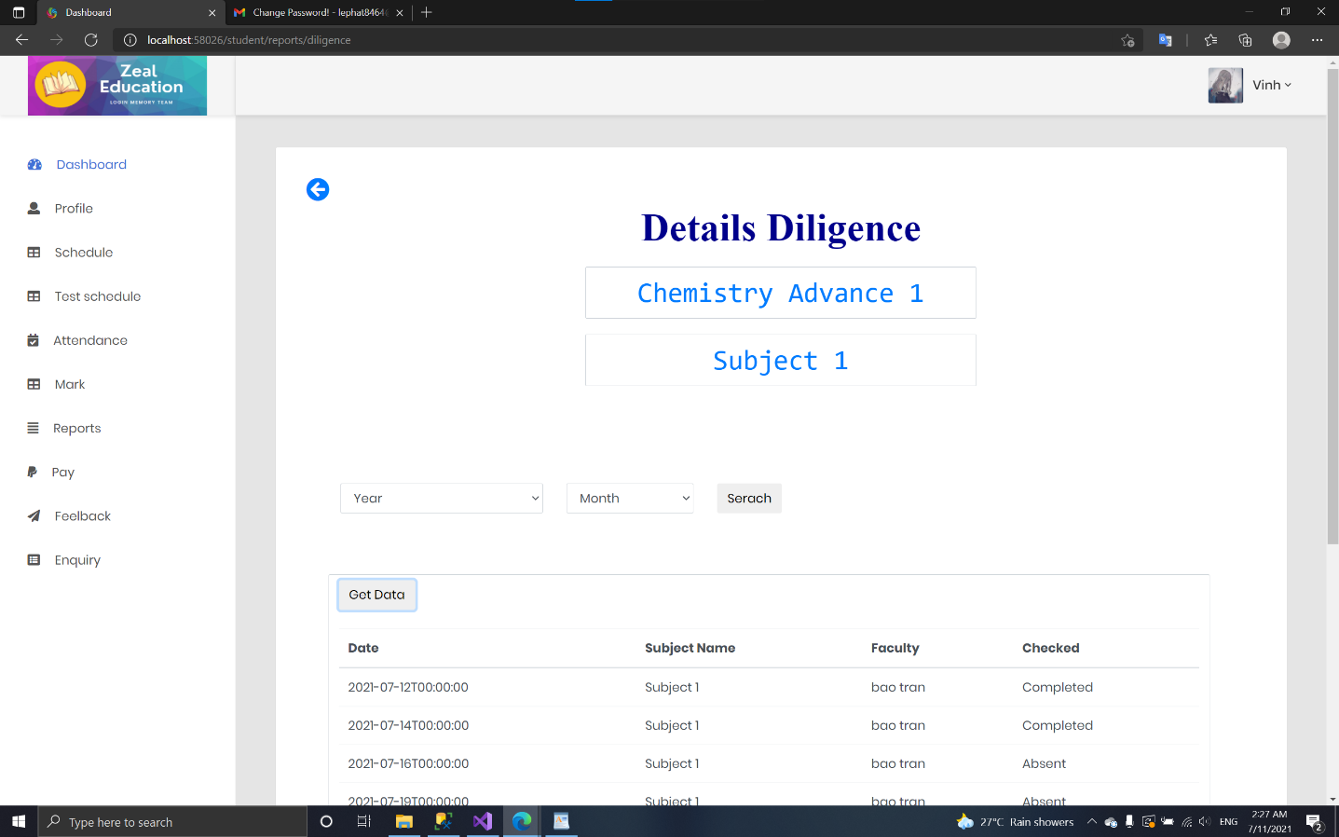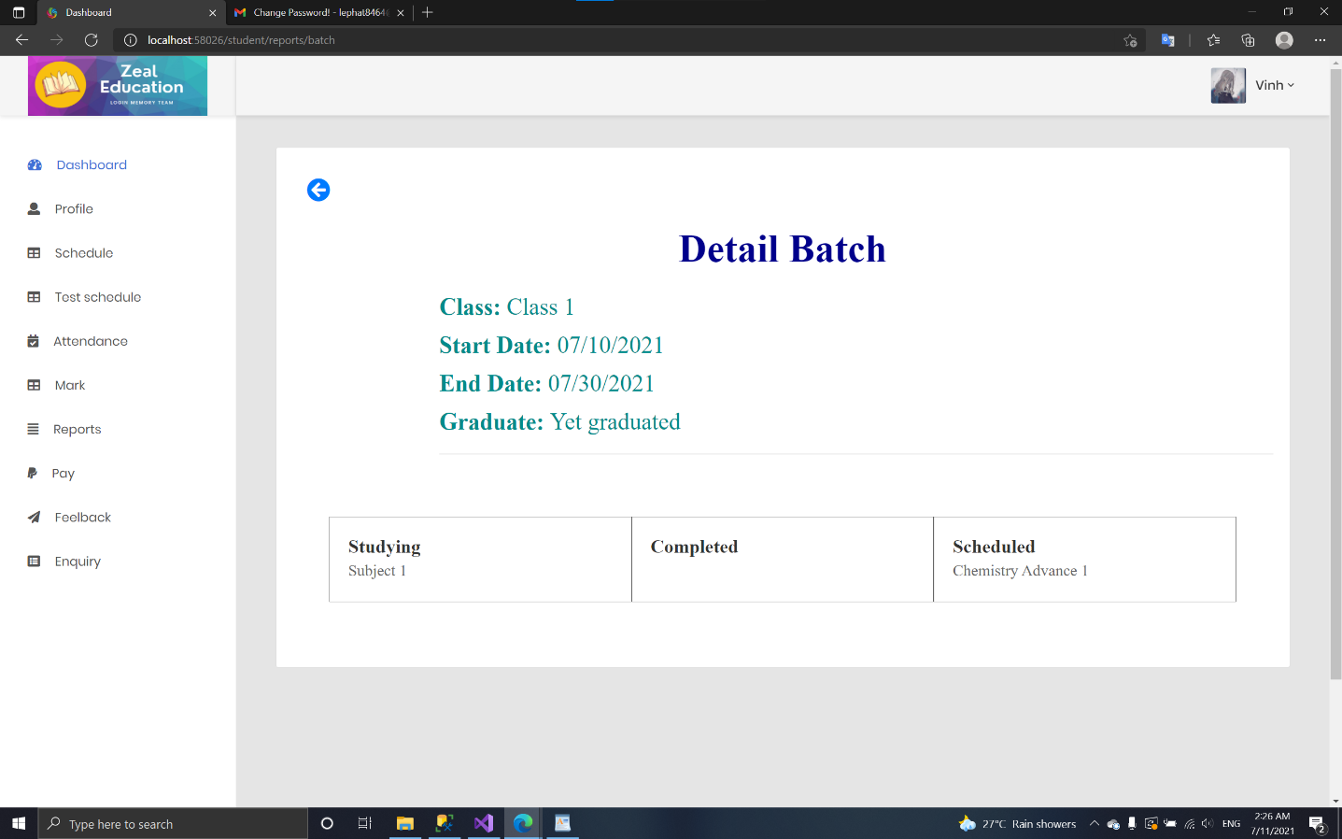

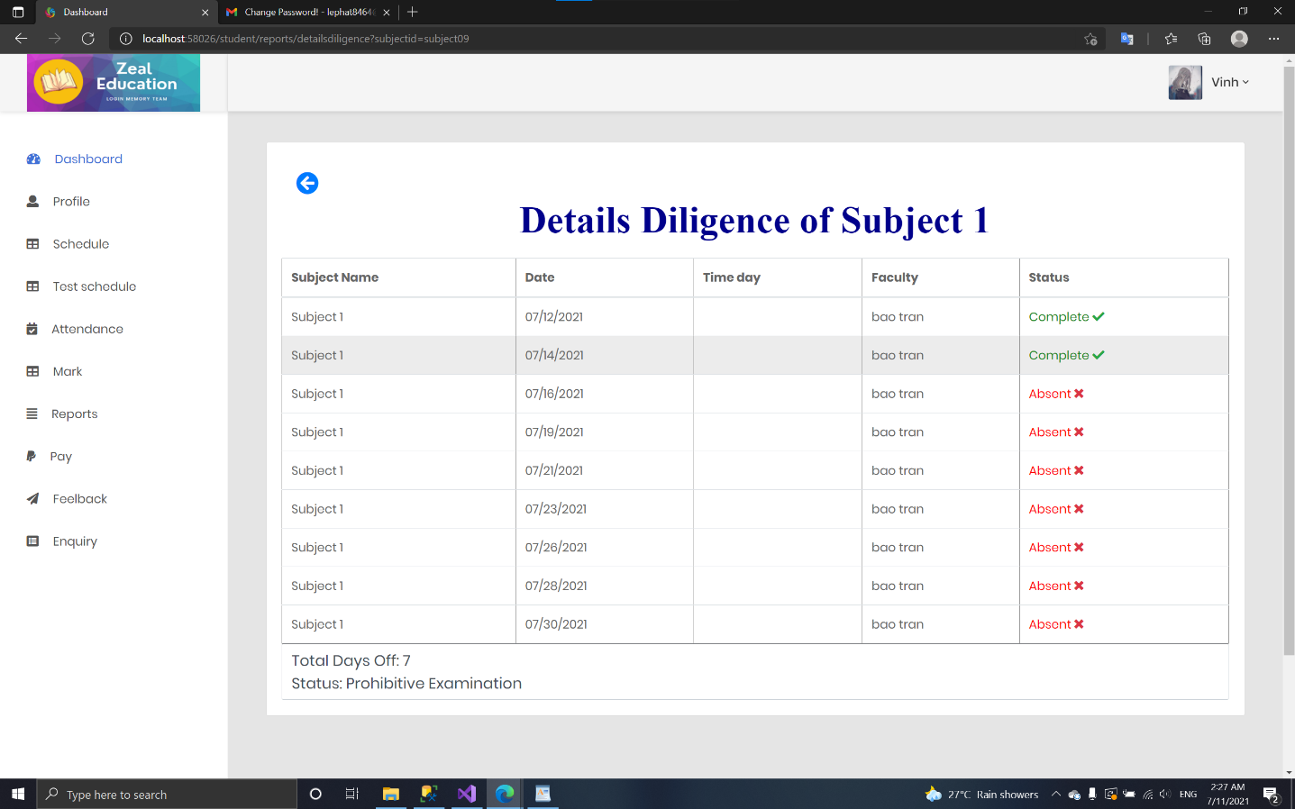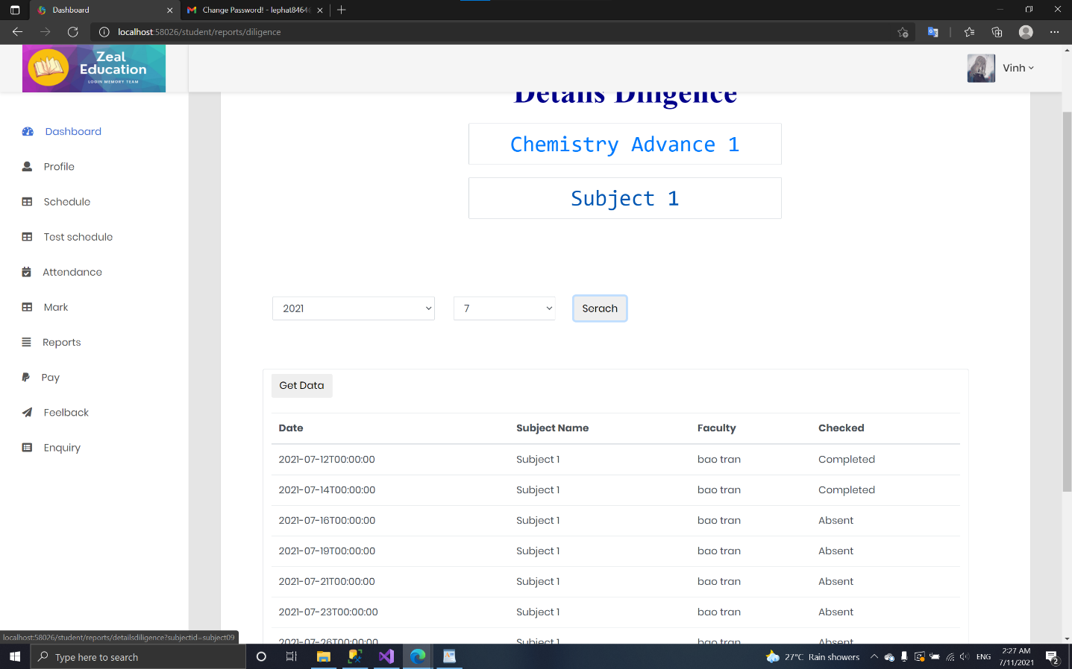

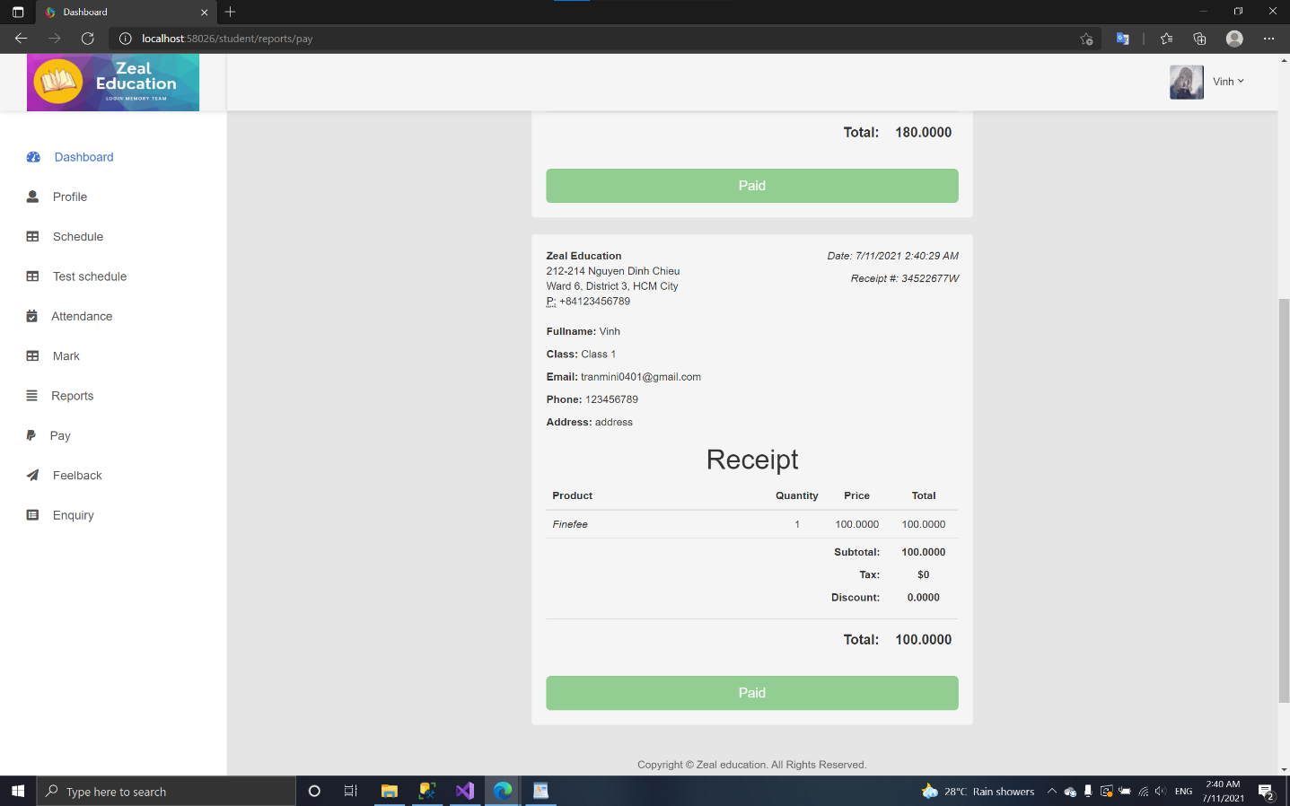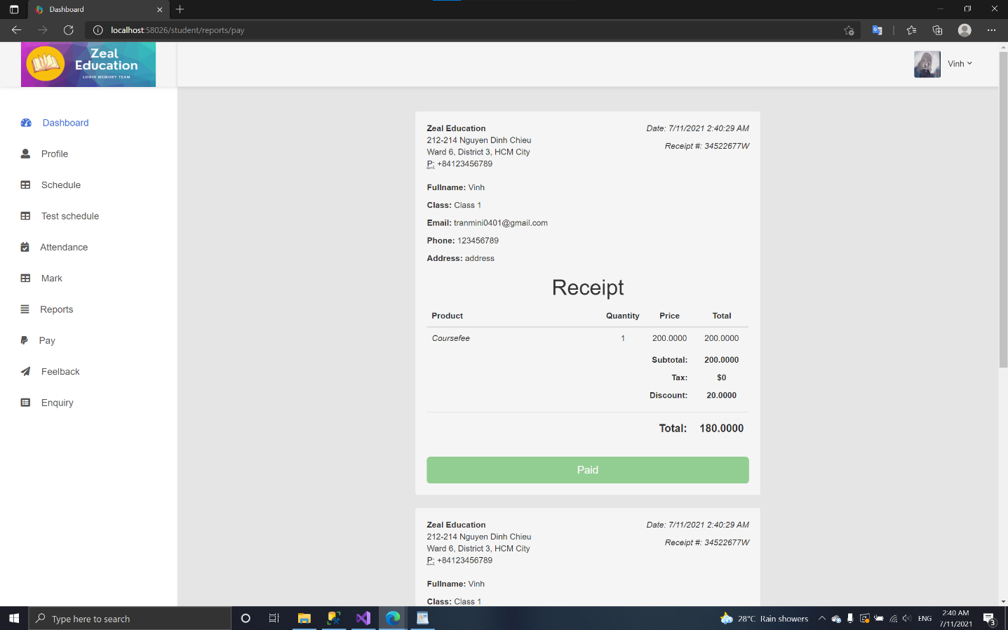

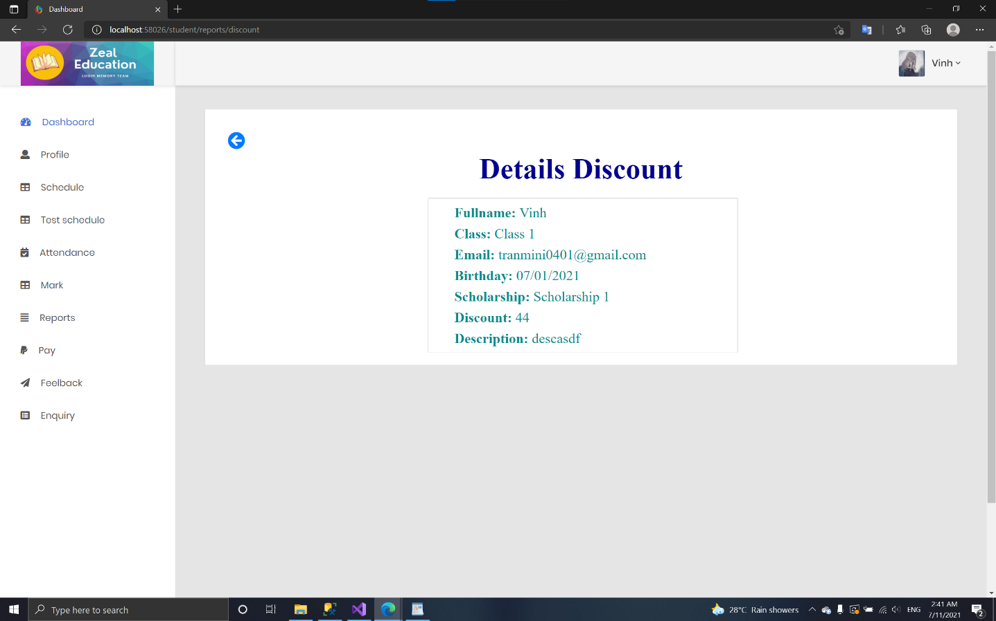

* + 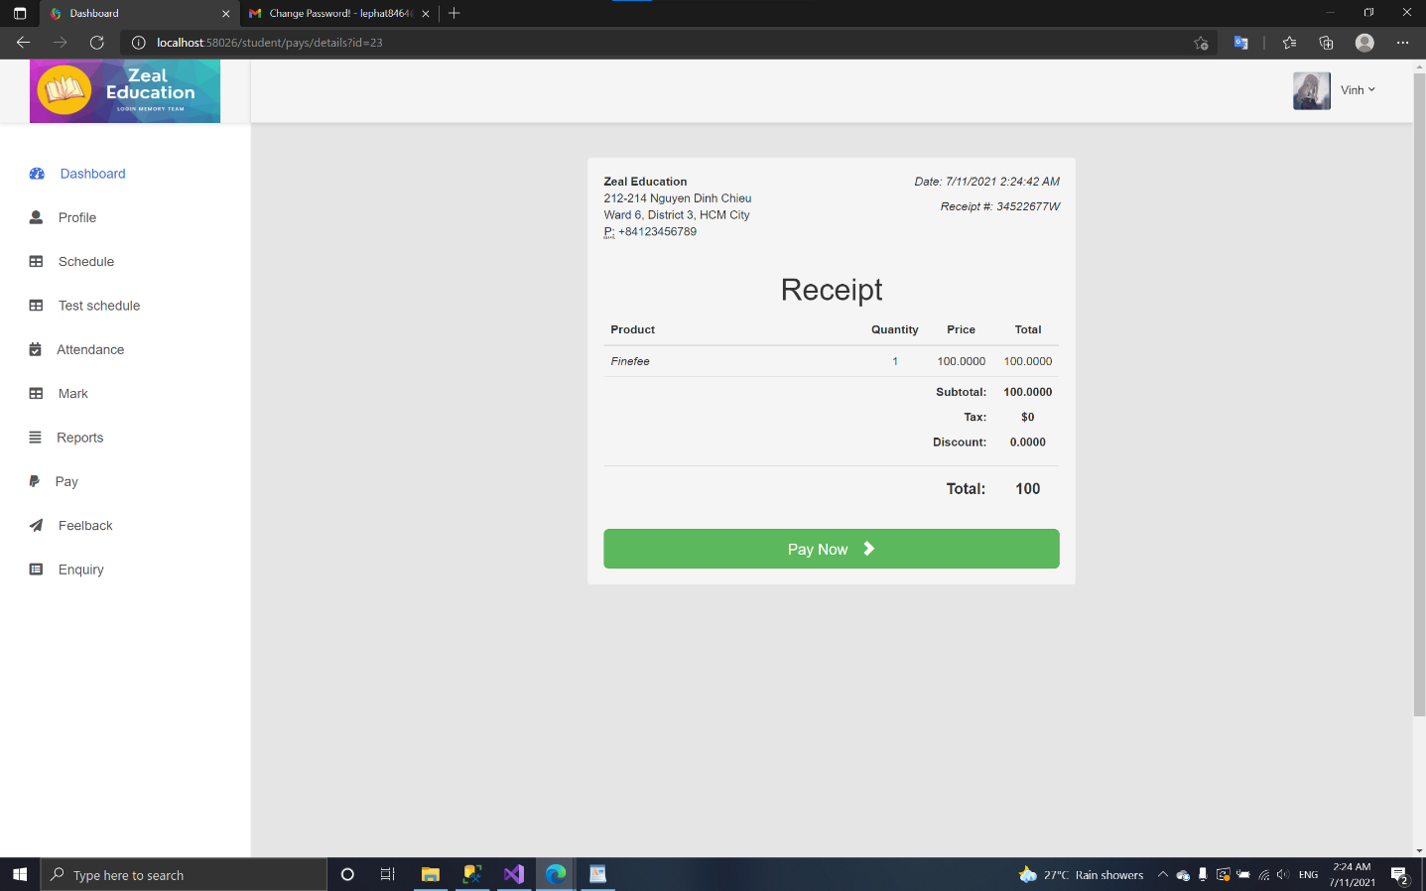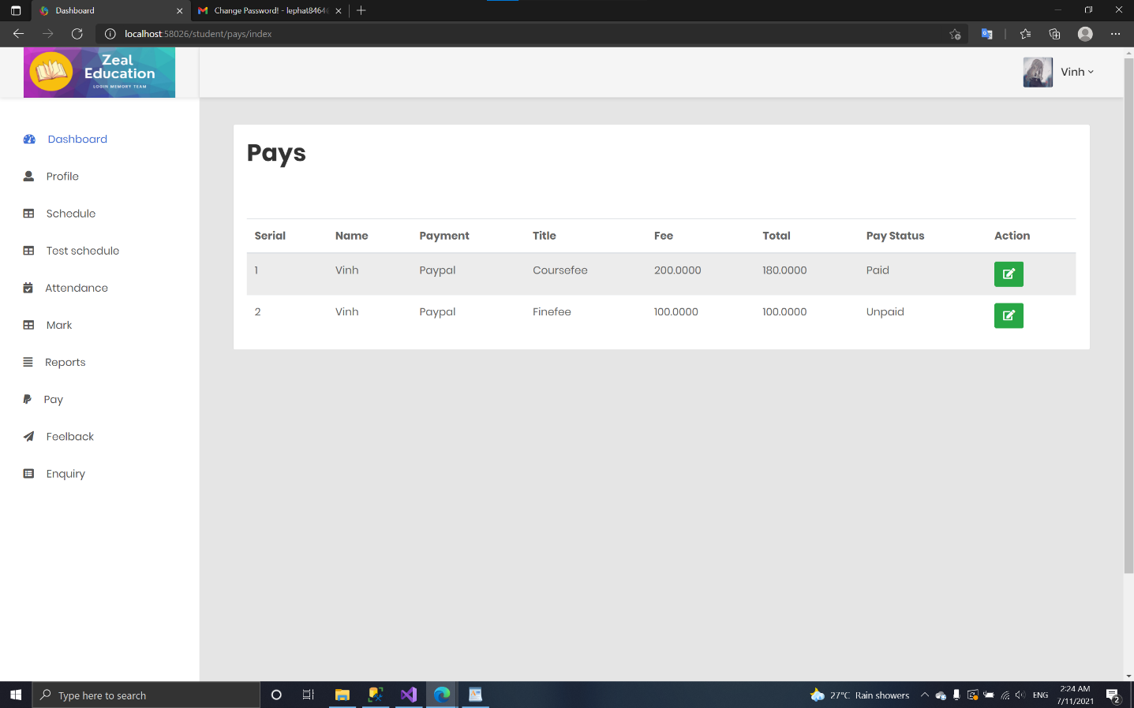**Pay:**

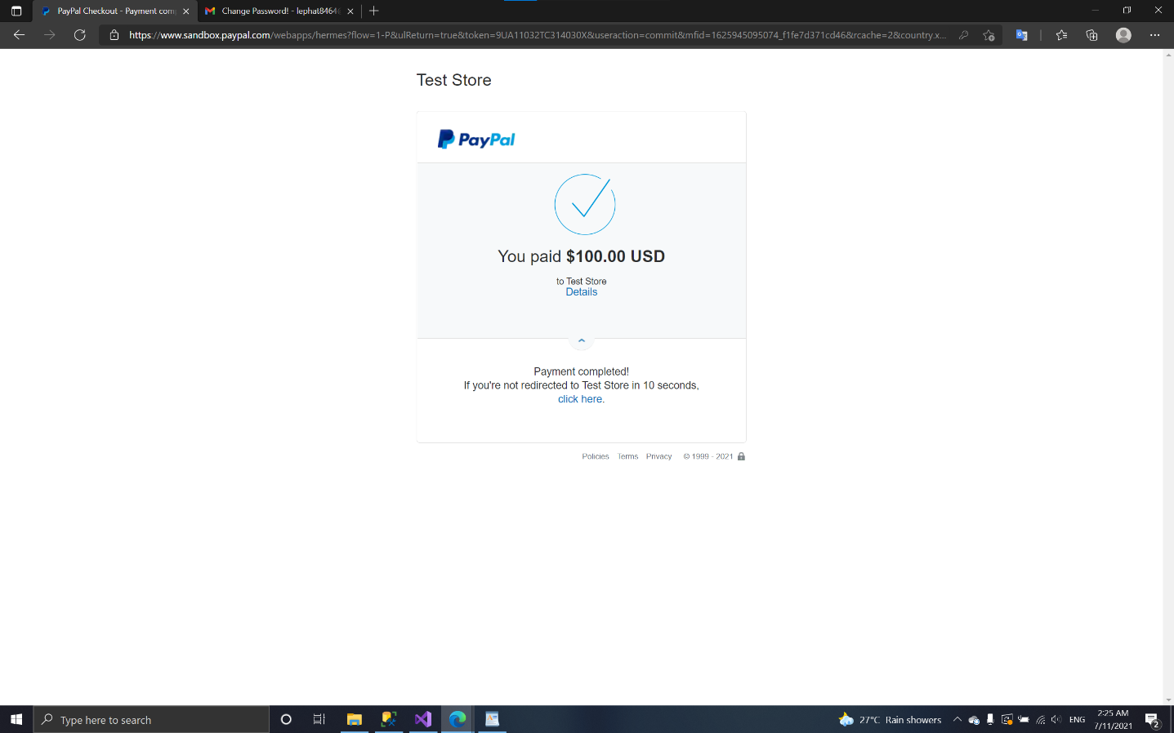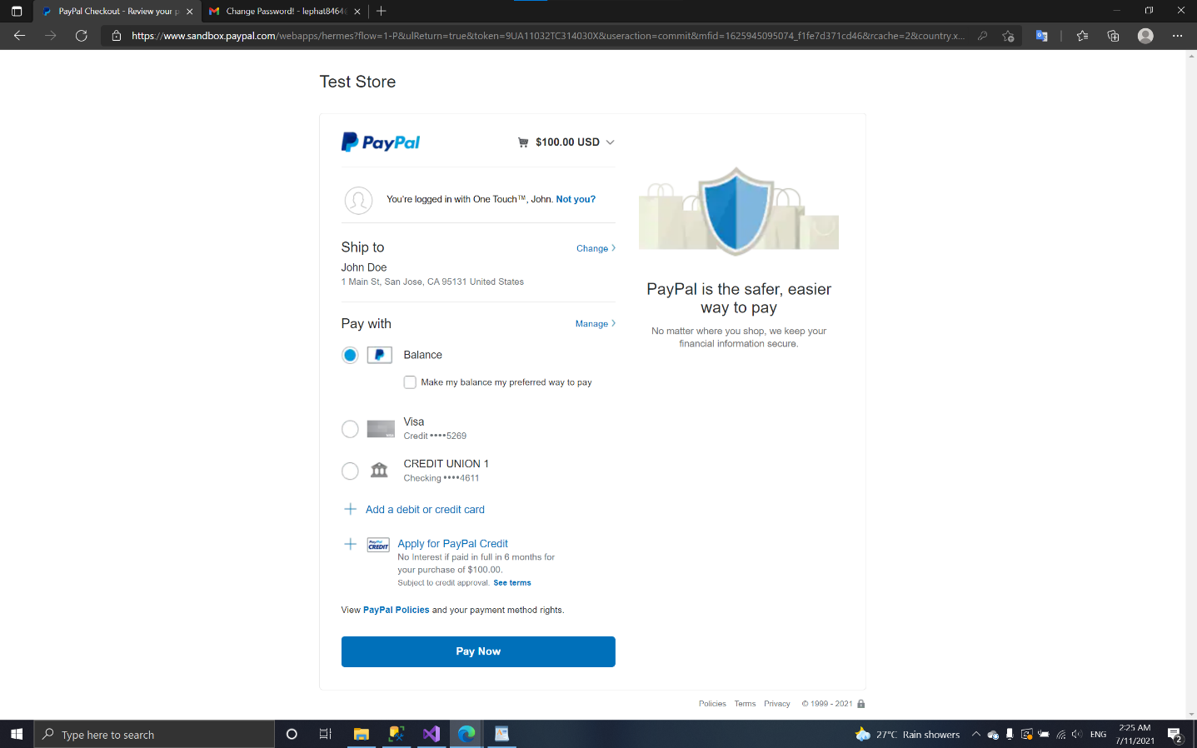

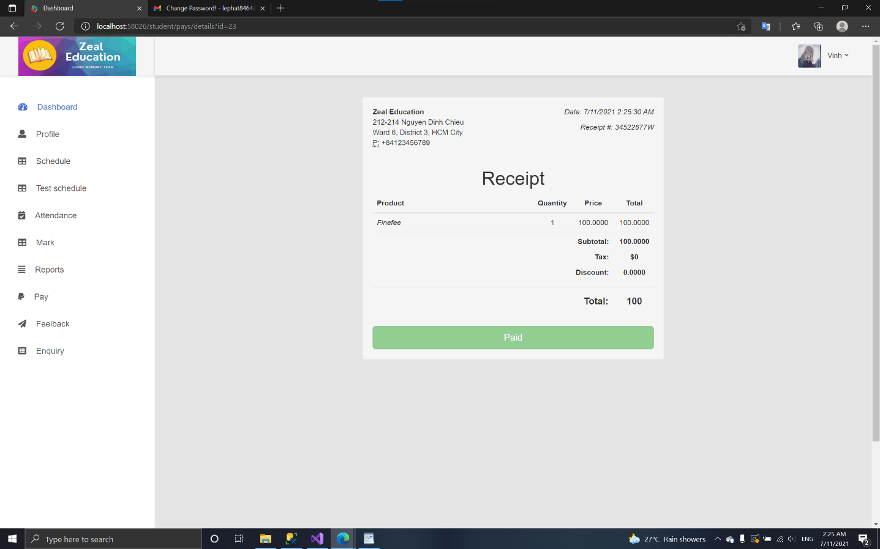

* + 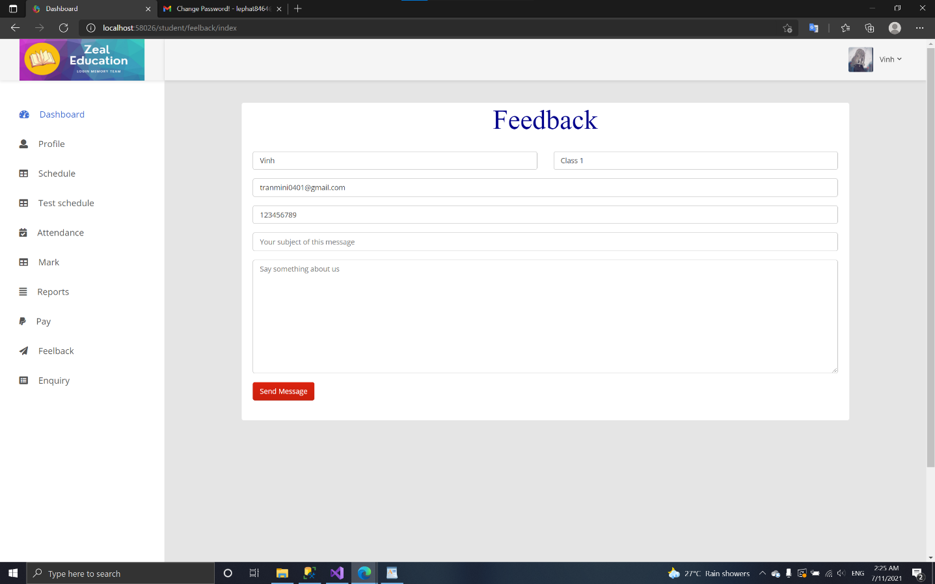**Feedback:**
  + 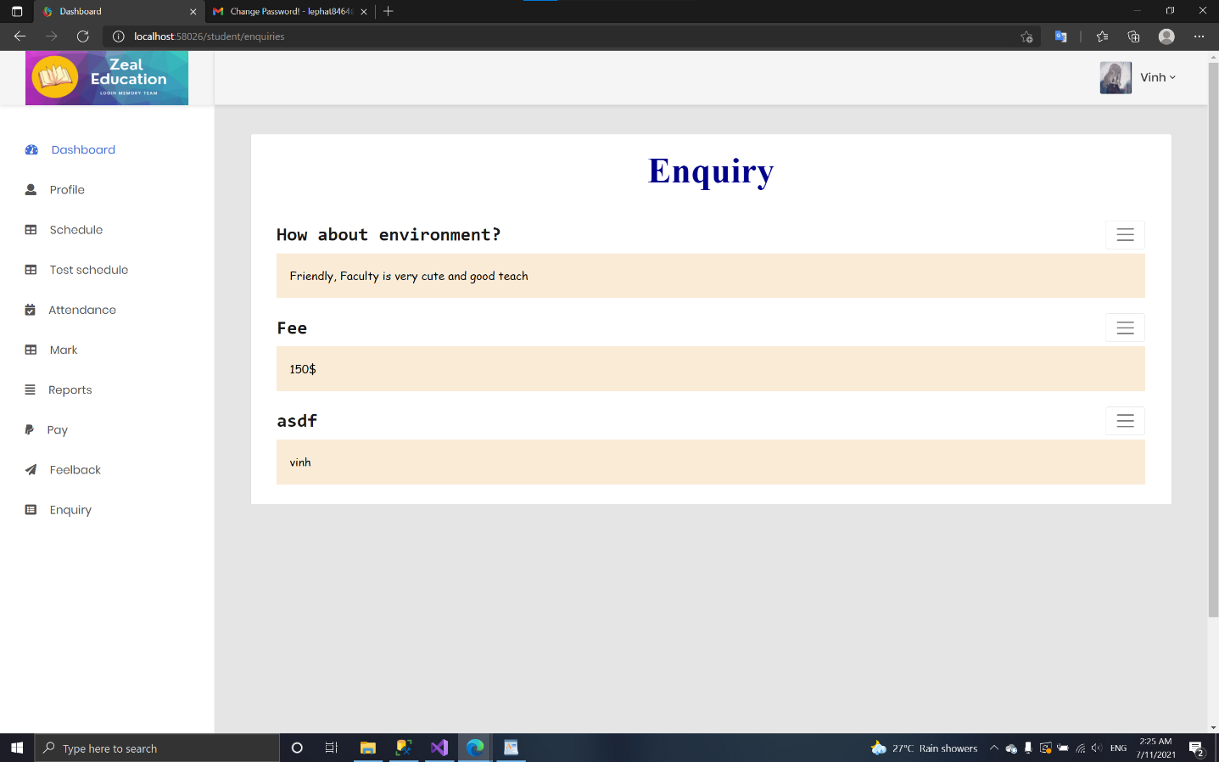**Enquiry:**

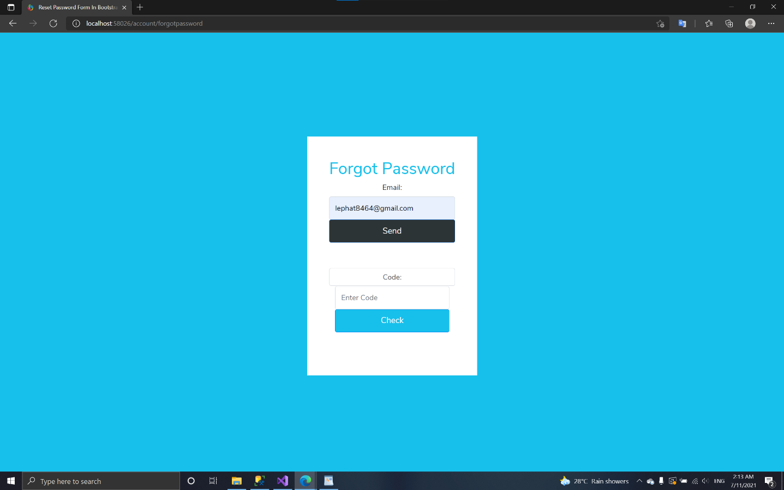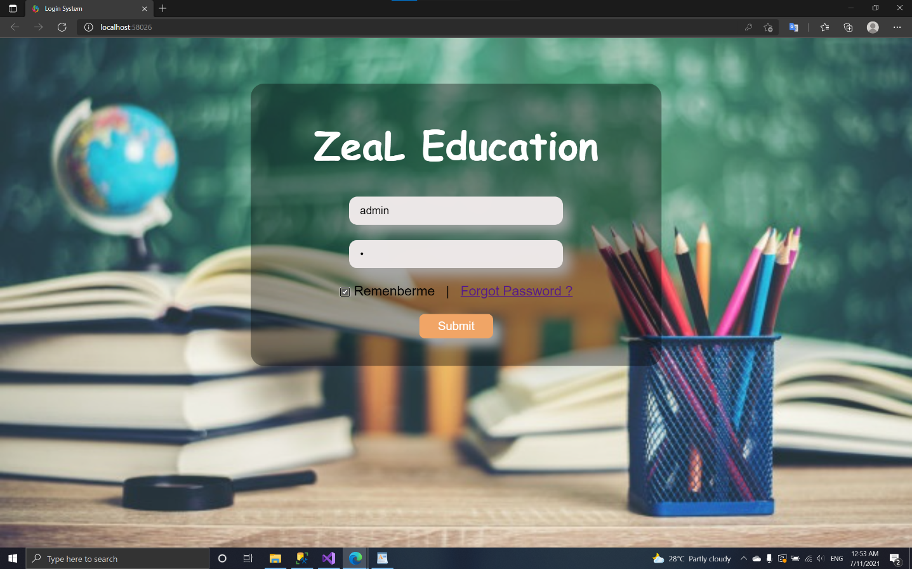***\* Forgot password***:

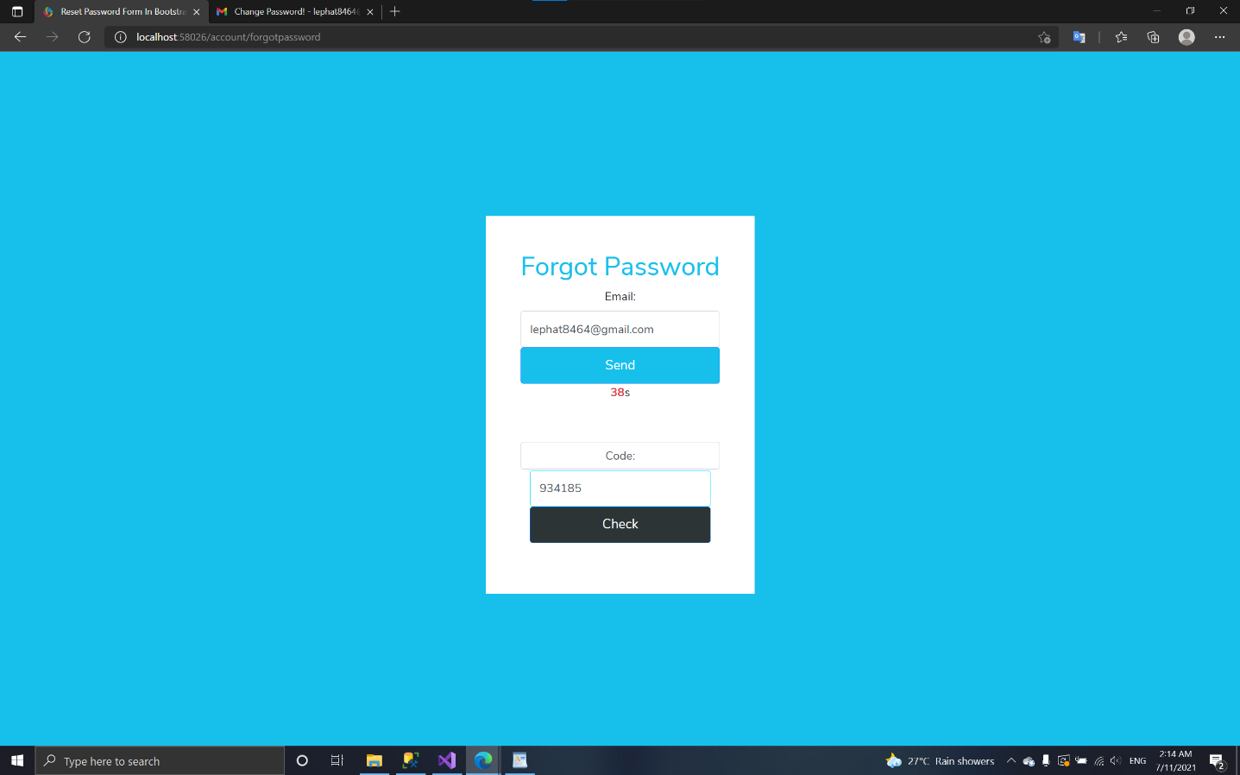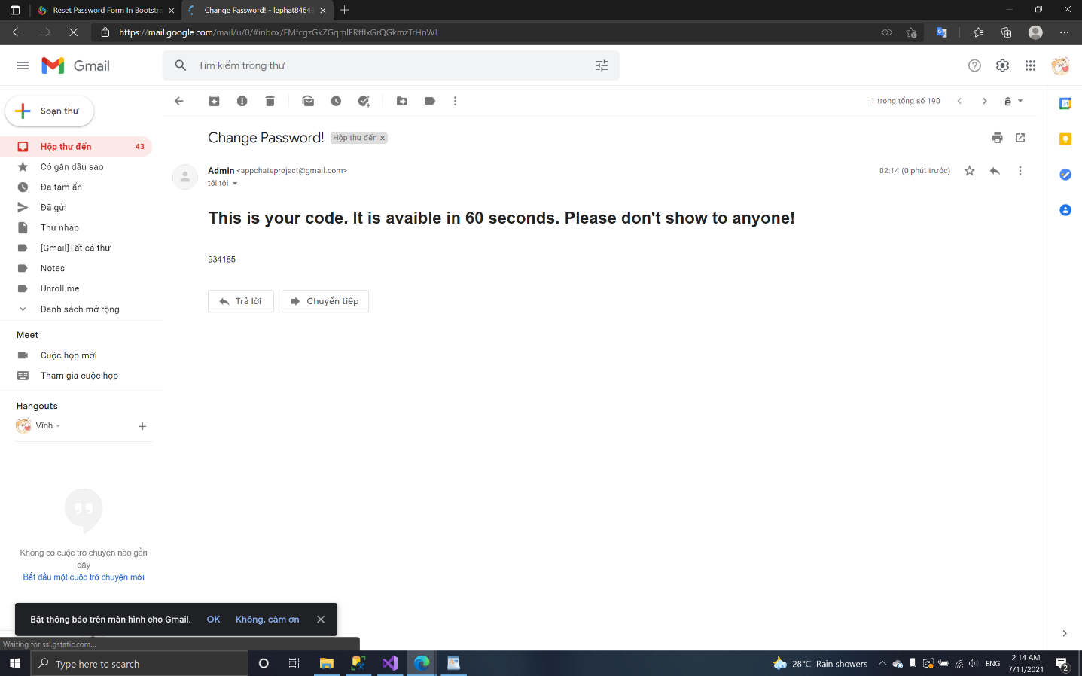

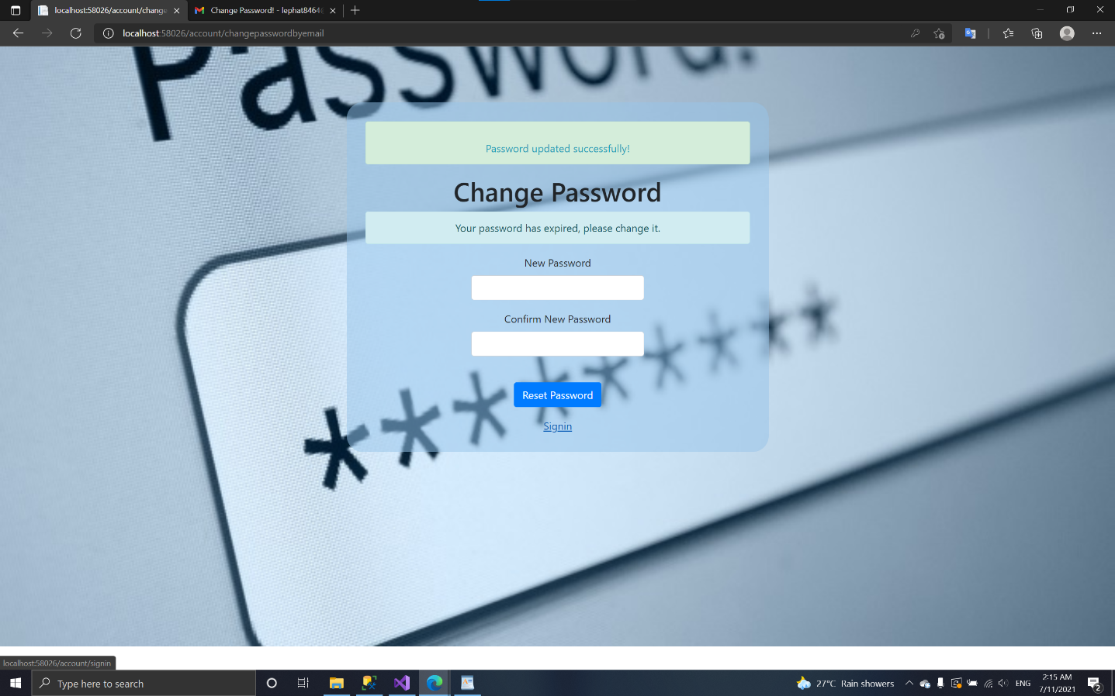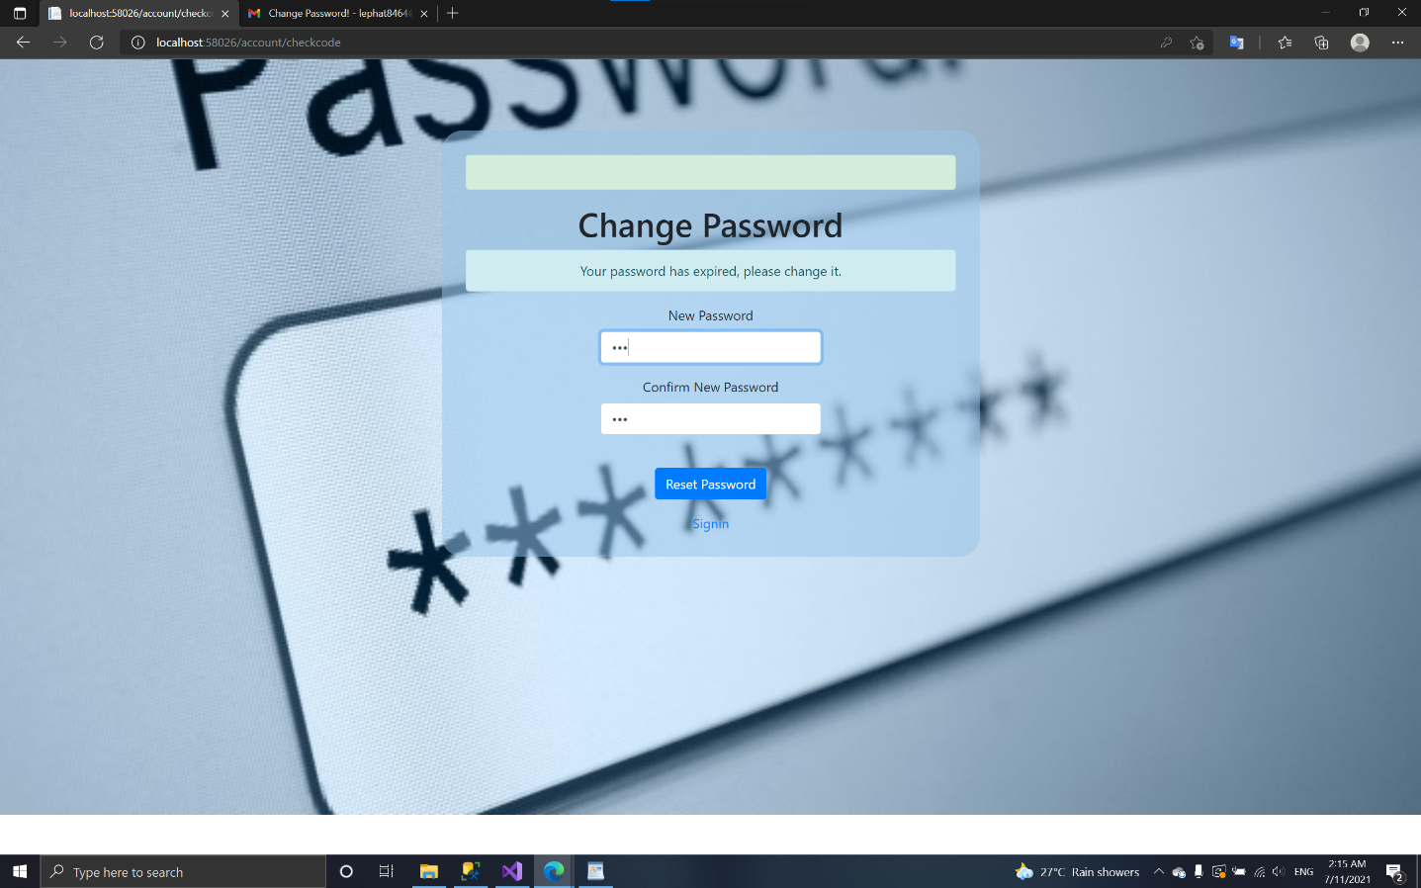

1. *Client:*
   * **Home Page:**

* **Course page:**
* 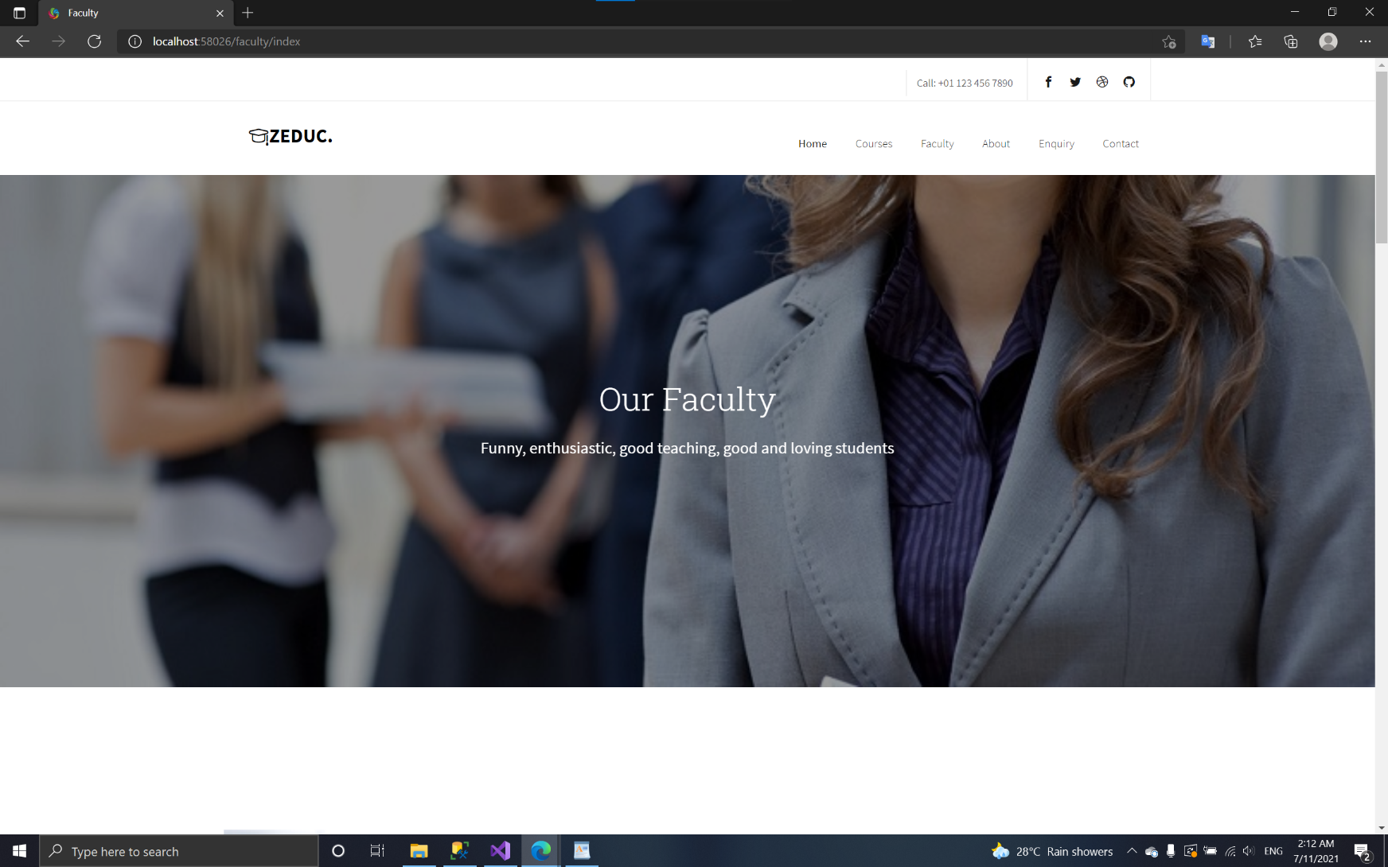**Faculty page:**
* 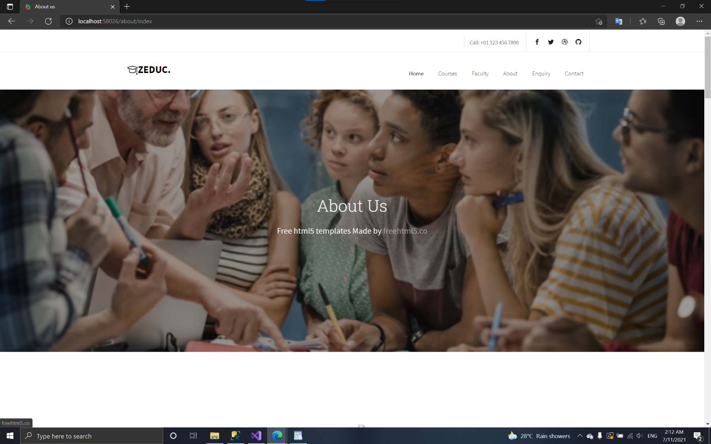**About page:**
* 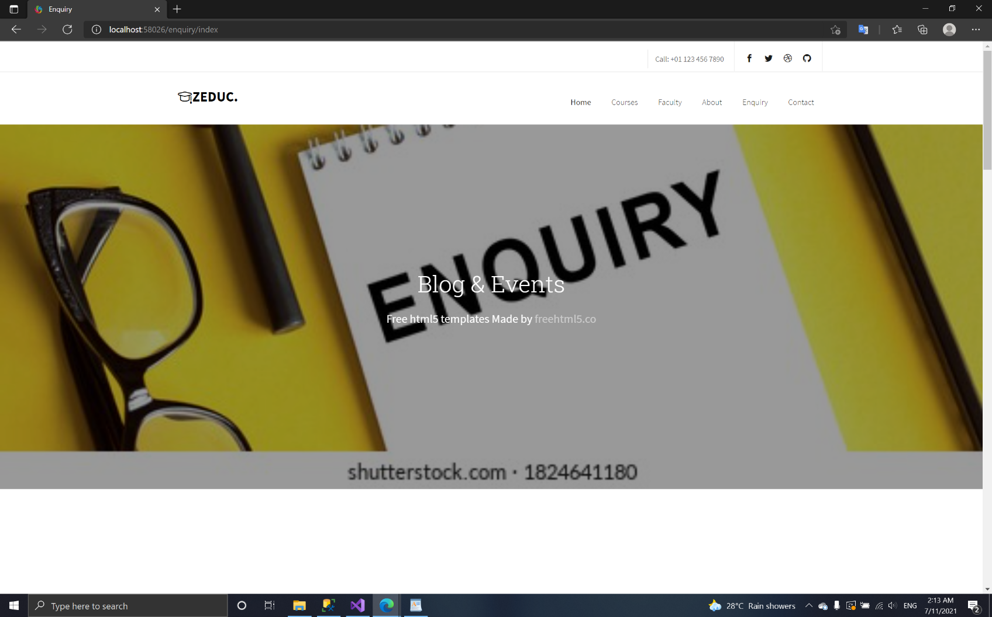**Enquiry page:**
* 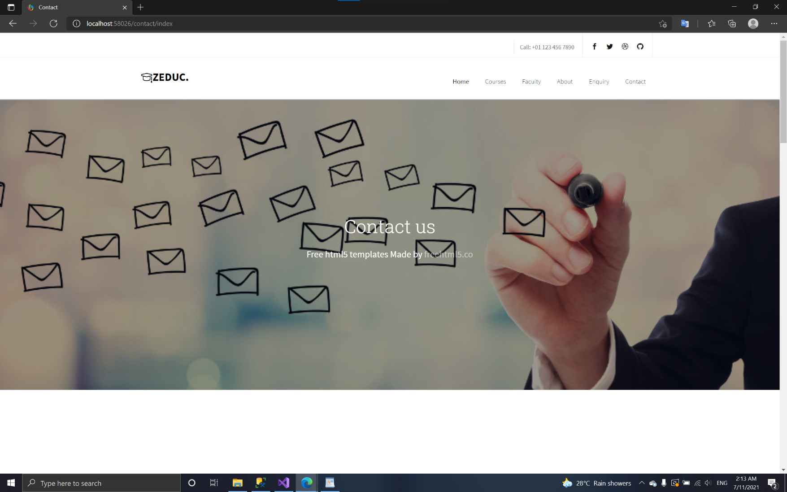**Contact page:**

***Chapter VI: INDIVIDUAL PROJECT SCHEDULE***

